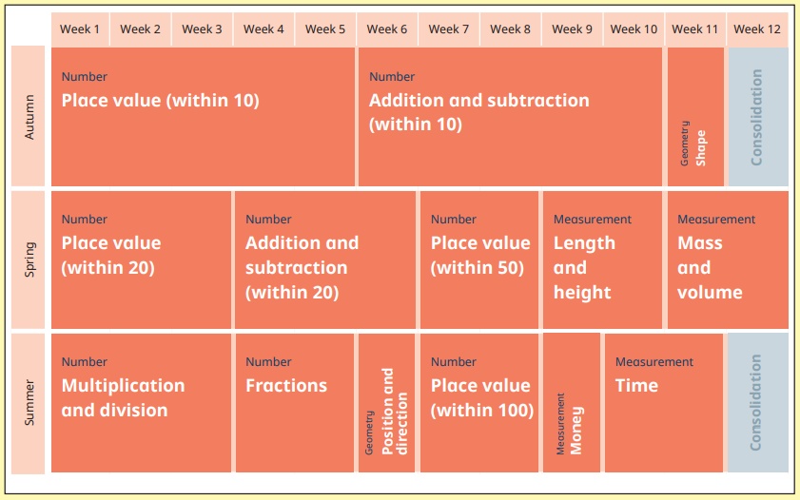
Working within the year 1/2 class we currently have two teachers. This allows for both joint year group lessons as well as singular year group lessons. Teachers use their professional judgement to decide which is most appropriate with each small step so you will see both during the year in KS1.
Year 1

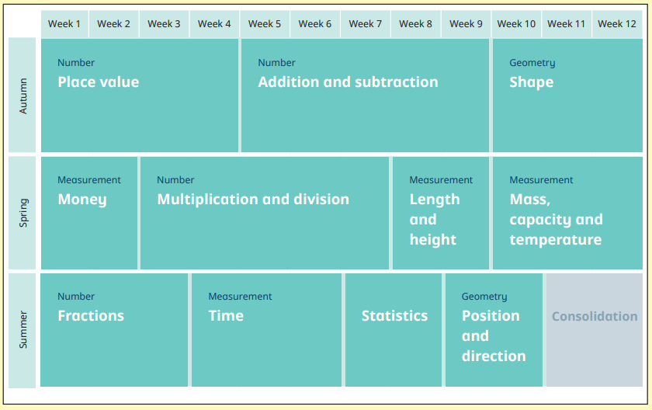
Year 2

