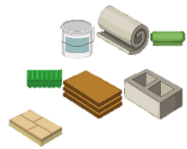
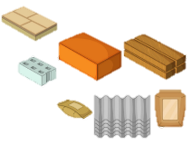
Use of EVERYDAY MATERIALS
KNOWLEDGE ORGANISER

What you should already know… |  |  | Properties of Materials
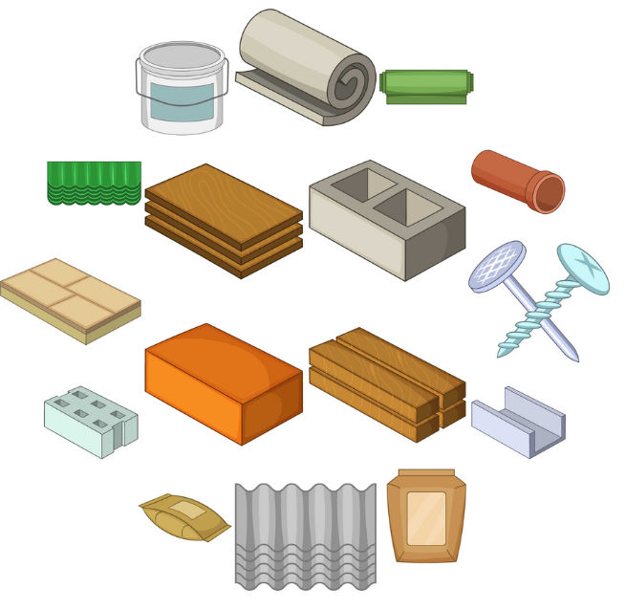  -Materials are the substances that things are made from.  -We use lots of different materials every day, e.g. metal, plastic, wood, and glass.  -Different materials have certain properties, e.g. glass is see-through, metal is strong and often shiny, etc.  -Composites are made from two or more materials together.  - Some materials are used to make many things. |  |  | Material | Image | Properties | What could it be used for?
 |  |  | Metal | 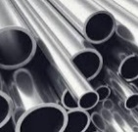 | -Metals are often strong, shiny, hard and long-lasting.  -Metals can be hammered into different shapes. | -Metals can be made into things like pots and pans.  -Metals can stretched into wires and rods.
 |  |  | Glass | 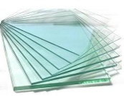 | -Glass can be strong, but thin glass shatters.  -Glass is transparent and waterproof. It can be made into different shapes. | -Glass is most often used to make windows and glasses.  -It is also used in making mirrors, table-tops and windscreens.
 |  |  | Wood | 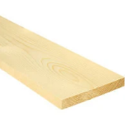 | -Wood is hard and strong;  -Wood is long-lasting and is a natural product.  -Wood is flammable. | -Wood is often used to build furniture, like benches and desks.  -Wood can be used to build houses and cabins.
 |  |  | Plastic | 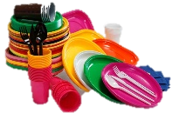 | -Plastics can be tough or flexible and can be made into any shape. Plastics can be dyed different colours and can be made transparent. | -Plastics can be used to make packaging, bottles and toys.  -Plastics can be moulded into plates, knives and forks.
Development of Materials
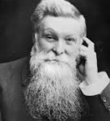
John Dunlop
-John Dunlop is famous for developing the pneumatic (air-filled) tyre.
-He did this, at first, to improve the tyres on his son’s bicycle!
-He used his understanding of rubber to fit it to a wooden disc. He then used an inflated tube of sheet rubber to blow up the tyre.
 |  |  | Rubber | 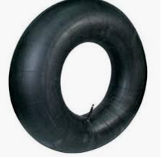 | -Rubber is extremely tough, but also very flexible.  -Rubber is elastic and also waterproof. Rubber doesn’t tear easily. | -Not including food and drinks, water is still used in many, many products. For example, it is used in making paints, toothpastes, shampoos and cement.
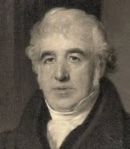  Charles Macintosh  -Charles Macintosh is best known for inventing the raincoat.  -He discovered a way in which rubber could be placed between two layers of cloth, to make it waterproof.  -His name lives on today – a raincoat is often called a Macintosh or Mac. |  |  | Brick | 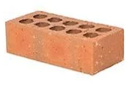 | -Bricks are very hard and strong. They are difficult to break. Bricks are thick and store heat well. | -Bricks are normally attached together with mortar and are used to make buildings.  -They are also used for paving.
 |  |  | Paper | 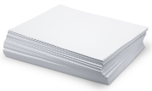 | -Paper is often thin and can be made into lots of different shapes. Paper can be torn. It goes soggy when wet. | -Paper is normally used for writing. Paper is used in diaries, notebooks and for printing on. Paper is used for posters/displays.
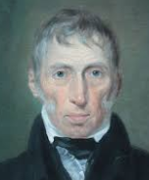
John McAdam
-John McAdam was the first person to think of tarmac roads.
-Roads used to be made from clay, earth, or chalk, but these materials were messy and not very smooth.
-He spread hot tarmac on a road, adding lime chippings & flattening.
 |  |  | Cardboard | 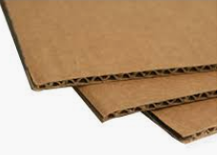 | -Cardboard is often thin but is firmer and tougher than paper. Cardboard is more difficult to tear. It goes soggy when wet. | -Cardboard is often turned into boxes and is then used for packaging items. It can be used for protection, e.g. protecting floors when painting.

Properties of Materials Vocabulary
Firm
Soft
Waterproof
Translucent
Flammable
Flexible
Dull
Hard
Bumpy
Bouncy
Absorbent
Smooth
Squashy

