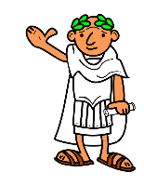
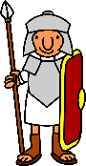
THE ROMANS
KNOWLEDGE ORGANISER
Diagram – Map of the Roman Empire |  |  | Important Places and Daily Life in the Roman Empire
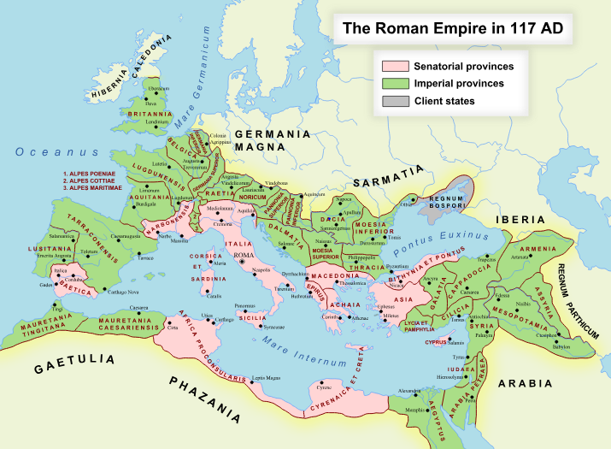  Map of the Roman Empire (117AD)  This map shows the Roman Empire at its largest, during the rule of Trajan in 117AD. Much of what is now Europe and North Africa was dominated by the empire, as was virtually all of the Mediterranean coastline. However, with the increasing size, the Romans’ ability to run the empire effectively was decreased, meaning that there was a gradual loss of territory from this point onwards, particularly in the 3rd Century. |  |  | The Colosseum | 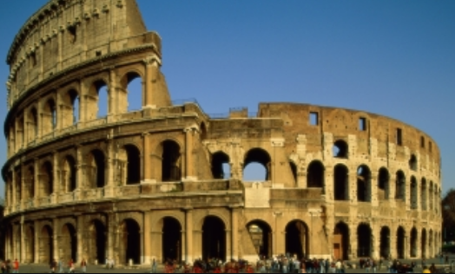 | The Colosseum was built between around 80 AD by the Emperor Vespasian. It could seat about 50,000 spectators who came to watch events including gladiatorial combats, wild animal hunts and sporting games. | Where?  Rome, Italy | Key Fact:  The Colosseum is 189m long and 156m wide!
 |  |  | The Pantheon | 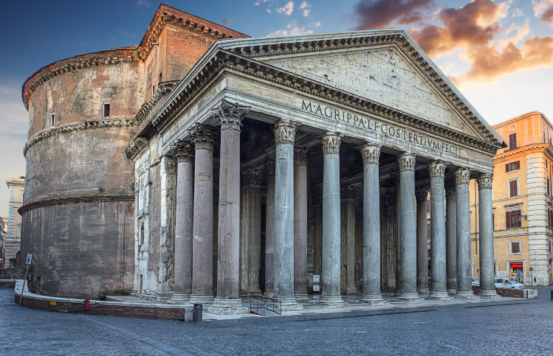 | The Pantheon was originally built as a temple to the gods of Ancient Rome, however was rebuilt in its current form in 126AD. It is the best preserved of the Roman buildings in Rome. Since it was built, it has always been used. | Where?  Rome, Italy | Key Fact:  Pantheon translates as ‘temple of all gods.’
 |  |  | Hadrian’s Wall | 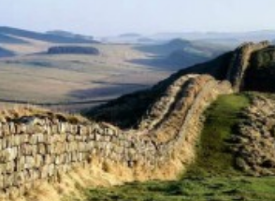 | Hadrian’s Wall, begun in 122AD, was a fortification designed to stop tribes in Scotland attacking England (part of the Roman Empire). It took over ten years to build. It was the most heavily fortified wall in the Empire. | Where?  73 miles along northern England | Key Fact:  Lots of the wall still exists, and can be followed by path.
 |  |  | Diocletian’s Palace | 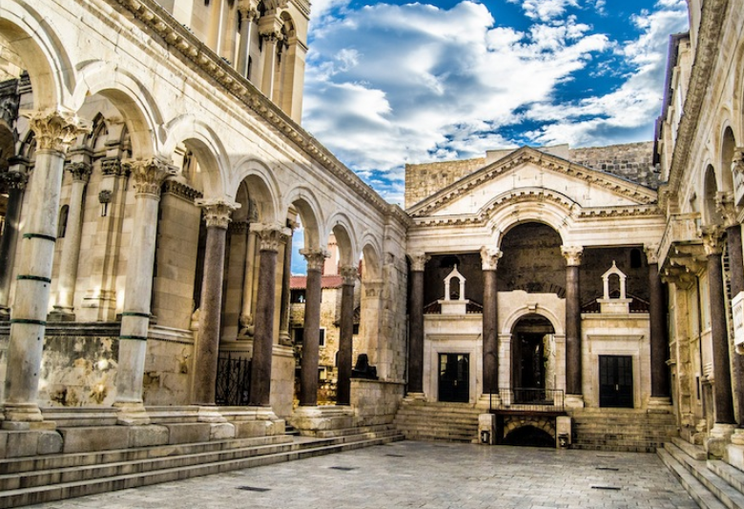 | Diocletian’s Palace was built as a retirement residence for the Roman Emperor Diocletian around 305AD. He lived in the palace until his death in 316AD. Although called a palace, it was also space for a whole army garrison! | Where?  Split, Croatia | Key Fact:  It is so huge that it makes up about half of the old town of Split!
 |  |  | Aqueduct of Segovia | 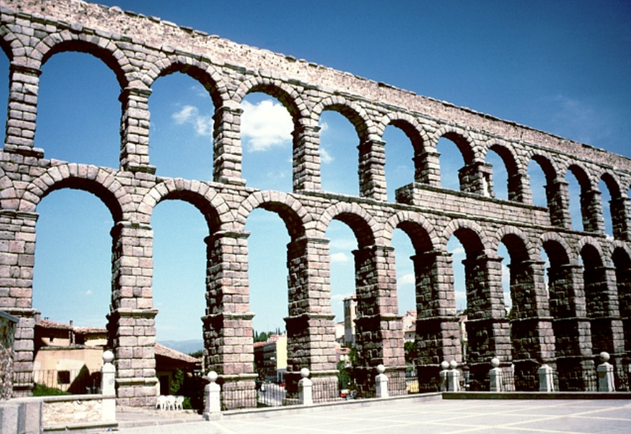 | The Aqueduct of Segovia is a well-maintained Aqueduct in Spain. It is predicted to have been built around 112AD. It once transported water from the Rio Frio river to Segovia. | Where?  Segovia, Spain | Key Fact:  At its tallest, the aqueduct reaches a height of 28.5m!
Roman Leaders and Emperors
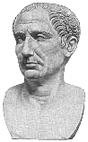  Julius Caesar (100BC-44BC)  Julius Caesar was best known for the being the first dictator of Rome – putting to an end the Roman Republic. A powerful army general, Caesar gathered enormous support amongst Romans. In opposition to the rules of the Senate, he marched his army to Rome and took control. As leader, he built many famous buildings and changed the calendar to the type we use today. He was eventually murdered by members of the Senate. | 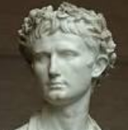  Augustus (63BC-14AD)  Augustus is best known for being the first Emperor of Rome and for establishing the Roman Empire. Formerly known as Octavian, Augustus gained his title when he became the ruler. After many years of civil war, he brought peace to the land, and began to rebuild the empire, including roads and buildings. He also expanded the empire around the Mediterranean, and brought peace and prosperity to Rome. |  | Family Life | 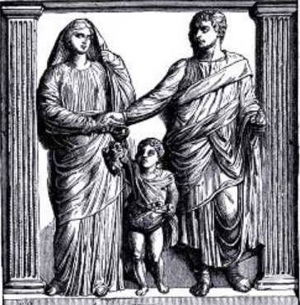 | Family was an important part of Roman life – laws were written to protect the family structure. The family that you belonged to had a lot to do with your place in Roman society. | How?  Slaves and servants were counted as a part of the ‘familia.’ | Key Fact:  The ‘familia’ of Roman Emperors could extend into thousands!
 |  |  | Slaves and Peasants | 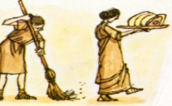 | Slaves performed much of the hard work and construction in the Roman Empire. Most slaves were people captured in times of war, but some children were born as slaves. | How?  Most slaves worked in building or on farms. | Key Fact:  Some people sold themselves into slavery to pay debts!
 |  |  | Life in the City | 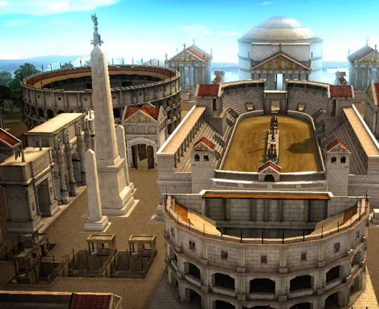 | In Ancient Rome, the city was the hub of life. It was the place where goods could be traded, people could be entertained, and important decisions took place. | How?  The Romans used city grids to plan their new cities | Key Fact:  Although Rome was the biggest, there were many important cities across the Empire
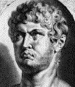  Nero (37AD-68AD)  Nero has a reputation for being one of the worst Emperors of Rome. It is rumoured that he executed anyone who did not agree with him (including his own mother!) and that he played the fiddle whilst Rome burned in a great fire (this is debated). Despite starting out with good intentions, Nero became a tyrant, killing people in horrible ways, often with little proof of their guilt. In 68AD, fearing that he would be executed, Nero committed suicide. | 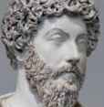  Marcus Aurelius (121AD-180AD)  Marcus Aurelius was considered the last of Rome’s ‘Five Good Emperors.’ He was well-liked - the word ‘Aurelius’ itself means golden. He skillfully guided the Roman Empire through wars on several fronts, whilst also receiving loyalty from those in positions of power around him. Aurelius made sure that his son (Commodus) succeeded him after his death - a bad choice as Commodus proved to be self-centred and inexperienced.
 |  |  | Life in the Country | 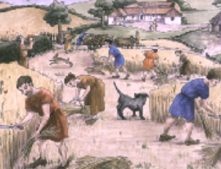 | Most of the Roman population lived in the countryside – many were farmers. Life was hard, with most people working from dawn right up until dusk. | How?  Crops were grown in the country to be shipped to cities like Rome | Key Fact:  The city of Rome had to import 6 million sacks of grain a year!
 |  |  | School | 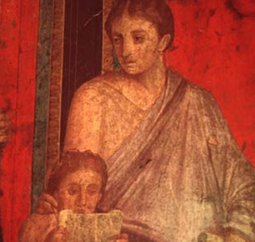 | Roman children started school at the age of seven. Wealthy children could be taught by a tutor, whilst others went to public school. Poor children could not go to school. | How?  Children learnt reading, writing and maths. | Key Fact:  Many girls were not allowed to school.
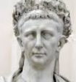  Claudius (10BC–54AD)  Claudius was the fourth Roman Emperor. He had some kind of disability, in both speech and waliking, which meant he was kept from power until he was the last remaining male in the family, aged 38. Claudius, however, proved himself to be a good leader, expanding the Empire and doing a great deal for the public. Unfortunately his adopted son, Nero, later undid much of his good work. | 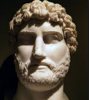  Hadrian (76AD–138AD)  Hadrian was the Roman Emperor who is now best-known for building Hadrian’s Wall, which marked the northern limit of Roman territory in Britain. He also built the Pantheon in Rome, amongst many other famous buildings. Hadrian was a kind Emperor who was considered the third of the ‘Five Good Emperors.’ Throughout his reign, he travelled to almost every province. |  | Food | 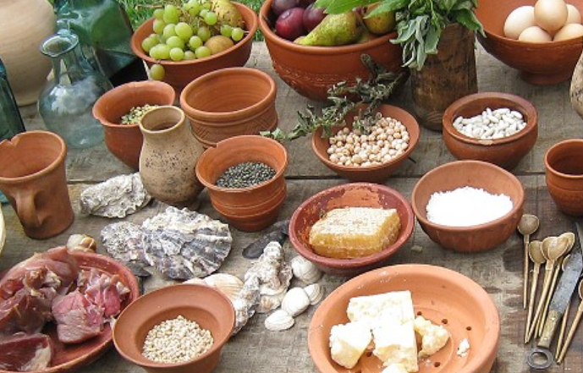 | A wide variety of foods were available, depending upon a person’s wealth and where they lived. The Romans ate 3 meals a day, with the largest meal eaten in the afternoon. | How?  Foods were imported all around the empire. | Key Fact:  The poor largely ate a porridge called ‘puls.’
 |  |  | Clothes | 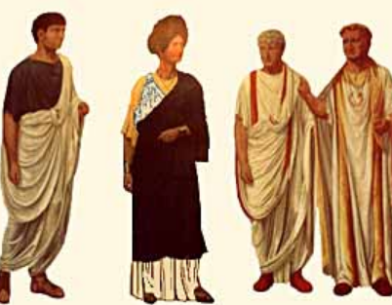 | Most men and women wore tunics, with a belt. However the women’s tunic was normally slightly longer. Women wore white until they were married. Most Romans wore sandals (made of leather) on their feet. | How?  Most clothes were made from wool. | Key Fact:  The rich could afford linen and silk clothes.

476 AD – Romulus is overthrown and the Roman Empire is no more.
306 AD – Constantine converts to Christianity, making Rome a Christian empire.
121 AD – Hadrian’s Wall is built.
80 AD – The Colosseum is built.
27 BC – The Roman Empire begins, with Augustus as the first Roman emperor.
45 BC– Julius Caesar becomes the first dictator of Rome, signaling the end of the Roman republic.
73 BC – Spartacus the gladiator leads the slaves in an uprising.
509 BC – Rome becomes a republic. Rome is run by elected senators.
753 BC – The city of Rome is founded.
Roman Timeline

