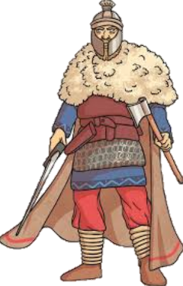
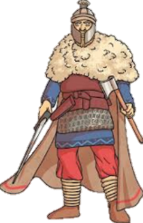
THE ANGLO-SAXONS
KNOWLEDGE ORGANISER
Diagram – Anglo-Saxon Routes |  |  | Kingdoms, Battles and Life in the Anglo-Saxon Times
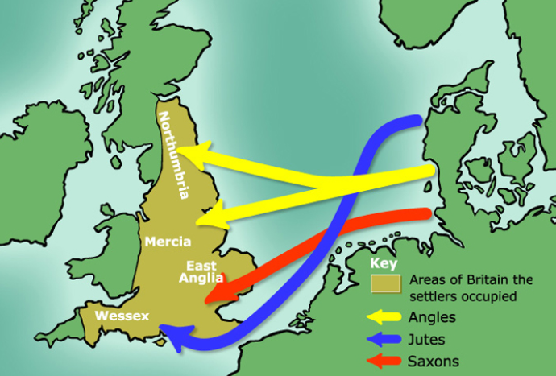  Map of Anglo-Saxon Routes  After the Romans left Britain, it became more open to invasion. The Anglo-Saxons were made up of people who rowed across the North Sea from an area that is now northern Germany, Denmark and the Netherlands. These people were from three tribes: the Angles, the Saxons, and the Jutes. The Angles settled in northern England and East Anglia. The Saxons settled in large sections of southern England. The Jutes, meanwhile, adopted areas of Hampshire, Kent, and the Isle of Wight. |  |  | East Anglia | 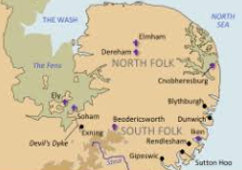 | East Anglia was a small independent kingdom of the Angles, which was formed in the 6th Century in the wake of the Anglo-Saxon settlement of Great Britain. It was incorporated into the Kingdom of England in 918. | Where?  The East of England | Key Fact:  The swampy ‘Fens’ separated much of East Anglia from the other kingdoms.
 |  |  | Mercia | 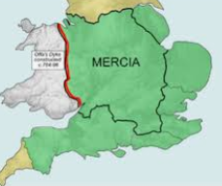 | Mercia was a large Anglo-Saxon kingdom that was centred around the River Trent. For 300 years (between 600 and 900AD) Mercia dominated England south of the River Humber – a period known as the Mercian Supremacy. | Where?  English midlands | Key Fact:  After invasions by the Vikings, much of Mercia was absorbed into Danelaw.
 |  |  | Wessex | 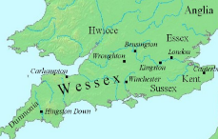 | Wessex was an Anglo-Saxon kingdom in the south of the country. A number of famous Wessex kings have become prominent figures in history, including Alfred the Great and Egbert – the first King of England. | Where?  South and South West-England | Key Fact:  Wessex ceased to exist after King Harold’s defeat in 1066.
 |  |  | Northumbria | 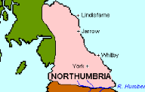 | Northumbria was another medieval Anglican kingdom. It was originally made up of two separate kingdoms – Bernicia (from around Cumbria) and Deira (from around York) – until the two united around the year 654. | Where?  North-eastern England and south-eastern Scotland | Key Fact:  The name Northumbria means ‘the people north of the Humber.’
 |  |  | Danelaw | 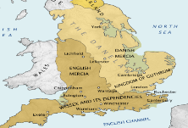 | King Alfred the Great defeated the Vikings in 878 AD, and had them sign a treaty, which governed that the Vikings stick to their own land in north and east England – this section of land became known as the Danelaw. | Where?  North and East England | Key Fact:  The Vikings did not give up on ruling all of England, and eventually did!
Famous Anglo-Saxons
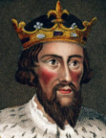  Alfred the Great (849-899 AD)  Alfred the Great was an Anglo-Saxon king of Wessex, who was famous for his victories against the Vikings. Alfred, a great military mind, made strategical changes to ensure that Wessex stood strong, where other kingdoms fell to the Vikings. He eventually established Danelaw to keep Vikings in the east. He was also deeply interested in learning – he translated texts from Latin to English, and began to develop law across the land. | 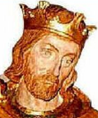  Edward the Elder (874/877-924 AD)  Edward the Elder was the son of Alfred the Great, and was King of Wessex from 899 until his death in 924. He was involved in several battles throughout the time of his father’s reign, and this continued throughout his own reign. His succession to the throne was threatened by his cousin Ethelwald, who sided with the Viking. The two battled numerous times, until Ethelwald was eventually killed in battle at Holme in Essex. |  | Battle of Edington | 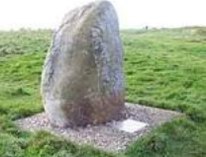 | At the Battle of Edington, an Anglo-Saxon army led by King Alfred the Great defeated the Great Heathen Army, a collection of Viking warriors led by Guthrum. | When?  May 878 AD | Key Fact:  Afterwards, Guthrum was baptized and made to accept Alfred as his leader.
 |  |  | Battle of Stamford Bridge | 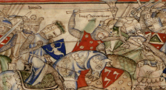 | This battle took place in the village of Stamford Bridge, in the east riding of Yorkshire. King Harold of England defeated a Viking army led by Harald Hardrada | When?  25/09/1066 –widely considered the end of the Viking era | Key Fact:  Harold’s army was defeated only 3 weeks later at the Battle of Hastings.
 |  |  | Battle of Hastings | 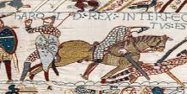 | 3 weeks after the Battle of Stamford Bridge, King Harold was killed by the Normans at the Battle of Hastings. William of Normandy, who became the first Norman King. | Who?  William became known as ‘William the Conqueror.’ | Key Fact:  The common belief that Harold was killed by an arrow in the eye is unproven.
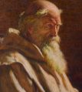  Saint Bede the Venerable (673AD-735AD)  Saint Bede was a monk at the monastery of St. Peter and St Paul in the Kingdom of Northumbria. Bede travelled to several monasteries as a young boy, being lucky to avoid the plague that killed most at Jarrow monastery. He was an author and scholar, and his most famous work: The Ecclesiastical History of the English people, led to him being named ‘The Father of English History. He was also a skilled linguist and translator. | 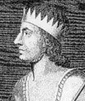  Egbert (Ecgherht) (771/775AD-839AD)  Egbert (also spelt Ecgherht) was King of Wessex from 802AD until his death in 839AD. He was the first monarch to establish a stable and extensive rule over Anglo-Saxon England, and as a result is often referred to as the first King of England: after his victories in Mercia and Northumberland he was recognised by the title Bretwalda (‘ruler of the British’). A year before he died, he defeated a combined force of the Danes and Cornish.
 |  |  | Houses | 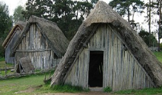 | The British forests had all that the Anglo-Saxons needed to build their houses. They were small wooden huts with straw roofs, and one room in which the whole family lived. | How?  A hole was placed in the roof to allow smoke from cooking fire to escape. | Key Fact:  The biggest house in each village was reserved for the chief of the village.
 |  |  | Religion | 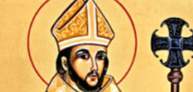 | Most Anglo-Saxons were pagans, believing in lots of different gods, until the Pope in Rome sent over Augustine as a missionary, in 597AD. Slowly, the country became Christian. | Who?  Augustine became the first archbishop of Canterbury | Key Fact:  Churches built at this time were normally made of wood.
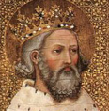  Edward the Confessor (777BC–859AD)  Edward the Confessor was the last but one of the Anglo-Saxon kings, known for his deep religious faith, which governed all aspects of his life. It is rumoured that Edward promised the throne to up to four different potential heirs before his death. This led to the eventual successor, Harold Godwinson, inheriting an unstable throne. Many belief this triggered the downfall of Anglo-Saxon rule. | 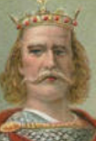  Harold Godwinson (1022AD–1066AD)  Harold Godwinson, often called Harold II, was the last crowned Anglo-Saxon King of England. He had a short reign, lasting from 6th January 1066 until his famous death at hands of the Normans in the Battle of Hastings (on 14th October of the same year). Only weeks before, he had successfully repelled an attack from the Danish leader Harold Hardrada at Stamford Bridge. |  | Food | 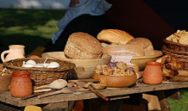 | Anglo-Saxons enjoyed huge feasts. They ate bread, meats such as pork and lamb, vegetables such as carrots and parsnips, and drank milk and beer! | How?  Anglo-Saxons grew wheat to make bread and porridge. | Key Fact:  Extra animal fat was used to fuel oil lamps.
 |  |  | Clothes | 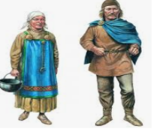 | Men wore long-sleeved tunics made of wool or linen, and these were often decorated with patterns. Women would wear an underdress of linen, and an outer pinafore-like dress called a ‘peplos.’ Shoes were made of leather. | How?  Anglo-Saxons made their clothes from natural resources. | Key Fact:  Belts were used to hang tools and small weapons from.

1016-1035 AD – Canute the Great – the first Viking king - rules
871-899 AD – Alfred the Great rules.
410 AD – The Romans leave Britain unguarded.
Anglo-Saxon Timeline
547-586 AD– The Kingdoms of Northumberland, East Anglia, and Mercia are formed.
1066 AD – At the Battle of Hastings, the Normans defeat the Anglo-Saxons.
802 AD – Egbert becomes the first King of England.
597 AD – St. Augustine arrives in Britain and introduces people to Christianity.
477-495 AD – The Kingdoms of Wessex and Essex are formed.
455 AD – The Kingdom of Kent is established (primarily by the Jutes).

