Welcome to Cambois Primary School Nursery & Reception

The staff team
Miss Allan
Mrs Philips
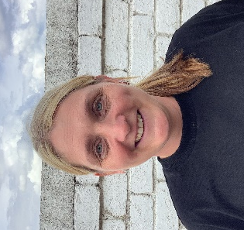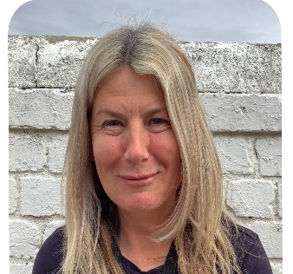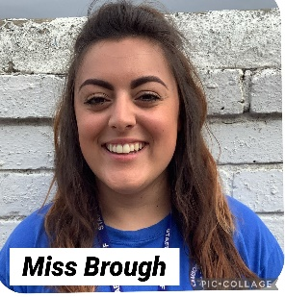
Mrs Kirk
Mrs Buckle
Children can come into school from 8.30am.
School begins at 8.40am
Children should come into school via the gate at the right hand side of the school where they will be met by members of the Early Years Team.
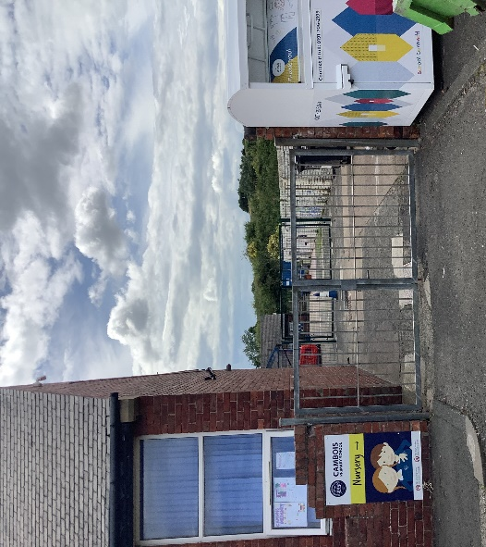

The morning Nursery session finishes at 11.30
Children in Reception or who access 30 hours in Nursery finish at 3pm. Please collect children from the same gate.
For information about Breakfast club and after school clubs please contact the school office - admin@cambois.northumberland.sch.uk
It would be helpful if children bring a pair of wellington boots and an outdoor rain suit to remain at school. We go outside and play in all weathers and children will attend forest school (on site) each week.

Children in Early Years access physical play every day so no jewellery should be worn at school.

School uniform can be purchased
https://www.border-embroideries.co.uk/schools/cambois-primary-school.html
- Black/Grey Trousers / Skirts
- White Polo shirt / T-shirt
- Shoes
- Blue jumper / blue cardigan - does not need to have the school logo
- Pinafores
- Bookbag
For P.E.
- Shorts
- T-shirt
- Trainers
- Blue hoodie - does not need to have the school logo on
Children will need to come into school wearing their PE kit on the days they have PE. (Twice a week)

We look forward to your child being part of the school and working with you.

