Personal, Social and Emotional Development/ Religious Education  This half term our focus week will be centred around the religion of Christianity and in particular the story of Easter. | Physical Development  As part of our university this ½ term we will be doing rugby with ‘The Bear’ from Cramlington Rockets, so we will need an outdoor kit each week.  We will continue going swimming each Wednesday. | Topic  Our topic this ½ term is still Ancient Greece. We will be looking at Greek Theatre, art work and food this half term. Medium term overview available on our class page on our school website.
Literacy  In Talk For Writing we are focusing on non-fiction texts this ½ term and in y5/6 it will be non-chronological reports. We will be writing reports linked to animals and the book Fantastic Beasts and Where to Find them. Towards the end of the ½ term we will be looking at poetry. | This is Me  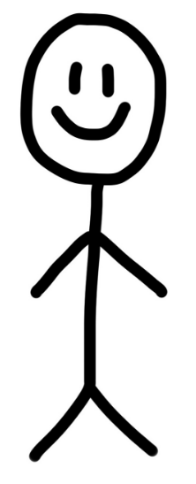 | Mathematics  Years 5 and 6 will be split for maths to allow yr6 to focus on upcoming SATs. Yr6 will be taught by Mrs Darbyshire and Y5 by Mrs Allan and Mrs Richardson. In y5 we continue to build on our mastery approach focusing on fluency, problem solving and reasoning linked to the 4 operations (+ - x ÷).
Homework and reading  Reading folders should be brought into school daily.  The format of homework will remain as an optional format in order to receive praise points. | Science  We will be learning about evolution and inheritance. In this topic we look at how species have evolved over time, fossils and animals that have become extinct. We will also be looking at characteristics that we have inherited from our parents. | PE kit  Most of Year 5 and 6 will have PE on Friday and all will have Swimming on Wednesday. Kits should be brought into school on the first day of term and we suggest you leave it until half term.  Remember they’ll need: a plain white t shirt, blue/black shorts, sandshoes / trainers. Swimming will cost £2 each week.
Educational visits  You will be informed any further visits. | Important information  Mrs Darbyshire will have PPA on Wednesday pm so will be out of the classroom. The children will have swimming during this time. | Dates for the diary  - Y5 biking 9th March  - Parents consultation meetings 15th March
Supporting your child at home  Please remember to read with your child at home and sign their books twice a week at least. It is vital they are questioned about what they’ve read in order to improve their comprehension skills at this stage. |  | Follow us on Twitter and Facebook!    

