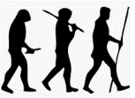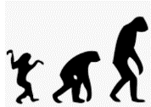

**EVOLUTION and INHERITANCE**

KNOWLEDGE ORGANISER

Y6

|  |  |  |  |
| --- | --- | --- | --- |
| **Overview** | |  | Evidence for Evolution |
| -Evolution is a change over time. It occurs when there is competition to survive (natural selection).  -Characteristics are passed from parents to their offspring. This is called inheritance.  -Offspring are not identical to their parents. Some characteristics are inherited, but some are new in the offspring – these are called mutations.  -Fossils are remains of living things, and provide evidence about living things from the past.  -Animals and plants are suited to their environments, and adaptation leads to advantageous changes. | |  | Fossils are the remains of living things, found in sedimentary rocks. |
|  | -When paleontologists compare animals in fossils to animals today, they can see similarities and differences between them.  -e.g. Fossils show that giraffes necks did not used to be as long. They have developed over time to reach high branches.  -Living things also provide evidence of natural selection and evolution.  -e.g. On the Galapagos Islands, Charles Darwin found differences between finches from island to island. They had adapted for the different foods that they eat. |
|  |  |  |  |
| **Inheritance and Mutation** | |  | **Adaptation** |
| Evolution is the name given for changes to a species over time. | |  | Evolution & natural selection have enabled living things to adapt to their environments. |
| -Living things produce offspring of the same kind.  -Some of a parent’s characteristics are passed down to the offspring – this is called inheritance.  -This is why we often share similar features with our parents, and some conditions are shared (see image).  -Inheritance is genetic, not environmental. E.g. If two blonde-haired parents dye their hair black, this does not mean they will have a black-haired child.  -Some features are new to the offspring. These are called mutations. This is why we are not exact copies of our parents.  -These changes in offspring over time allow evolution to take place. | | -Sometimes, changes that offspring have from their parents are advantageous – they allow the offspring to cope better in their environment.  -However, often the changes are not advantageous (called maladaptations). When this is the case, the offspring will find it more difficult to thrive.  -Natural selection can ensure that, over time, the advantageous characteristics survive in the species.  -For example, many polar animals have adapted to possess layers of blubber and/or fur (for warmth) and white outer coats (for camouflage).  -The dodo, with no predators on its island, had adapted in a number of ways that made it unable to survive when humans arrived (maladaptations). |
|  |
|  |
|  |
|  |
|  |

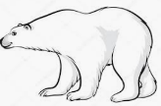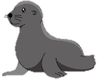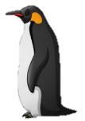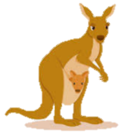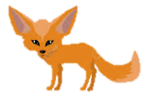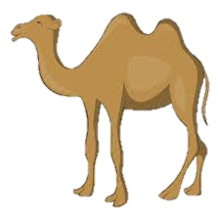

Polar Bear

Seal

Penguin

Kangaroo

Fennec Fox

Adapted to Cold Environments

Adapted to Warm Environments

Camels