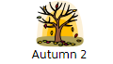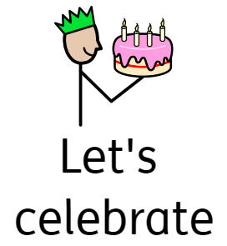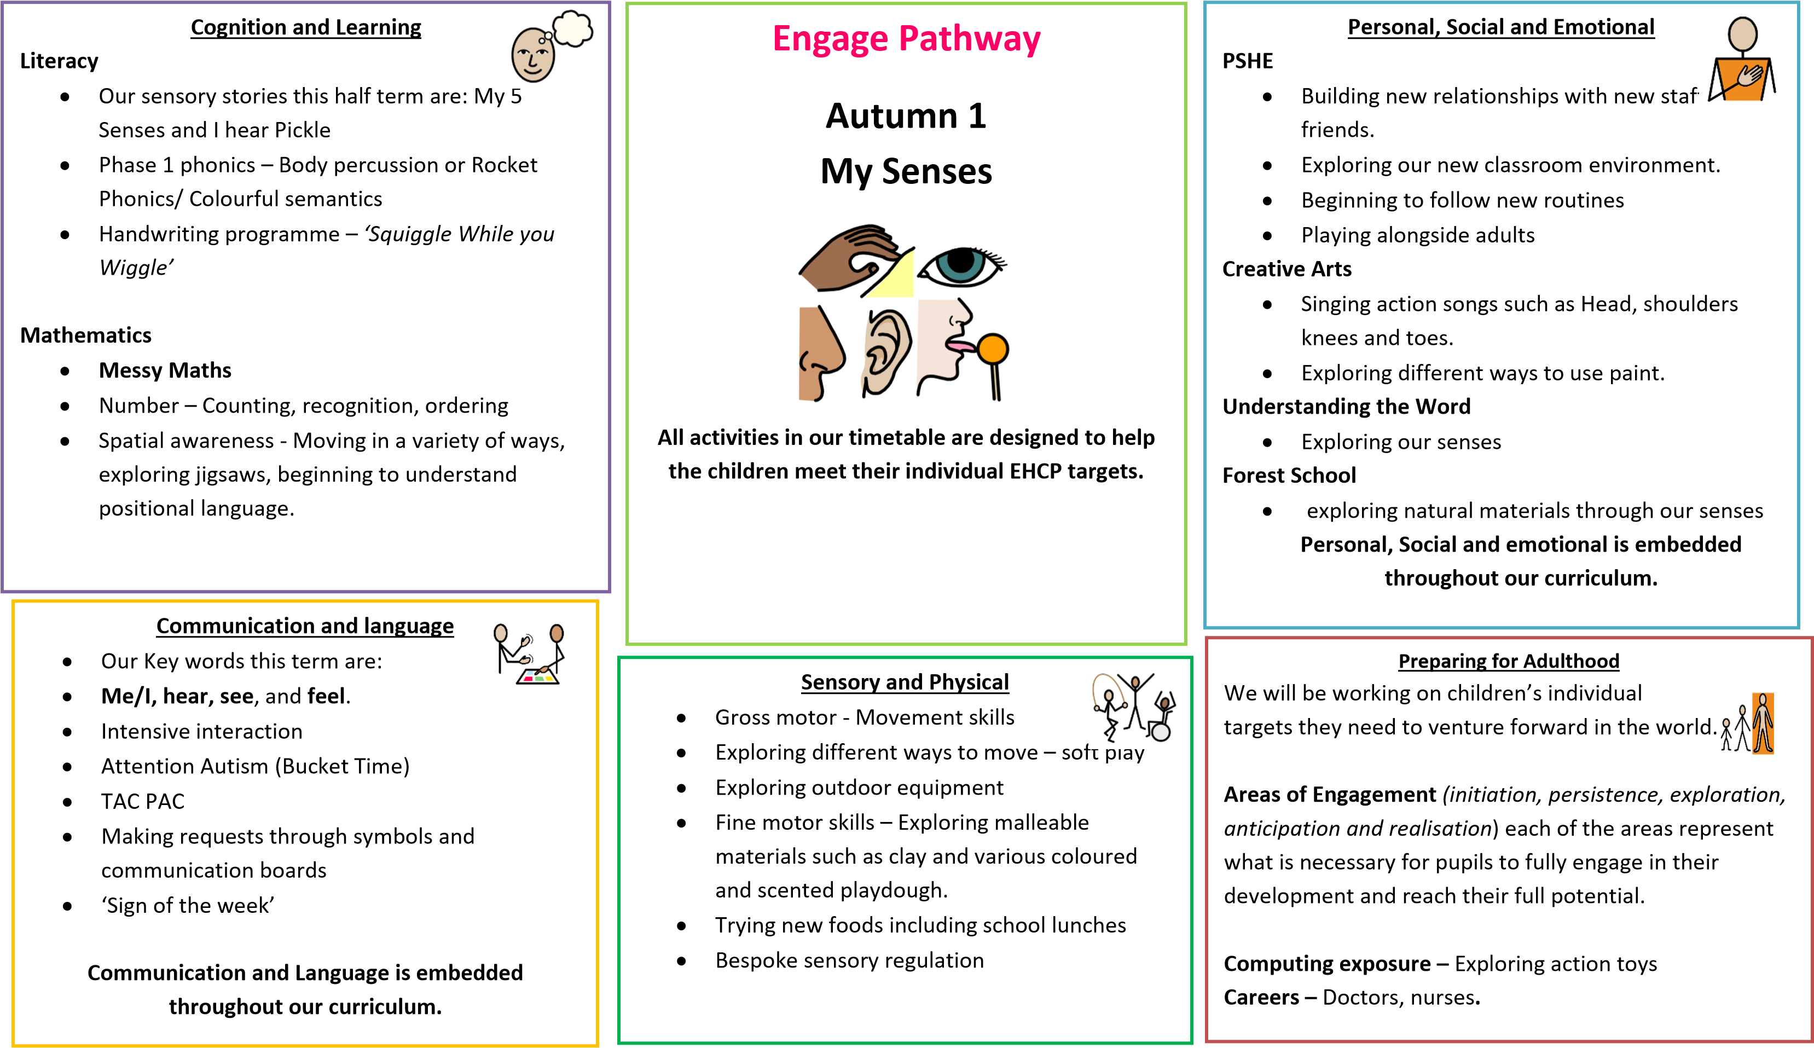 **Topic Overview**

Exploring different celebrations

* Preformal writing shapes
* Phonics flash cards.
* Nursery Rhymes
* Retelling stories

**Want**