Mathematics at Greater Depth
At the centre of the mastery approach to the teaching of mathematics is the belief that all children have the potential to succeed. They should have access to the same curriculum content and, rather than being extended with new learning, they should deepen their conceptual understanding by tackling challenging and varied problems. Similarly, with calculation strategies, children must not simply rote learn procedures but demonstrate their understanding of these procedures through the use of concrete materials and pictorial representations. This policy outlines the different calculation strategies that should be taught and used in Year 1 to Year 6 in line with the requirements of the 2014 Primary National Curriculum.

Background
The 2014 Primary National Curriculum for mathematics differs from its predecessor in many ways. Alongside the end of Key Stage year expectations, there are suggested goals for each year; there is also an emphasis on depth before breadth and a greater expectation of what children should achieve. In addition, there is a whole new assessment method, as the removal of levels gives schools greater freedom to develop and use their own systems. One of the key differences is the level of detail included, indicating what children should be learning and when. This is suggested content for each year group, but schools have been given autonomy to introduce content earlier or later, with the expectation that by the end of each key stage the required content has been covered. For example, in Year 2, it is suggested that children should be able to ‘add and subtract one-digit and two-digit numbers to 20, including zero’ and a few years later, in Year 5, they should be able to ‘add and subtract whole numbers with more than four digits, including using formal written methods (columnar addition and subtraction)’. In many ways, these specific objectives make it easier for teachers to plan a coherent approach to the development of pupils’ calculation skills. However, the expectation of using formal methods is rightly coupled with the explicit requirement for children to use concrete materials and create pictorial representations – a key component of the mastery approach.

Mathematical Language
The quality and variety of language that pupils hear and speak are key factors in developing their mathematical vocabulary and presenting a mathematical justification, argument or proof.

2014 Maths Programme of Study
The 2014 National Curriculum is explicit in articulating the importance of children using the correct mathematical language as a central part of their learning (reasoning). Indeed, in certain year groups, the non-statutory guidance highlights the requirement for children to extend their language around certain concepts. It is therefore essential that teaching using the strategies outlined in this policy is accompanied by the use of appropriate and precise mathematical vocabulary. New vocabulary should be introduced in a suitable context (for example, with relevant real objects, apparatus, pictures or diagrams) and explained carefully. High expectations of the mathematical language used are essential, with teachers only accepting what is correct. The school agreed list of terminology is located at Appendix A to this document.

How to use the policy
This mathematics policy is a guide for all staff at Cambois Primary school and has been adapted from work by the NCETM and The White Rose Maths Hub. It is purposely set out as a progression of mathematical skills and not into year group phases to encourage a flexible approach to teaching and learning. It is expected that teachers will use their professional judgement as to when consolidation of existing skills is required or if to move onto the next concept. However, the focus must always remain on breadth and depth rather than accelerating through concepts. Children should not be extended with new learning before they are ready, they should deepen their conceptual understanding by tackling challenging and varied problems. All teachers have been given the scheme of work from the White Rose Maths Hub and are required to base their planning around their year groups modules and not to move onto a higher year groups scheme work. These modules use the Singapore Maths Methods and are affiliated to the workings of the 2014 Maths Programme of Study.

Teachers can use any teaching resources that they wish to use and the policy does not recommend one set of resources over another, rather that, a variety of resources are used. For each of the four rules of number, different strategies are laid out, together with examples of what concrete materials can be used and how, along with suggested pictorial representations. The principle of the concrete-pictorial-abstract (CPA) approach [Make it, Draw it, Write it] is for children to have a true understanding of a mathematical concept, they need to master all three phases within a year group’s scheme of work.
.

Content of the Policy

Addition
- Subtraction
- Multiplication
- Division
- Mathematical Language

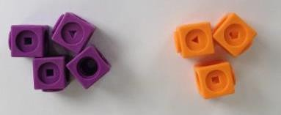
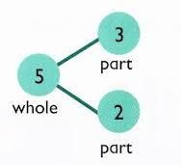
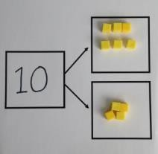
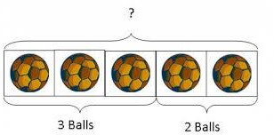
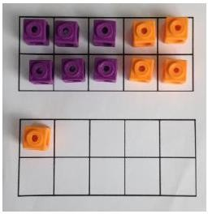
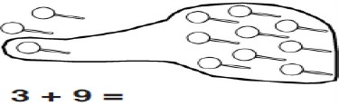
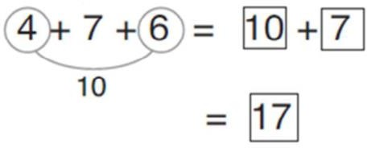
Addition

Objective and Strategies | Concrete | Pictorial | Abstract
Combining two parts to make a whole: part- whole model | Use cubes to add two numbers together as a group or in a bar.  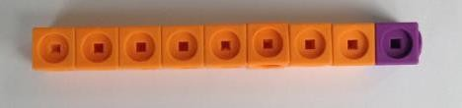 | Use pictures to add two numbers  together as a group or in a bar.  8 1 | 5 4 + 3 = 7  Use the part-part  whole diagram as shown above to move  into the abstract.  3 10= 6 + 4
Starting at the bigger number and counting on | 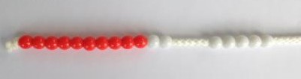  Start with the larger number on the bead string and then count on to the smaller number 1 by 1 to find the answer. | 12 + 5 = 17  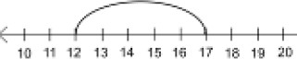  Start at the larger number on the number line and count on in ones or in one jump to find the answer. | 5 + 12 = 17  Place the larger number in your head and count on the smaller number to find your answer.
Regrouping to make 10. | 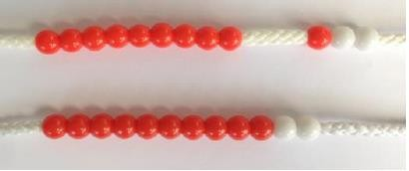  6 + 5 = 11  Start with the bigger number and use the smaller number to make 10. | Use pictures or a number line. Regroup or partition the smaller number to make 10.  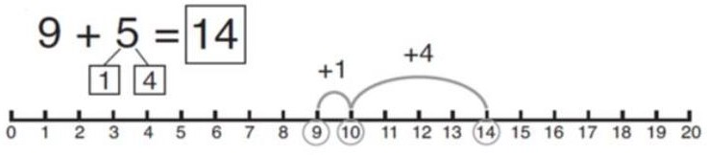 | 7 + 4= 11  If I am at seven, how many more do I need to make 10. How many more do I add on now?
Adding three single digits | 4 + 7 + 6= 17  Put 4 and 6 together to make 10. Add on 7.  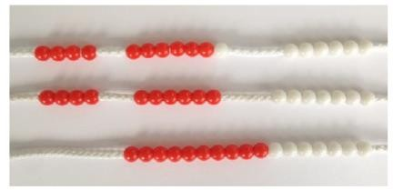  Following on from making 10, make 10 with 2 of the digits (if possible) then add on the third digit. | + +  +  Add together three groups of objects. Draw a picture to recombine the groups to make 10. | Combine the two numbers that make 10 and then add on the remainder.

Column method- no regrouping | 24 + 15=  Add together the ones first then add the tens. Use the Base 10 blocks first before moving onto place value counters.  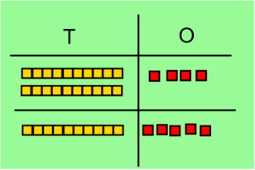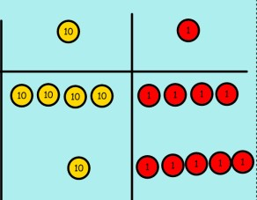 | After practically using the base 10 blocks and place value counters, children can draw the counters to help them to solve additions.  T O | 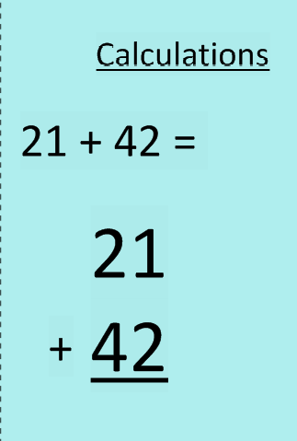
Column method- regrouping | Make both numbers on a place value grid.  Add up the units and exchange 10 ones for one 10.  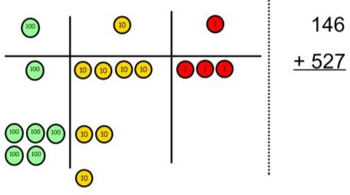  Add up the rest of the columns, exchanging the 10 counters from one column for the next place value column until every column has been added.  This can also be done with Base 10 to help children clearly see that 10 ones equal 1 ten and 10 tens equal 100.  As children move on to decimals, money and decimal place value counters can be used to support learning. | Children can draw a pictoral representation of the columns and place value counters to further support their learning and understanding.  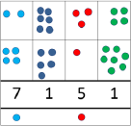 | Start by partitioning the numbers before moving on to clearly show the exchange below the addition.  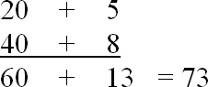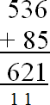  As the children move on, introduce decimals with the same number of decimal places and different. Money can be used here.  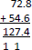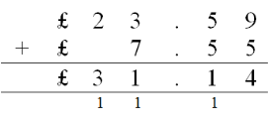  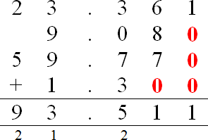
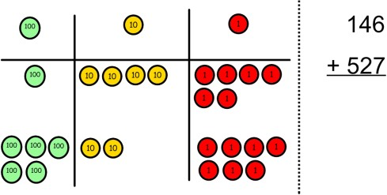

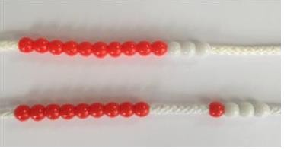
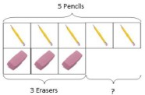
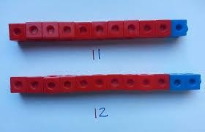
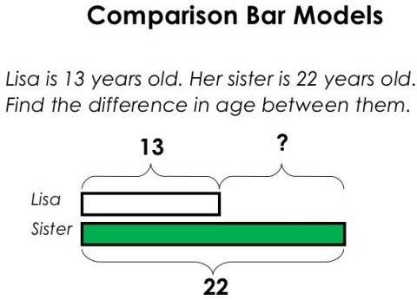
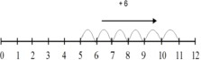
Subtraction

Objective and Strategies | Concrete | Pictorial | Abstract
Taking away ones | Use physical objects, counters, cubes etc to show how objects can be taken away.  6 – 2 = 4 | Cross out drawn objects to show what has been taken away.  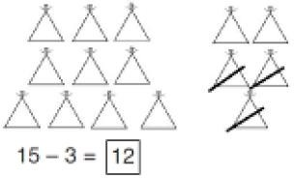 | 18 -3= 15  8 – 2 = 6
Counting back | Make the larger number in your subtraction. Move the beads along your bead string as you count backwards in ones.  13 – 4  Use counters and move them away from the group as you take them away counting backwards as you go.  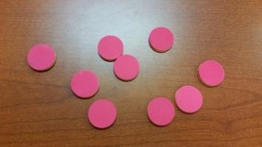 | Count back on a number line or number track  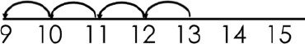  Start at the bigger number and count back the smaller number showing the jumps on the number line.  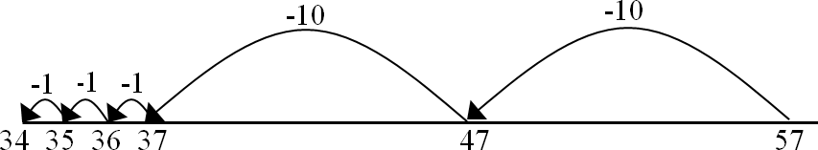  This can progress all the way to counting back using two 2 digit numbers. | Put 13 in your head, count back 4. What number are you at? Use your fingers to help.
Find the difference | Compare amounts and objects to find the difference.  Use cubes to build towers or make bars to find the difference  Use basic bar models with items to find the difference. | Count on to find the difference.  Draw bars to find  the difference between 2 numbers. | Hannah has 23 sandwiches, Helen has 15 sandwiches. Find the difference between the number of sandwiches.

Part Part Whole Model | Link to addition- use the part whole model to help explain the inverse between addition and subtraction.  If 10 is the whole and 6 is one of the parts. What is the other part?  10 - 6 = | Use a pictorial representation of objects to show the part part whole model. | 5  10  Move to using numbers within the part whole model.
Make 10 | 14 – 9 =  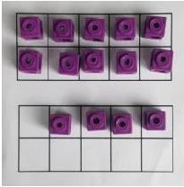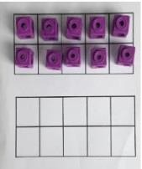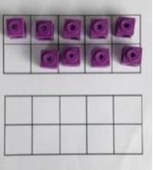  Make 14 on the ten frame. Take away the four first to make 10 and then takeaway one more so you have taken away 5. You are left with  the answer of 9. | 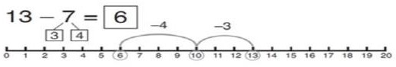  Start at 13. Take away 3 to reach 10. Then take away the remaining 4 so you have taken away 7 altogether. You have reached your answer. | 16 – 8=  How many do we take off to reach the next 10? How many do we have left to take off?
Column method without regrouping | Use Base 10 to make the bigger number then take the smaller number away.  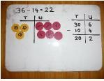  Show how you partition numbers to subtract. Again make the larger number first. | Draw the Base 10 or place value counters alongside the written calculation to help to show working.  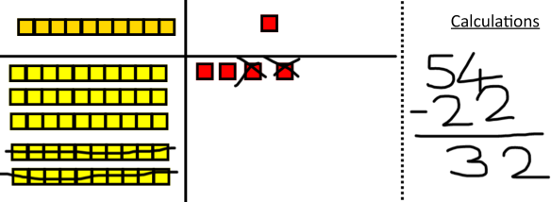  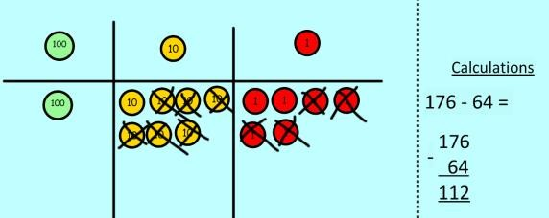 | 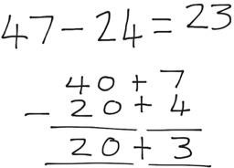  This will lead to a clear written column subtraction.  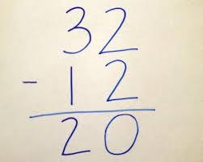
Column method with regrouping | Use Base 10 to start with before moving on to place value counters. Start with one exchange before moving onto subtractions with 2 exchanges.  Make the larger number with the place value counters  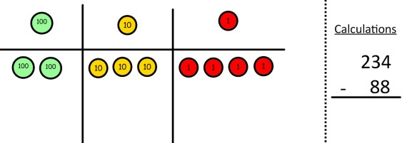  Start with the ones, can I take away 8 from 4 easily? I need to exchange one of my tens for ten ones. | Draw the counters onto a place value grid and show what you have taken away by crossing the counters out as well as clearly showing the exchanges you make.  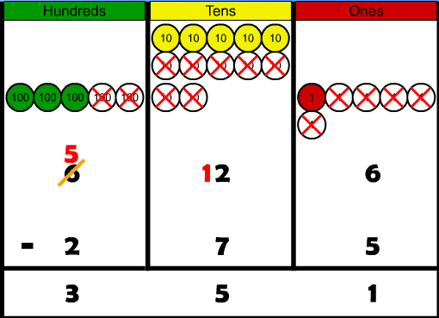 | 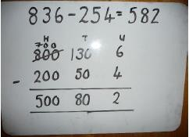  Children can start their formal written method by partitioning the number into clear place value columns.
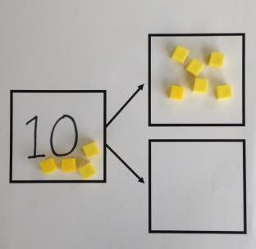
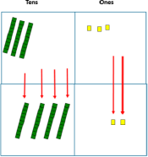

 | 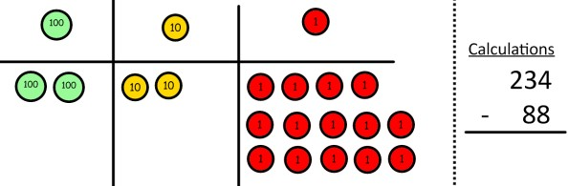  Now I can subtract my ones.  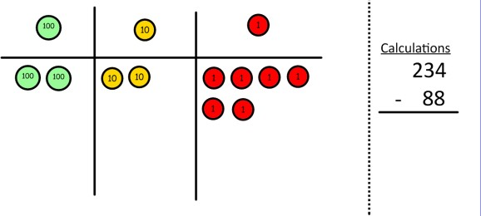  Now look at the tens, can I take away 8 tens easily? I need to exchange one hundred for ten tens.  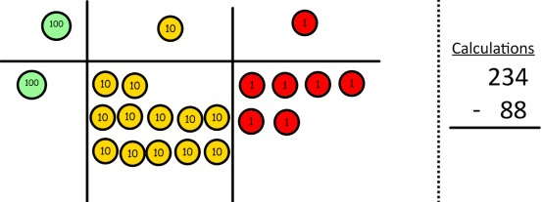  Now I can take away eight tens and complete my subtraction  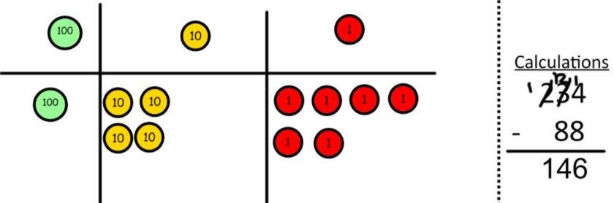  Show children how the concrete method links to the written method alongside your working. Cross out the numbers when exchanging and show where we write our new amount. | When confident, children can find their own way to record the exchange/regrouping.  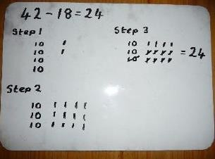  Just writing the numbers as shown here shows that the child understands the method and knows when to exchange/regroup. | 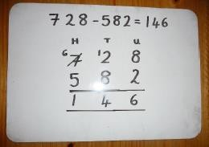  Moving forward the children use a more compact method.  This will lead to an understanding of subtracting any number including decimals.  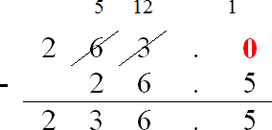

Multiplication

Objective and Strategies | Concrete | Pictorial | Abstract
Doubling | Use practical activities to show how to double a number.  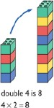 | Draw pictures to show how to double a number.  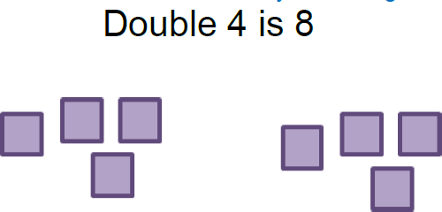 | Partition a number and then double each part before recombining it back together.
Counting in multiples | 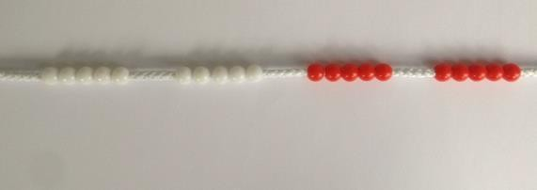  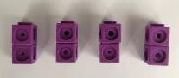  Count in multiples supported by concrete objects in equal groups. | 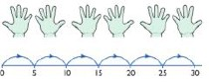  Use a number line or pictures to continue support in counting in multiples. | Count in multiples of a number aloud.  Write sequences with multiples of numbers.  2, 4, 6, 8, 10  5, 10, 15, 20, 25, 30
Repeated addition | 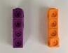  Use different objects to add equal groups. | 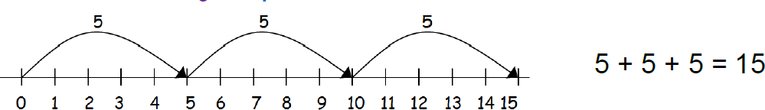 | Write addition sentences to describe objects and pictures.  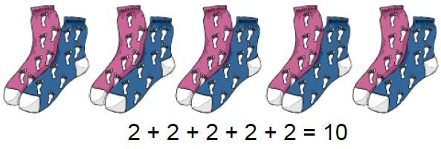
Arrays- showing commutative multiplication | Create arrays using counters/ cubes to show multiplication sentences.  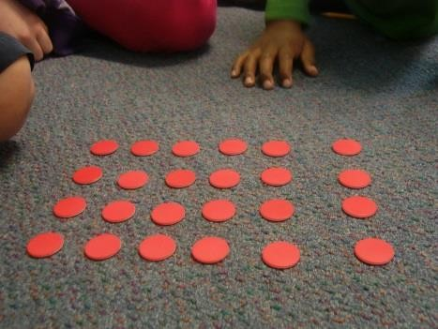 | Draw arrays in different rotations to find commutative multiplication sentences. | Use an array to write multiplication sentences and reinforce repeated addition.

 | 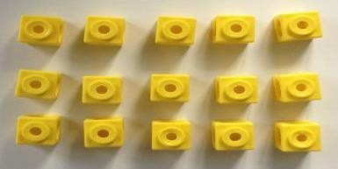 | Link arrays to area of rectangles. | 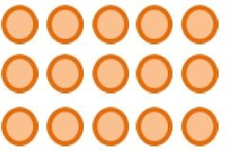  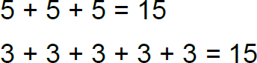
Grid Method | Show the link with arrays to first introduce the grid method.  4 rows of 10  4 rows of 3  Move on to using Base 10 to move towards a more compact method.  4 rows of 13  Move on to place value counters to show how we are finding groups of a number. We are multiplying by 4 so we need 4 rows.  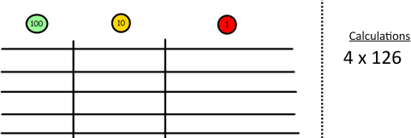  Fill each row with 126.  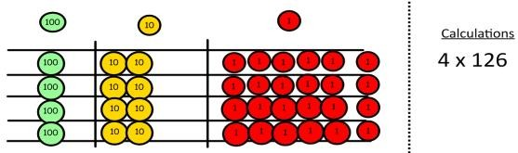  Add up each column, starting with the ones making any exchanges needed. | Children can represent the work they have done with place value counters in a way that they understand.  They can draw the counters, using colours to show different amounts or just use circles in the different columns to show their thinking as shown below.  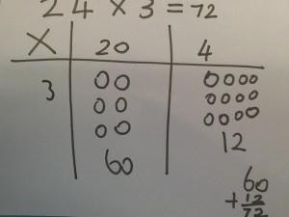 | Start with multiplying by one digit numbers and showing the clear addition alongside the grid.  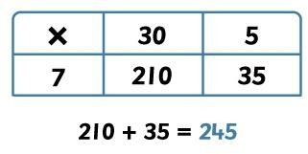  Moving forward, multiply by a 2 digit number showing the different rows within the grid method.  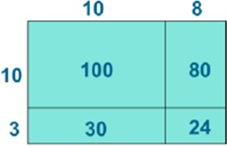  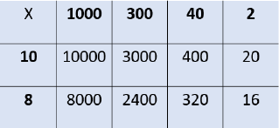
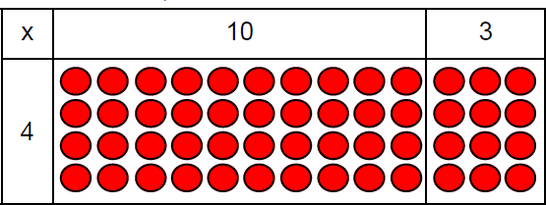
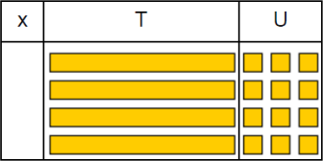

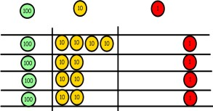
Then you have your answer.

Column multiplication | Children can continue to be supported by place value counters at the stage of multiplication.  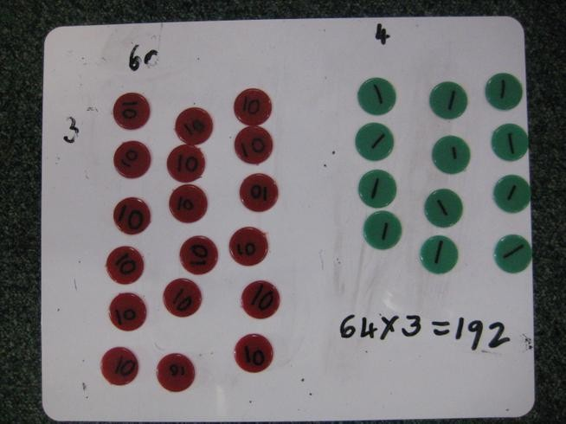  It is important at this stage that they always multiply the ones first and note down their answer followed by the tens which they note below. | Bar modelling and number lines can support learners when solving problems with multiplication alongside the formal written methods.  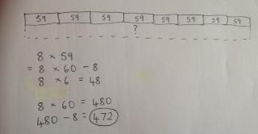  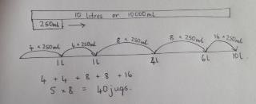 | Start with long multiplication, reminding the children about lining up their numbers clearly in columns.  If it helps, children can write out what they are solving next to their answer.  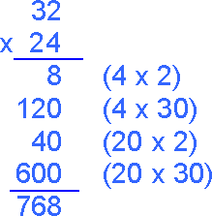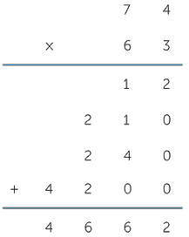  This moves to the more compact method.  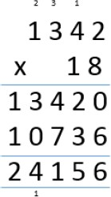

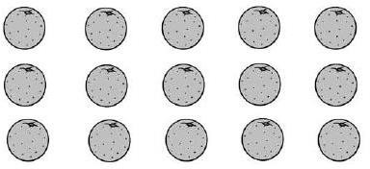
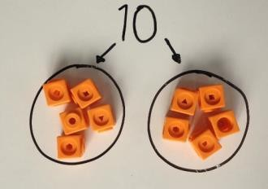
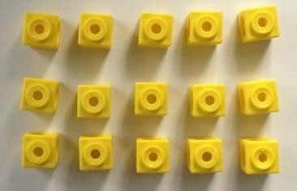
Division

Objective and Strategies | Concrete | Pictorial | Abstract
Sharing objects into groups | 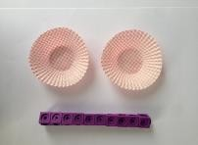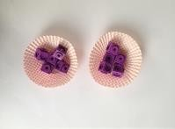  I have 10 cubes, can you share them equally in 2 groups? | Children use pictures or shapes to share quantities.  8 ÷ 2 = 4 | Share 9 buns between three people.  9 ÷ 3 = 3
Division as grouping | Divide quantities into equal groups.  Use cubes, counters, objects or place value counters to aid understanding.  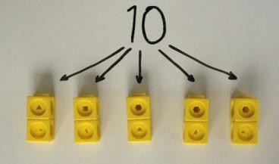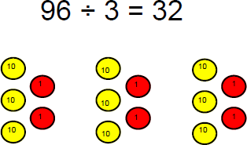 | Use a number line to show jumps in groups. The number of jumps equals the number of groups.  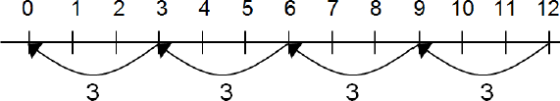  Think of the bar as a whole. Split it into the number of groups you are dividing by and work out how many would be within each group.  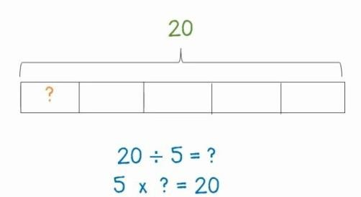 | 28 ÷ 7 = 4  Divide 28 into 7 groups. How many are in each group?
Division within arrays | Link division to multiplication by creating an array and thinking about the number sentences that can be created.  E.g. 15 ÷ 3 = 5 5 x 3 = 15 15 ÷ 5 = 3 3 x 5 = 15 | Draw an array and use lines to split the array into groups to make multiplication and division sentences. | Find the inverse of multiplication and division sentences by creating four linking number sentences.  7 x 4 = 28  4 x 7 = 28  28 ÷ 7 = 4  28 ÷ 4 = 7

Division with a remainder | 14 ÷ 3 =  Divide objects between groups and see how much is left over  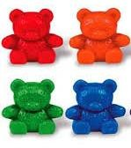  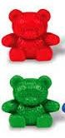 | Jump forward in equal jumps on a number line then see how many more you need to jump to find a remainder.  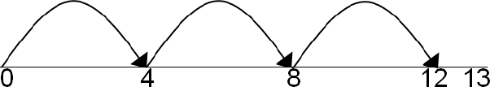  Draw dots and group them to divide an amount and clearly show a remainder.  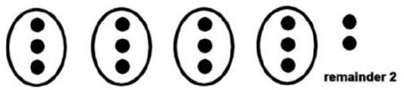 | Complete written divisions and show the remainder using r.  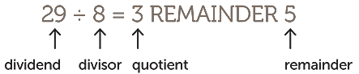
Short division | 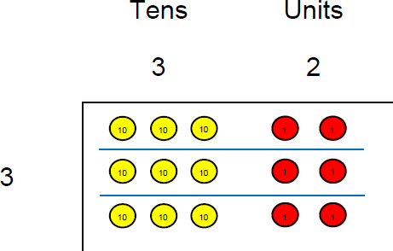  Use place value counters to divide using the bus stop method alongside | Students can continue to use drawn diagrams with dots or circles to help them divide numbers into equal groups.  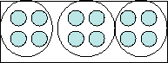  Encourage them to move towards counting in multiples to divide more efficiently. | Begin with divisions that divide equally with no remainder.  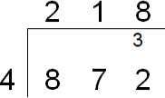  Move onto divisions with a remainder.  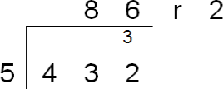  Finally move into decimal places to divide the total accurately.  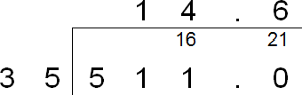
Long division

Mathematical Language
High expectations of the mathematical language used are essential, with staff only accepting what is correct. Consistency across the school is key:

Correct Terminology | Incorrect Terminology
ones | units
is equal to (is the same as) | equals
zero | oh (the letter o)
exchange exchanging  regrouping | stealing borrowing
calculation  equation | generic term of ‘sum’ or ‘number sentence’
known
unknown
whole
part

