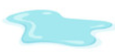
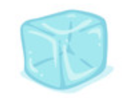
KNOWLEDGE ORGANISER
STATES OF MATTER
Y4

Overview |  |  |  | Changing States of Matter
-Matter makes up our planet and the whole Universe.  -There are three main states of matter – solids, liquids and gases.  - Matter can change state, depending on its temperature.  -Several processes describe the processes of changing states, e.g. melting, evaporation, freezing and condensation.  -The water cycle depends upon some of these processes.  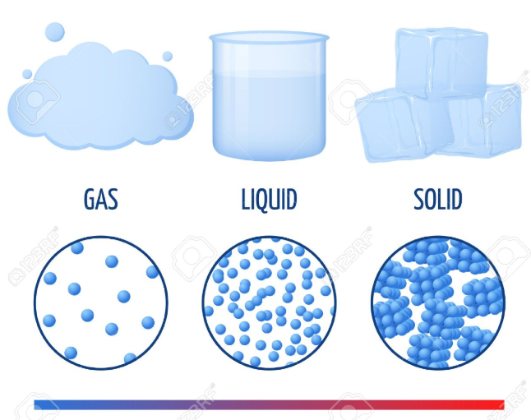 |  |  |  | 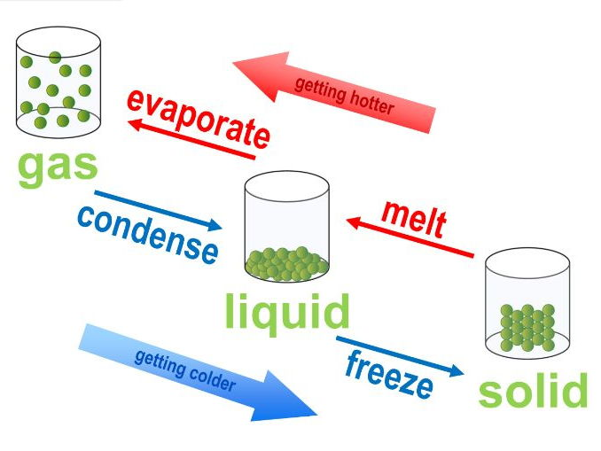 | States of matter can change, depending upon the temperature of the matter.  -Melting is the process of changing a solid into a liquid.  -Evaporation is the process of changing a liquid into a gas.  -Condensation is the process of changing a gas into a liquid.  -Freezing is the process of turning a liquid into a solid.
Solids, Liquids and Gases |  |  |  | Role in the Water Cycle
All matter exists in three states: solids, liquids and gases. |  |  |  | 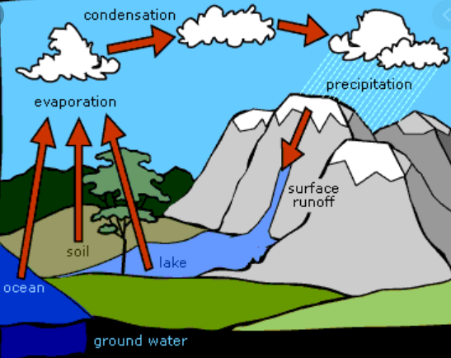  Changing states of matter play an important part in the water cycle:  EVAPORATION  Energy from the sun heats up the surface of the Earth. This causes the temperature in rivers, lakes and oceans to rise, and evaporate into the air.  CONDENSATION  As the water vapour rises, it cools in the higher air and turns back into liquid – condensation. This creates clouds.  PRECIPITATION  When too much water has condensed, the clouds become too big for air to hold them. Precipitation occurs.
SOLIDS  -Solids hold their shape  -Solids are rigid  -Solids have a fixed volume  Examples include ice cubes, rock, glass and most metals. |  | 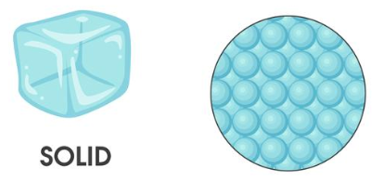
LIQUIDS  -Liquids do not hold their shape  -They are not rigid  -However, they have a fixed volume.  Examples include water, oil, blood and milk |  | 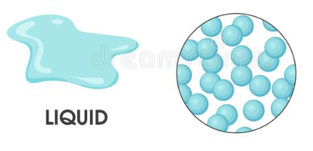
GASES  -Gases do not hold their shape  -They are not rigid  -They do not have a fixed volume.  Examples include oxygen, carbon dioxide and helium. |  | 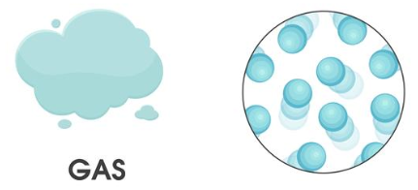

Gases
Liquids
Solids
Carbon Dioxide
Air
Oxygen
Shower Gel
Coffee
Water
Ice Cube
Glass
Wood

