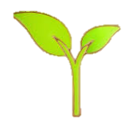
KNOWLEDGE ORGANISER
PLANTS

Flowering plants produce flowers to help them reproduce. They follow this life cycle:
Seed – Flowering plants begin life as seeds. They need soil, air and water to grow.
Seedling – When the plant first starts to grow, it is called a seedling.
Flowering – When the plant is fully grown, it will produce its own flowers. These flowers will eventually produce seeds. When the seed gets to the ground, the cycle starts again.

Overview |  |  | Basic Structure of Plants
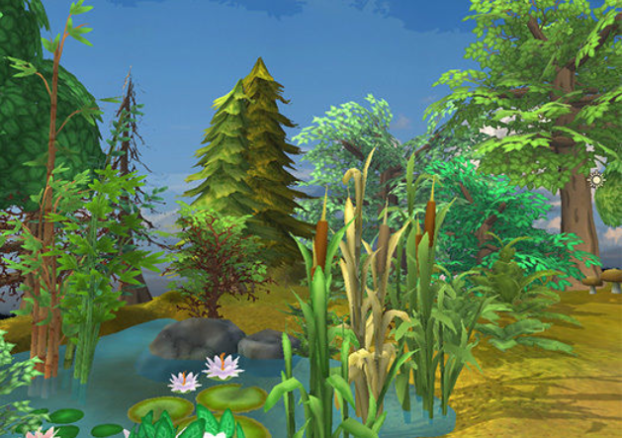  -Plants are a large group of living things that use sunlight to make their own food.  -There are many, many different kinds of plants, including trees, vines and grasses.  -Plants have lots of different parts, for example stems, leaves and roots.  -Some trees lose their leaves in the winter (deciduous). Some keep their leaves through the year (evergreen).  -Some plants are ‘flowering plants’ – they grow flowers sometimes. |  |  | 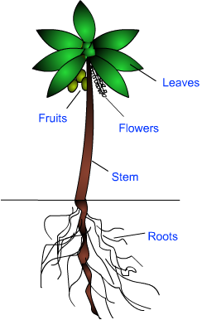 |  | -Plants are made up of many different parts.  -Roots – Roots absorb water and minerals from the ground. They also help the plant to stay standing in the ground.  -Stem – The stem supports the plant above the ground. It also helps to carry water and minerals from the roots to the leaves.  -Leaves – Leaves collect energy from the Sun and turn this into food for the plant (photosynthesis).  -Flowers and Fruits – Flowers and fruits help the plant to reproduce (to make more plants).
Types of Plants
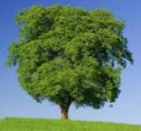  Trees  Trees are tall, woody plants. They usually have a stem called a trunk.  -Some trees can live for hundreds or even thousands of years.  -Trees include birches, palms and pines. | 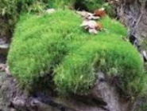  Moss  Mosses are small, seedless plants that grow in moist places.  -Mosses grow together in large, thick mats.  -There are more than 10,000 different types of moss around the world.
 |  |  | Flowering Plants
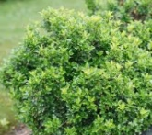  Bushes/Shrubs  Bushes and shrubs are quite low plants that have lots of branches.  -Bushes do not normally grow as tall as trees.  -They include lavender, periwinkle and thyme. A shrubbery is a place with lots of shrubs. | 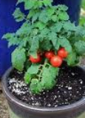  Vegetables  -Vegetables normally come from a type of plant called a herbaceous plant. Vegetables can be eaten.  -Lettuce, spinach and broccoli are the leaves of plants. Asparagus is the stem of a plant. Some vegetables grow in the ground, e.g. carrots.
 |  |  |  | 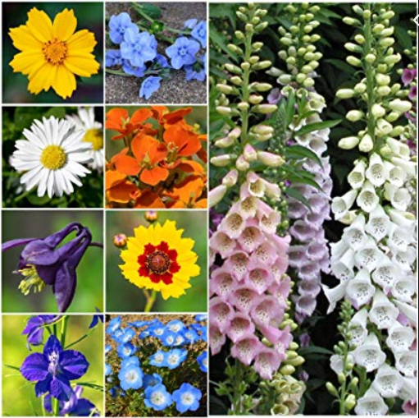

Evergreen Trees
Deciduous Trees
Blue Spruce
Fir
Hemlock
Pine
Yew
Beech
Elm
Horse Chestnut
Holly
Sycamore
Maple
Oak

