The Cambois flat-back dragon
What is the Cambois flat-back dragon?
The Camois flatback dragon is a species of dragon typically found in the north east of England. Dragon specialists estimate that there are approximately 6 in the whole of England. Generally it is extremely rare to spot a Cambois flat-back dragon. Despite being a type of dragon, they are in fact harmless.
What do they look like?
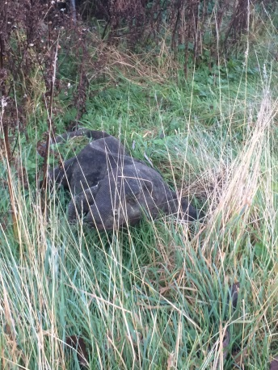
All flat-backs have a head, 4 short legs with large claws, a body and a long thick tail. Generally, adult flat-backs grow to 130cm long including their tail. Typically, infant flat-backs are about 50cm long. Flat-backs are well known for their long thick tail. Their tail is used to help as a weapon to protect themselves against predators.
Where do they live?
All varieties of flat-backs live in the north east area including Newcastle. However, the Cambois flat-back is only found in Cambois. Generally, their habitat is in long grass near trees and bushes. This is to camouflage them from predators. They are commonly found near other large mammals as they use their fur or hair to make their nests. Typically, they have been known to sneak into houses and buildings to keep warm in autumn and winter.
The diet of a Cambois flat-back
Unlike the Yorkshire ridge-back, the Cambois flat-back is a herbivore. Their preferred diet is grass, vegetables and the skin of fruit such as banana. However, despite the fact that they are herbivores with flat molars, they have a very powerful bite.
Did you know
A Cambois flat-back dragon only lays an egg once every 3 years. This is why they are so rare.

