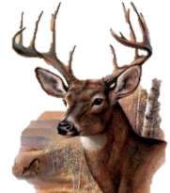
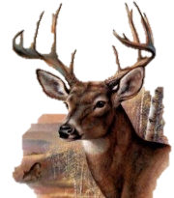
Y4
ANIMALS including Humans
KNOWLEDGE ORGANISER

What you should already know… |  |  | Teeth
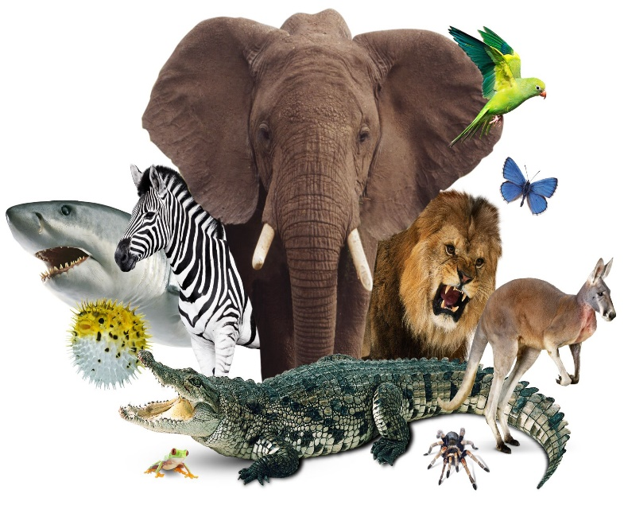  -Animals cannot create their own food, they must eat in order to get nutrition.  -Because of this, animals are called consumers.  -Animals and humans need the right types and amounts of nutrition.  -Nutrition groups include carbohydrates, fats, proteins, fibre, vitamins and minerals.  -Skeletons are important for support, movement and protection. Muscles help us to move and keep our posture. |  |  |  | 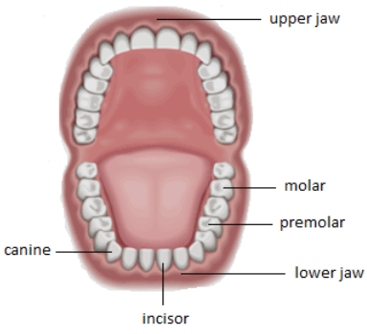 | -Humans have up to 32 adult teeth, made up of 4 different types. Each of these types have an important job:  -Incisors (at the front) are used to cut food.  -Canines are used to tear food.  -Pre-molars are used to crush food.  -Molars (at the back) are used to grind food.  Our teeth are like this because we are omnivores. Different animals have different teeth layouts depending on their food.
Food Chains |  |  | The Digestive System
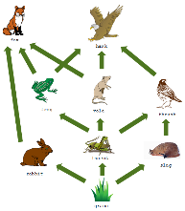  What are Food Chains?  -Food chains show how each living thing gets food, and how nutrients are passed from producers through different consumers.  -Food chains begin with plant life, and end with animal life. At the top of the food chain are apex predators – animals which have no natural predators that eat them. |  |  | Parts  Pancreas  Small Intestine  Large Intestine  Stomach  Liver  Anus  Esophagus  Mouth |  |  | 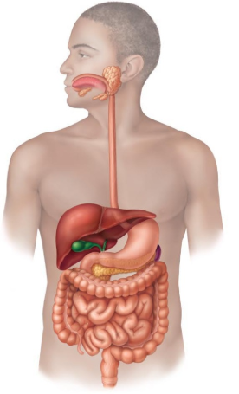  Stages/ Functions  -There are three main stages of the digestive system:  Ingestion – The food is taken in by the mouth, and broken down by teeth and saliva.  Absorption – Food is further broken down in the stomach & intestines. Nutrients are absorbed into our bodies through our blood. The liver and pancreas produce the bile and enzymes to help the digestion along.  Excretion – Waste food that the body doesn’t need is sent to the anus for excretion.  Digesting food takes many hours.
Example Food Chain  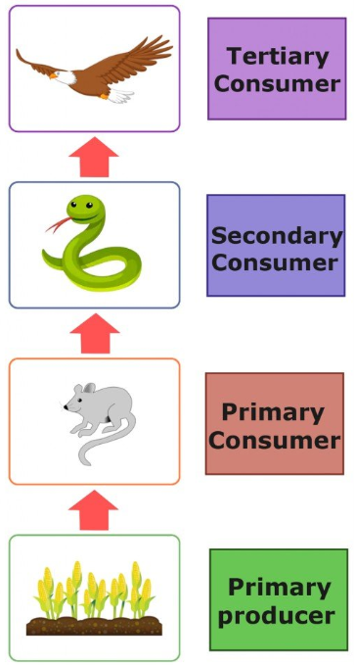 | Explanation  -Producers are able to make their own food (for example plants, through photosynthesis).  -Primary consumers are animals that eat producers.  -Secondary consumers are animals that eat primary consumers.  -Tertiary consumers are animals that eat secondary consumers.  -Each plant and animal in the food chain is affected by the others. For example, if there were fewer mice in the habitat, there may be more plants (because the mice aren’t eating them) but less snakes (fewer mice to eat).
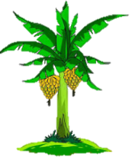
Rainforest Food Chain
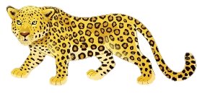
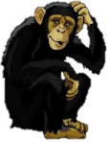
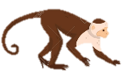
Tertiary Consumer Leopard
Secondary Consumer Chimpanzee
Primary Consumer Monkey
Producer Banana Tree

