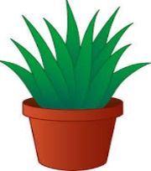
KNOWLEDGE ORGANISER
PLANTS
Y3

Plants need air, light, water, nutrients, temperature and space in order to live and grow. The amounts needed of each of these requirements varies from plant to plant.
-A plant that is kept in a dark place will grow tall and spindly, as it searches for light.
-A plant that is not watered will have a weak stem. Its leaves will dry up and eventually it will die.
-A plant that is not given enough space will have stunted growth, and may die if it cannot reach enough light.
-A seed will not germinate at all if the temperature is too cold.

What you should already know… |  |  | The Role of Flowers
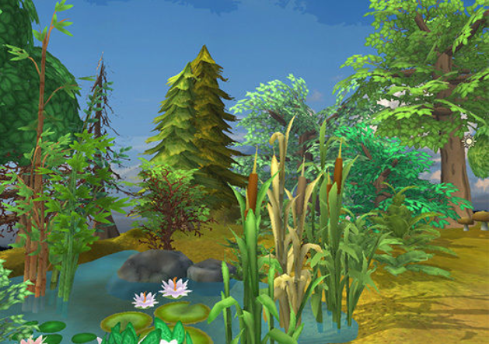  -Plants need a number of different things in order to grow, including water and nutrients, light, the right temperature, space and time.  -Plants begin life as seeds or bulbs. Seeds do not need sunlight as they have their own food store.  Water and oxygen allow seeds and bulbs to germinate (start to grow).  -Plants have a life cycle, that includes the seed, seedling and flowering stages. |  |  |  | 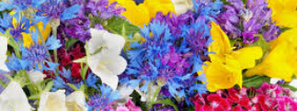  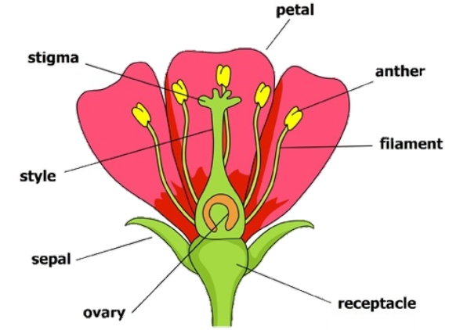 | -Flowers play an important role in the reproduction of plants.  -The male part of a flower is called a stamen – it is made up of a filament and an anther. The anther contains pollen.  -The female part of a flower is called a carpel. It is made of a stigma, a style and an ovary.  -When the male pollen lands on the female stigma pollination occurs.  -This process means that a seed is produced.  -Insects are drawn to flowers by bright petals. When they feed on the flower’s nectar they are dusted with pollen. They then spread this to other places when they leave.
Functions of Different Plant Parts
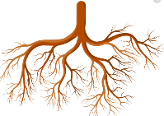  Roots  -The roots grow into the ground. They are responsible for pulling water and minerals to the plant.  -They expand into the ground to widen the area they can find water. They also help to anchor the plant into the ground. | 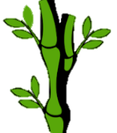  Stem/Trunk  -The stem/trunk carries the water and nutrients up to the leaves.  -The stem also carries food from the leaves to the rest of the plant.  -Stems grow upwards, reaching up for the sun.
 |  |  | Requirements for Life
 |  |  |  | 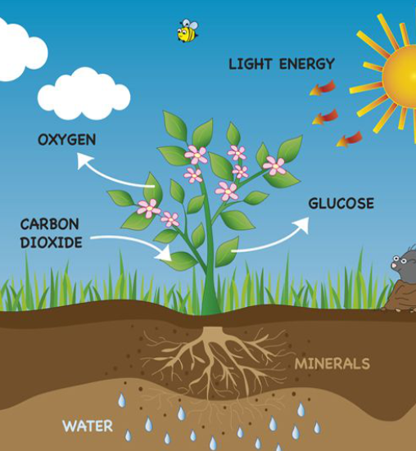
Leaves  -Leaves are responsible for catching sunlight. They also allow both air and water to enter the plant.  -Leaves have veins inside them, to allow water and nutrients to flow. There are many different sizes & shapes of leaves, to fit the plant’s needs. | 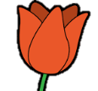  Flowers  -Flowers are the parts of plants that are responsible for making both food and seeds.  -The petals of a flower attract insects for pollination. The flower has male and female parts, which work together to make seeds. |  | TEMPERATURE |  | SPACE

Water Transport in Plants
Water escapes from the plant as vapour (a gas) through tiny holes
Water reaches the leaves and flowers, keeping them hydrated.
The water travels up small tubes in the stem called xylem.
The water is drawn up from the roots to the stem.
Water is found in the soil by the roots.

