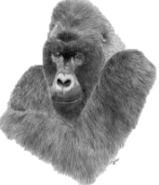
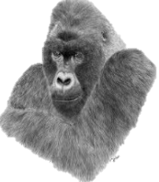
LIVING THINGS and their habitats
KNOWLEDGE ORGANISER
Y6

What you should already know… |  |  |  |  |  | Linnaeus Classification
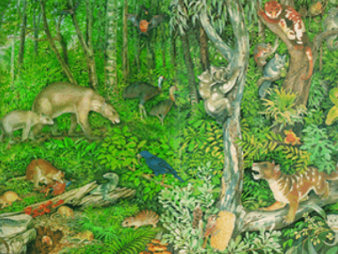  -Animals and plants can be classified into different groups based on their characteristics.  -Animals can be grouped into vertebrates (with a backbone) and invertebrates (without a backbone).  -They can then be subdivided into further groups, for example mammals, fish, reptiles etc. (vertebrates) or spiders, snails, worms etc. (invertebrates).  -Plants are commonly grouped into flowering plants and non-flowering plants. They too can be sub-divided beyond these broad classifications. |  |  |  |  |  | Carl Linnaeus  Carl Linnaeus was a Swedish scientist, botanist and zoologist who is known as the ‘father of taxonomy.’  He created something called the binomial nomenclature, which was a way of classifying plants and animals (taxonomy).  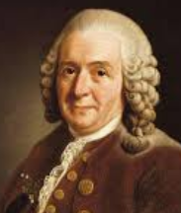  He classified man among the primates, which brought him criticism at the time!  He was made a noble by the Swedish King. He lived from 1707-1778. Parts of his system are still used today. | Classification System  Linnaeus gave each organism a two part Latin scientific name, based on their genus and species. A genus is a group made up of several species.  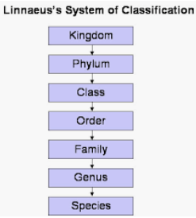  For example, the genus ‘Pan’ is made up of the chimpanzee (pan troglodytes) and the bonobo (pan paniscus).  His scientific process involved observing, recording the information and making conclusions.
Classification of Animals |  |  |  |  |  | Classification in Local Habitats
M-R-S G-R-E-N  You can remember the seven features of living things by using the acronym MRS GREN (Movement, Respiration, Sensitivity, Growth, Reproduction, Excretion and Nutrition. |  |  |  |  |  | 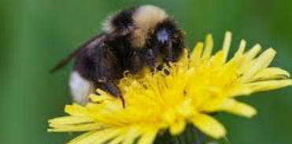  Garden  Vertebrates: Mammals = cats, dogs, rabbits, foxes. Birds = sparrow, robin, crow. Amphibians = frogs, toads.  Invertebrates: Insects = bee, wasp, fly, Spiders, Worms = earthworm, Snails = garden snail, Crustaceans = woodlouse.  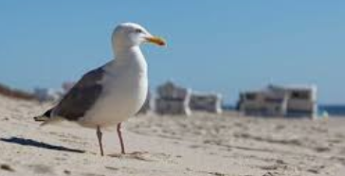  Seaside  Vertebrates: Mammals = Beach mice, Birds = seagulls, pigeons, Reptiles = sea turtles, Fish = cod, haddock.  Invertebrates: Crustaceans = crabs, lobsters, prawns, Echinoderms = starfish, sea cucumbers, sea urchins.  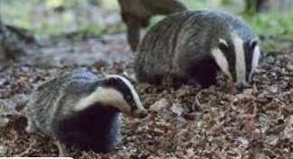  Forest  Vertebrates: Mammals = badger, deer, squirrel, boar, pine marten. Birds = woodpecker, owl, warbler. Reptiles: adder, lizard, slowworm.  Invertebrates: Spiders: harvestman, woodlouse spider, Insects: Ants, crickets, grasshoppers.
Mammals  -Mammals are warm-blooded.  -They often have hair/fur on their bodies.  -Mammals give birth to live young.  -Mammals often drink milk from their mothers. |  | Bears, Lions, Dogs, Cats, Rabbits, Squirrels, Whales, Monkeys, Horses, Cows, Pigs, Sheep, Tigers, Humans. | Snails  -Snails have shells.  -They have a large muscular foot, which secretes mucus.  -Their stomach is directly above their muscular foot.  -Most snails live underwater. | Garden Snail, Scutalus, Giant African Land Snail.
Reptiles  -Reptiles are cold-blooded.  -They normally lay eggs (but some don’t).  -Reptiles have scales or scutes. |  | Crocodiles, Lizards, Turtles, Chameleons, Snakes, Geckos, Iguanas, Dinosaurs. | Slugs  -Slugs do not have shells.  -They have a large muscular foot, which secretes mucus.  -Their stomach is directly above their muscular foot. | Leopard Slug, Black Slug, Yellow Slug.
Amphibians  -Amphibians are cold-blooded animals.  -They have moist, scaleless skin. It is often permeable.  -Amphibians lay eggs. |  | Frogs, Salamanders, Toads, Newts, Tadpole. | Worms  -Worms have long, narrow bodies.  -Worms do not have limbs (arms and legs).  -They are bilaterally symmetrical (both sides the same). | Flatworms, Round Worms, Segmented Worms
Fish  -Fish are cold-blooded animals.  -Fish can breathe underwater, using gills.  -Fish lay eggs.  -Fins help to propel fish through the water. |  | Sharks, Goldfish, Carp, Swordfish, Stingray, Clownfish, Pike, Salmon, Bass, Haddock, Tuna, Cod, Eel, Turbot. | Spiders  -Spiders have eight legs.  -Spiders bodies are made of two main parts.  -Spiders create silk from their spinneret glands.  -Spiders lay eggs. | Tarantula, Wolf Spider, Huntsman Spider, Widow Spider.
Birds  -Birds are warm-blooded.  -Birds have feathers, wings and a beak.  -Birds lay eggs. |  | Parrot, Owl, Eel, Flamingo, Penguin, Puffin, Chicken, Toucan, Blackbird, Sparrow, Pigeon. | Insects  -Insects have exoskeletons: hard shell-like coverings of their body. They also have three main body parts.  -They have antennae on the top of their heads. | Beetle, Ant, Fly, Flea, Butterfly, Mosquito, Bee, Cricket.
Human Classification – from vague to specific
Genus: Homo
Species: Homo Sapiens
Family: Hominids
Order: Primates
Class: Mammals
Phylum: Chordates
Kingdom: Animals

