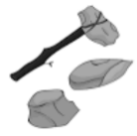
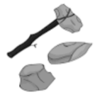
THE STONE AGE
KNOWLEDGE ORGANISER
Overview |  |  | Life in the Stone Age
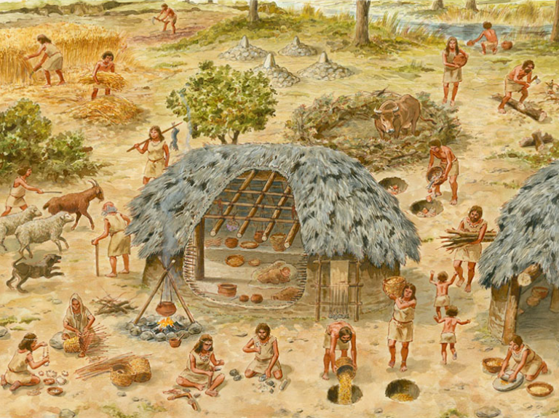  The Stone Age  The Stone Age is the name given to the earliest period of human culture – from the dawn of civilisation 2.5 million years ago, to around 5000 years ago, when humans began utilising stone to make tools and objects. The Stone Age is often divided into three periods:  -Paleolithic (Old Stone Age);  -Mesolithic (Mid Stone Age);  -Neolithic (New Stone Age);  The Paleolithic era lasted for such a long time that it accounts for 99% of all human history! |  |  | Food - Hunter Gatherers | 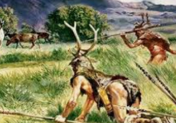 | In the Paleolithic era, humans found their food from the local environment. They mainly used tools such as spears and slings to kill and capture animals. They moved from site to site depending on the season, following sources of food as it migrated. | Fact  Early humans were also able to forage for fruit and nuts. | THE PALEOLITHIC ERA
 |  |  | Tools |  | Early hominids (even homo erectus) used tools in order to aid everyday life. Many were chopping and cutting tools, although basic spears and hand axes have been found from the era. Tools increased in complexity over the Paleolithic era. | Fact  Oldowan tools, the earliest tools, were shaped from rocks.
 |  |  | Language | 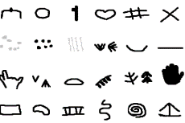 | Perhaps the most important innovation of the Paleolithic era was the beginnings of language. Scientists can infer from cave drawings and the establishment of social structures that Paleolithic humans must have developed language. | Fact  Scientists think the language part of the brain developed at this time.
 |  |  | Religion | 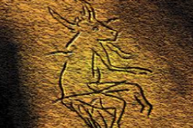 | The period also saw the development of religions. Cave paintings suggest that many tribes believed in ‘animism’, or the idea that everything has a spirit, including animals, plants and inanimate objects. | Fact  Cave paintings found in France are about 40,000 years old!
 |  |  | Food – Hunting and Fishing | 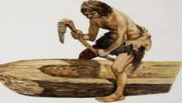 | More elaborate weapons, such as arrows and spears, were developed. Canoes were constructed to allows humans to fish in the rivers and seas, probably carved from tree trunks and branches | Fact  The oldest discovered canoe is 8,200 years old! | THE MESOLITHIC ERA
Hominids and Animals
Homo Erectus  Homo Erectus lived from about 2 million years ago, to about 150,000 years ago. Although they came from Africa, scientists believe that they may have spread to Asia and Europe. The nose and jaw of homo erectus skeletons are much wider than ours, their teeth were bigger, and they had considerably smaller brains. It is uncertain whether the demise of homo erectus was due to the arrival of the more intelligent homo sapiens species. | Homo Denisova  The Denisovans were a species of human that were closely related to the Neanderthals – it is thought that the two species branched off somewhere in the Middle East, with the Denisovans occupying the far-eastern hemisphere. Denisovans are a recent discovery, with the first bone fragments found in 2010. It is thought that humans and Denisovans co-existed for some time; up to 5% of modern Aboriginal and Melanesian DNA is Denisovan. |  | Domestication | 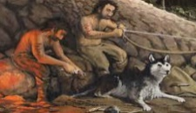 | Humans began to domesticate animals for various uses. For example, it is thought that dogs were domesticated from breeding the tamest wolves, and were used to aid hunting. | Fact  It is thought Stone Age man also bred dogs to be cute pets!
 |  |  | Clothes | 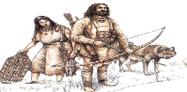 | Mesolithic humans used to wear clothes made of bark and leaves in the summer months, and clothes made of animal skins in the winter months. | Fact  The first leathers were probably made in this era.
 |  |  | Culture |  | As languages developed, so did distinct cultures. Art, dance, and social traditions appear to have been formed by this point in time. | Fact  Burials took place for the dead
Homo Neanderthalensis  Neanderthals are a species of hominid that lived relatively recently, from about 400,000 years ago, to about 40,000 years ago. They were a very near relative to our own species, and were probably highly intelligent, with large brains. They were shorter, but stockier, than modern humans. Their bones have only been found in Europe and parts of Asia. It is thought that they may have died out unable to compete with homo sapiens. | Homo Sapiens  Homo sapiens is the scientific name for our species – modern humans. It is thought that homo sapiens originated in Africa between 300 and 150,000 years ago, and branched out into Eurasia about 60,000 years ago. It may be coincidental, but it appears that wherever homo sapiens went, other hominids died out (most scientists believe that they could not adapt to compete with intellectually-superior homo sapiens).
 |  |  | Food - Agriculture |  | Animals such as cows and sheep were domesticated, providing a ready-made supply of meat, milk and bone. Grain was developed as it could be stored for a long time. | Fact  Agriculture meant that people settled in one place | THE NEOLITHIC ERA
 |  |  | Construction |  | Better tools and permanent settlements meant that large scale construction could take place. People lived in more permanent houses, which were congregated together in villages. | Fact  ‘Skara Brae’ off Scotland, is a well-preserved Neolithic village.
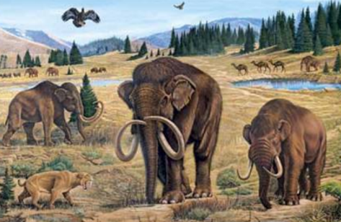  Stone Age Animals  The world was filled with creatures in the Stone Age, many of which are still around today, but lots of which are now extinct. One of the most famous examples of those that are now extinct is the wooly mammoth, a species of elephant that was covered in fur – adapted to survive in the last ice age. Another example is the sabre-toothed tigher, a large big cat with long canine teeth, weighing up to 400kg! (the largest tigers are around 300kg). Giant ground sloths were another interesting animal from the time. Living in South America, these sloths were as large as elephants, weighing up to 4 tonnes! It could stand on two legs in order to reach food from trees. |  |  | Roles/ Occupations | 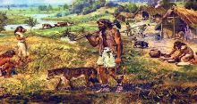 | Neolithic peoples created different roles in their societies, for example farmers, priests, and hunters. There is evidence that some people were made into leaders, whilst some became slaves. | Fact  Roles were decided based on gender and age.
 |  |  | Culture | 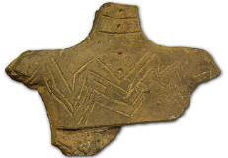 | A range of carvings and other art forms demonstrate rapid developments in culture. These moved beyond what was literally seen in the world to include moral/ spiritual ideas. This was influenced by improved language, society structures and tools. | Fact  People from this time were able to make mud and clay objects.

2.5 million years ago – Stone Age begins – first rock artefacts.
300-150,000 years ago – Home sapiens appear in Africa.
40,000 YA – First cave painting and carved figures, (Spain).
30,000 YA – Neanderthals become extinct
25,000 YA– Use of needles, saws and harpoons
Around 6,000 YA –Writing invented in Sumer. Horses domesticated
8,000 YA –Wheel invented, irrigation begins
10,500 YA – Cattle were domesticated
11,000 YA– End of the last Ice Age
15,000 YA – Domestication of pigs
25,000 YA – Earliest examples of pottery
Stone Age Timeline

