We hope you have had a lovely break and ready to return back to school. This half term Miss Fawcett will be working with year 3 and 4 and Mrs Trood will be working with year 1 and 2. | Physical Development  Every Tuesday afternoon this half term we will be doing rugby with Cramlington rockets.  Year 1 will also have another PE lesson on a Friday with Newcastle United Football Club, while year 2 our outside in forest school. Children must have an indoor and outdoor PE kit in school all week as this may change depending on commitments that week. | Topic  Year 1 and 2s topic this term is focused on wheels, wings and other things.  During this topic the children will have the opportunity to design a playground. The children will use a range of materials and tool and then evaluate their product. KS1 will also compare and contrast weathers around the world.  The children will also have the opportunity to look into significant people in history and art.
Literacy  This term we are focusing on a poems. We will be looking at a poem as a class to ‘magpie’ and replicate ideas to create their own.  We are continuing to use the literature works approach using strategies to develop the children’s writing and ideas. | Seahorses  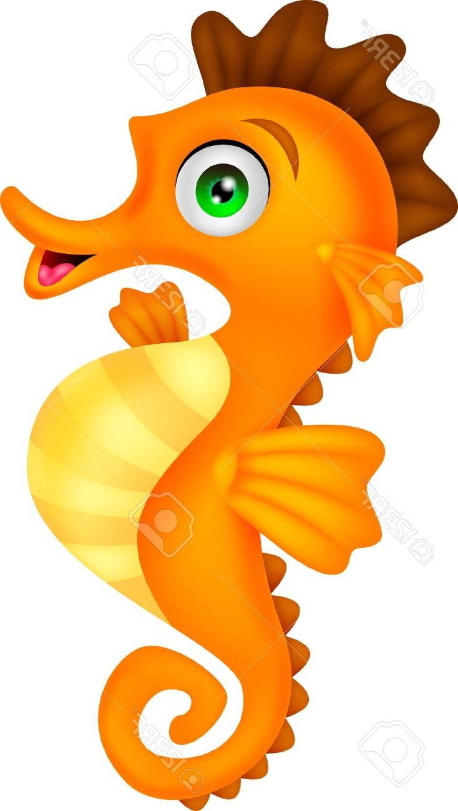 | Mathematics  Year 1 and 2 will continue to use the mastery approach in maths.  Year 1 and 2 will be looking at measurement and fractions as well as number to expand understanding with fluency.  In math the children will interact with practical resources as well as looking at pictorial and abstract representations to deepen understanding.
Homework and reading  Reading folders should be brought into school daily. Homework will be given on a Friday and is expected to return back into school on a Tuesday. Homework is now part of progress files so it is important to be completed. | Science  This half term we will be focusing our attention to animals. The children will have opportunities to go into forest school to research animal’s habitats. They will also focus on food chains and suitable environments. | PE kit  Most of Year 1 and 2 will have football on Tuesday and PE on Friday. Kits should be brought into school on the first day of term and we suggest you leave it until half term.  Remember they’ll need: a plain white t shirt, blue/black shorts, sandshoes / trainers.
Educational visits  You will be informed any further visits. Permission slips must be returned or unfortunately your child will be unable to attend the trip. | Important information  Miss Trood will work with year 3 and 4 on a Tuesday afternoon. The children will be split into two groups which they will do rugby with Cramlington rockets as well as music with Mr Allan.
Supporting your child at home  Please remember to read with your child at home and sign their books twice a week at least. It is vital they are questioned about what they’ve read in order to improve their comprehension skills at this stage. |  | Follow us on Twitter and Facebook!    

