**Cambois Blog** 

22nd October 2021



BROXFIELD FARM VISIT

The Children have been invited for a day at Broxfield Farm in Alnwick. They will meet the animals and take part in some woodland activities. We advise that children bring wellies and waterproof coats on the day they are attending the farm.

Year 1 and 2 will be attending on the 5th November and Year 3 and 4 will attend on the 10th November.

Half Term Holiday

A reminder that School will break up on Friday 22nd October and will re-open on Tuesday 2nd November. Monday 1st November is a Teacher Training Day.



PARENT GOVERNOR

We have a vacancy for a Parent Governor. If this is something that any parents would be interested in please contact Mrs Allan.



POPPY APPEAL

We have items provided by the Royal British Legion for the Poppy Appeal. If you would like your child to donate money please send them into school with the correct money. Items that can be purchased include poppies, zip pulls, wrist bands and snap bands. The suggested donation prices range from 50p to £1.50.

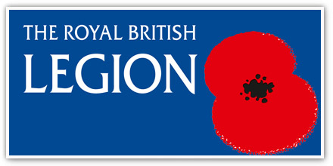

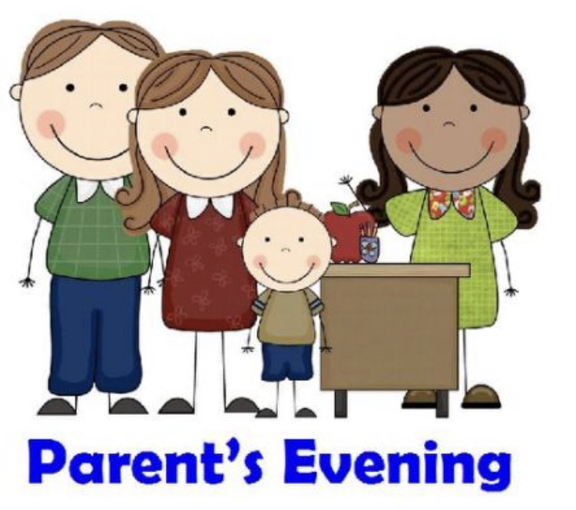

PARENTS EVENING

A reminder that all Parents Evenings will take place after Half Term. As per the letter sent last week please remember to book your parents evening appointment online. If anyone is struggling to arrange an appointment please contact the office.

The dates and times for each year group are as follows:-

* 2nd November – Years 1 and 2 - 8:30am – 4:30pm
* 2nd November – Years 3 and 4 – 8:30am – 4:30pm
* 3rd November – Mrs Darbyshire – English and Maths Groups – 12:45pm – 4:30pm
* 9th November – Years 5 and 6 – 8:30am – 4:30pm
* 10th November – Nursery and Reception – 8:30am – 4:30pm

As per the letter sent last week please remember to book your parents evening appointment online. If anyone is struggling to arrange an appointment please contact the office.



SCHOOL PHOTO DAY

The photographer will be coming into school on the 15th November to take photos of all children.

DATES TO REMEMBER

* Half Term – School closes Friday 22nd October and re-opens Tuesday 2nd November
* 5th November – Broxfield Farm Visit – Years 1 and 2.
* 10th November – Broxfield Farm visit – Years 3 and 4.
* 1st November – Teacher Training Day.
* 2nd November – Parents Evening Years 1,2,3 and 4
* 3rd November – Parents Evening – Mrs Darbyshire
* 9th November – Parents Evening – Years 5 and 6
* 10th November – Parents Evening – Nursery and Reception
* 15th November – Flu Vaccine
* 15th November – School Photo Day
* 18th November – Cinema Trip - Reception to Year 6.