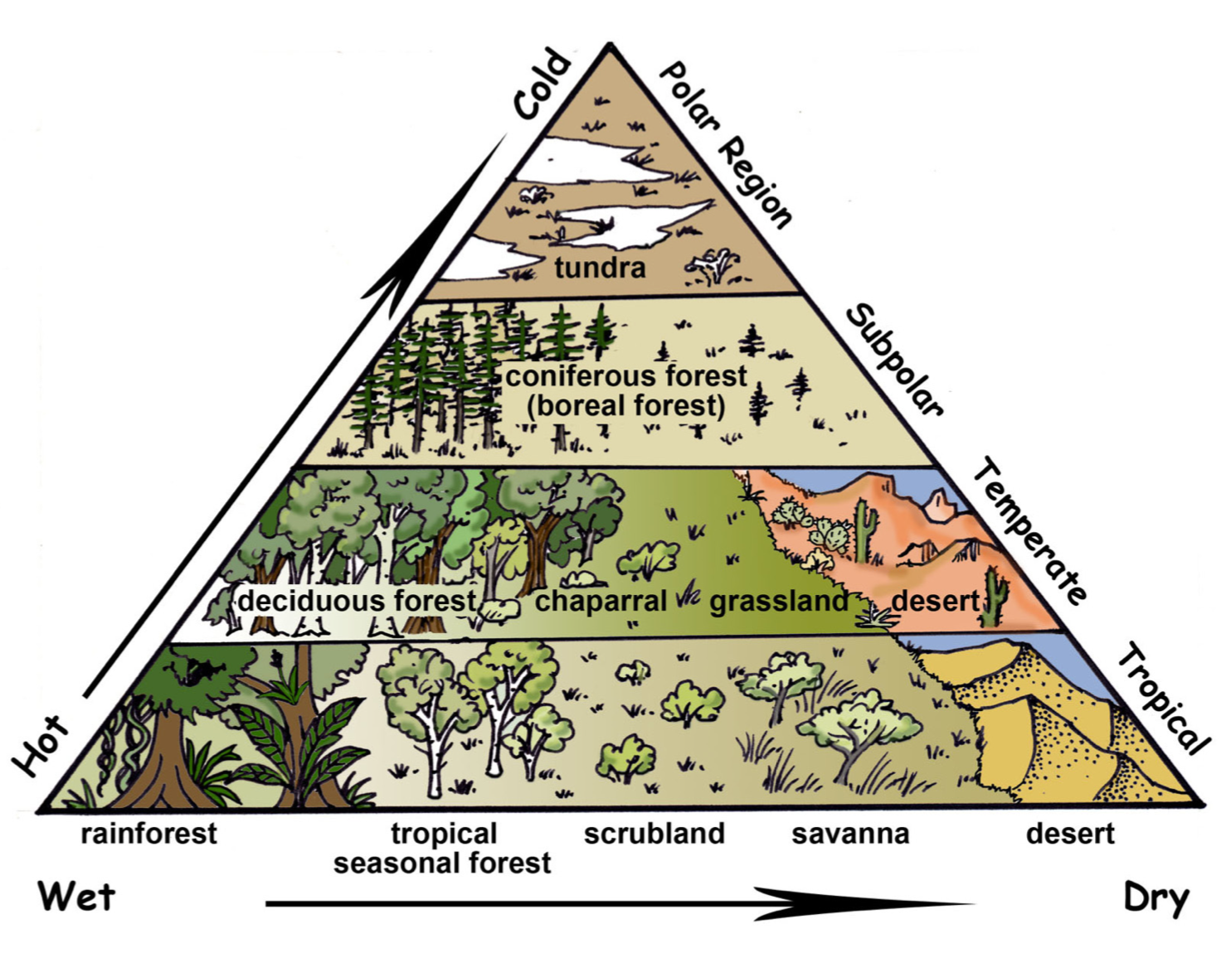
Breadth map for Geography

Geography lessons will take place every two weeks over a ten week term.

Notes on the rationale for breadth in upper key Stage 2
Two main biomes drive the curriculum in Upper Key Stage 2: terrestrial and aquatic. The aim is that students gain a greater world knowledge by looking at the biome, locations of them in both the northern and southern hemisphere; physical and human features of those locations.

The diagram opposite shows an overview of the main terrestrial biomes.

Upper Key Stage 2, cycle A
 | Term 1 | Term 2 | Term 3
Week 1 | Introduction to biomes terrestrial | Grassland (Eurasia -Steppes; South America- Pampas; South Africa- Veldts) | Tropical Desert
Week 3 | Tundra | Temperate Dessert | Tropical Deciduous rainforest
Week 5 | Taiga (boreal forest)  The largest biome on land with conifers (covering high latitudes of the northern hemisphere) | Alpine (mountainous) | …continued
Week 7 | Temperate Deciduous forest | Scrubland | Tropical rainforest
Week 9 | Chapparal | Savanna | …continued
Upper Key Stage 2, cycle B
 | Term 1 | Term 2 | Term 3
Week 1 | Introduction to biomes aquatic | Marine: Oceans and seas | Estuaries:
Week 3 | Freshwater: lakes and ponds | …continued ( included the human processes of fishing and the human impact of overfishing) | …continued (including some of the major estuaries in the UK and around the world)
Week 5 | The great lakes of North America | …continued (including the human behaviour that leads to pollution and attempts to manage it) | … continued (including how estuaries are changing shape from human pollution e.g. wet wipes)
Week 7 | Freshwater: rivers and streams | Coral Reef (Great Barrier Reef) | Pacific atolls ( ink to coral reefs)
Week 9 | Rivers of the world | …continued (including the human impact of coral bleaching) | Deep sea environments

