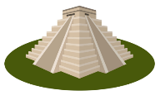
THE MAYA
KNOWLEDGE ORGANISER
Summary  Map showing the expanse of the Maya Empire between 300CE and 900CE |  |  | Maya Life |  |  |  |  | Key Vocabulary
The Maya were a civilisation who lived in Mesoamerica (now central America) between approximately 2000BCE and 900CE.  They are known for being the first Mesoamericans to develop writing. They also had a sophisticated culture in which they lived in city states.  They built spectacular monuments and stepped pyramids – some (e.g. Chichen Itza) have become world tourist destinations in the modern day.  They were also well-known for their advanced maths and calendars.  Around 900CE, Maya cities became abandoned. No one knows for sure why this happened. | 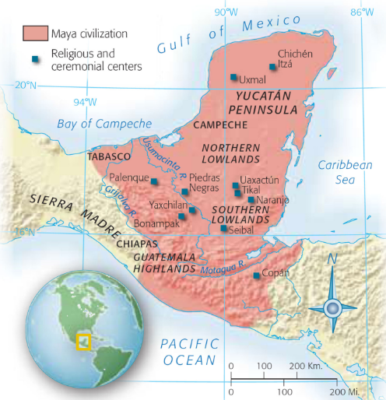 |  | RULERS | 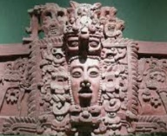 | Maya society was formed of many different city-states, each with their own ruler. The King and royal family were believed to be closely related to the gods. It was the job of the rulers to keep the gods happy and to represent them in the human world. Rulers lived in the finest Maya buildings. |  |  | Maya  City State  Mesoamerica  Polytheistic  Pyramid  Sacrifice  Civilisation  Calendar  Sisal  Hieroglyphics  Settlements  Architecture  Mexico  Central America
 |  |  | ARCHITECTURE | 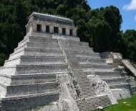 | Maya cities were characterised by huge monumental buildings and sculptures. Although the Maya were able to use metal, they preferred to carve into stone. They built elaborate temples, steeped pyramids, observatories and palace complexes. These were very detailed with artistic designs.
 |  |  | FOOD | 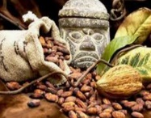 | The Maya at a wide variety of food. They grew crops such as maize, cacao, avocado and beans. Squash and chilli were also regularly grown. They kept animals such as dogs and turkeys for meat. They were also able to hunt very well, capturing animals like rabbits and deer for food.
 |  |  | CLOTHING | 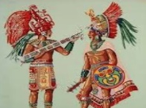 | Clothing was normally made from woven cotton or sisal (a fibre made from a local plant). For the rich, quetzal feathers were extremely popular for elaborate headdresses. The Maya also wore jewellery – highland areas provided stones such as jade and ores such as hematite for decoration.
 |  |  | WRITING | 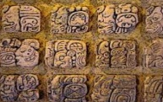 | Maya writing, also known as Maya glyphs, was one of the earliest forms of writing in the world, and the earliest in Mesoamerica. A series of pictures represented different words and letters. The earliest date back to around 2000BCE.
Maya Places and People
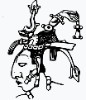  Pakal the Great (603-683CE)  K’inich Janaab Pakal, also known as ‘Pakal the Great’ or simply ‘Pakal’, is perhaps the most famous Maya monarch. He was the King of the city-state of Palenque, for 68 years, longer than any other Maya king or queen. He became King when only 12, but grew to be a powerful leader, expanding his kingdom eastwards. He also oversaw the building of many magnificent monuments, aligned with the stars. | 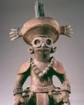  Yax K’uk Mo (426-437CE)  Yax K’uk Mo was the founder and first King of the Maya city of Copan (in modern day Honduras). Although he only reigned for 11 years himself, he built a strong rule meaning that his dynasty was in place for around 350 years. Archaeological records, including inscriptions from later rulers, show that Yax K’uk Mo was a greatly respected leader. He brought stability to the region. |  | MATHS | 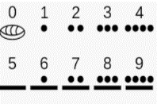 | Maya mathematics was highly advanced. The Maya people had a number system which included zero (many ancient civilisations didn’t) which meant that complex calculations could be performed quickly and accurately.
 |  |  | RELIGION | 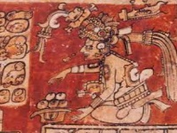 | The Maya were polytheistic (believed in many gods) and worship influenced most areas of their life. Buildings were constructed and games were played in worship to gods. The gods were bloodthirsty, and the people believed that they needed to make human sacrifices to keep them happy.
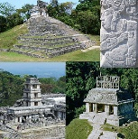  Palenque  Palenque (also anciently known as Lakamha) was a Maya state in what is now southern Mexico, which reached its peak between 600 and 700CE. Although it is only a medium-sized site, it contains some of the finest architecture and sculptures, showing the skill and intelligence of craftsmen from this area. Pakal the Great is the most famous Palenque ruler. | 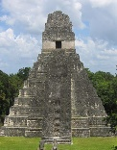  Tikal  Tikal was a Maya city that was built in an area of rainforest in what is now Guatemala. It dates back to the archaic Maya civilisation. Tikal was one of the most powerful kingdoms in Maya and probably reached its peak between 200 and 900CE. Tikal has some of the best-preserved ruins and tombs, giving historians some of the best clues about how the Maya people lived.
 |  |  | Top 10 Facts!
 |  |  | - Maya civilisation is split into two stages – the archaic period (2000BCE) and the classic period (250CE-900CE).  - The Maya considered people who had cross-eyes and big noses as beautiful!  - They also tied boards to babies’ heads in order to try and give them a flat forehead.  - The Maya played a game involving teams trying to get a rubber ball through stone hoops – the earliest team sport in the world!  - The pyramid at Chichen Itza has 365 steps. |  |  | - The Maya civilisation stretched from what is now south Mexico through central America.  - The Maya did not have any wheels or pulleys – there were also no large animals to transport goods – humans or canoes had to do this!  - The Maya pyramids were originally coated in plaster and painted red.  - The Maya had roads, reservoirs and plazas.  - The Maya adapted for life in different climates, e.g. rainforest, coastal, highland and lowland.
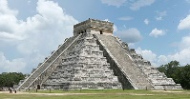
Chichen Itza

Chichen Itsa was a large city built by the Maya people of the Classical period. Positioned on the Yucatan Peninsula, it appears to have been a major Maya centre - containing a number of large temples, monuments and pyramids. It is most famous for the large stepped pyramid at its centre, El Castillo, which is about 1km in diameter. The pyramid was built as a dedication towards Kulkulkan, the Plumed Serpant. Every year during spring and autumn, the sun hits the pyramid in a way that it creates the appearance of a serpent climbing the steps of the pyramid. Other famous landmarks include the Temple of Warriors and Great Ballcourt.

615-683CE – The rule of Pakal the Great in Palenque.
219CE – The first King of Tikal: Yax Moch Xok
100BCE – City states begin to form, with powerful leaders.
250BCE – The first Maya hieroglyphics were used.
750BCE – The first Maya cities are built.
800-850CE – The huge stepped pyramid, El Castilla, is built at Chichen Itsa.
2000BCE – The first Maya people emerge.
909CE – The last recorded evidence of Classic Maya
800CE – The City of Tikal has around 100,000 people.
800-870CE – Many city states (e.g. Copan, Tikal) are deserted.
Maya Timeline

