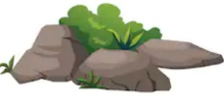
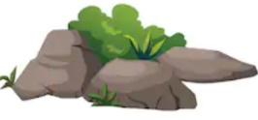
ROCKS
KNOWLEDGE ORGANISER
Y3

A fossil is the preserved remains of something that was once living. The process in which fossils are formed is called fossilization. Most living things don’t become fossilized – it takes very special conditions!
- After an animal dies, the soft parts of its body rot away (decompose) leaving just the hard things, like teeth and bones.

Overview |  |  | Soil
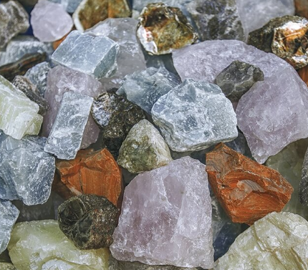  -Rocks are solid objects that are made up of one or more minerals.  -Scientists classify rocks by how they were formed. The different classifications are sedimentary, metamorphic and igneous.  -Soil is made of very fine rock particles that have mixed with water, air and particles from dead animals and plants. There are also three types of soil.  -Fossils are formed when things that have once lived are trapped within rock. |  |  |  | 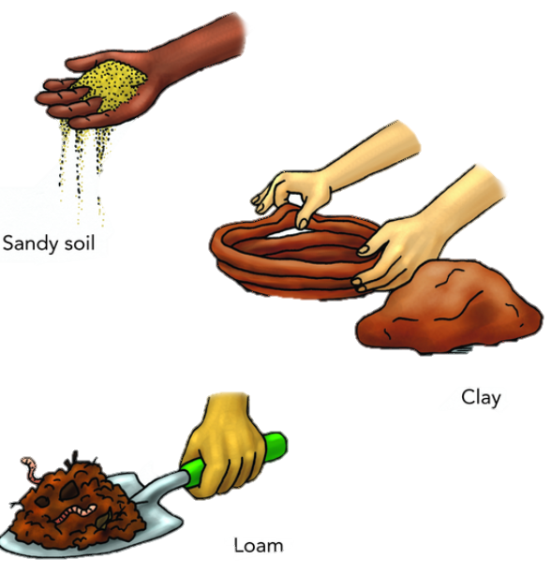 | -Soil is a combination of a range of materials, including ground up pieces of rock, particles from dead plants and animals, air and soil.  The amounts of each of the above, in addition to the type of rocks that have been broken down, decide which of the three types of soil it will be:  -Sandy soil is dry soil with lots of air found in it.  -Clay soil is sticky and doesn’t have much air in it. Clay soil often contains a lot of water.  -Loam soil is somewhere between the two – it has some water in it, and has a bit of air in it.  Loam soil is normally the best type of soil for growing plants in. If you dig through soil, you will find that there are different layers with different features.
Classifications of Rocks
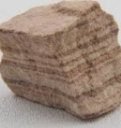  Sedimentary  -These rocks are formed when small particles of mineral are washed down rivers or other bodies of water.  -They become squashed at the bottom of lakes or and are formed over millions of years as sediment is squashed on top. They are porous (let water through) and can be easily worn down. | 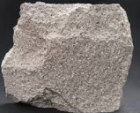  Igneous  -Igneous rocks are formed from magma, a hot underground liquid.  -Sometimes, magma cools under the earth’s surface and forms rocks. Other times, magma flows out in volcanic eruptions as lava. It mixes with other minerals to form rocks on the surface. Many igneous rocks are non-porous.
 |  |  | Fossils
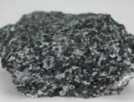  Metamorphic  -These rocks are formed when rock becomes warm enough to bend and mould, but not enough to become a liquid.  -Metamorphic rocks can sometimes form interesting shapes, depending upon how they have been moulded. Normally (but not always) metamorphic rocks are non-porous. | 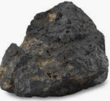  Meteorite (not formed on Earth)  -Meteorites are rocks that have landed on Earth from space.  -These rocks were not formed on Earth.  -This means that scientists are able to study planets without ever actually going there. |  |  |  | 2. The remains are buried by sediment.  3. As more layers of sediment build on top, the sediment around the remains begins to harden into rock.  4.Water seeps through, dissolving the bones. Minerals replace them, creating a rock replica of the bone – a fossil!
 |  |  |  | 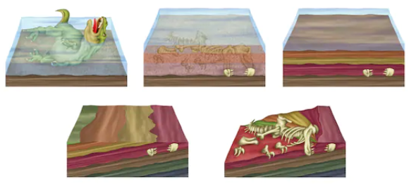

Igneous Rocks
Metamorphic Rocks
Sedimentary Rocks
Pumice
Granite
Basalt
Phyllite
Gneiss
Slate
Marble
Limestone
Chalk
Sandstone

