PARENT/ CARER INFORMATION
FULL RE-OPENING INFORMATION FOR SEPTEMBER – update Augist 2020

24th August 2020
Dear Parent/ carers

As discussed in my last letter I said I would write to you to inform you about the new plan for September and the measures in place to ensure a safe and happy return to school. We cannot wait to see all our pupils back and it has been a long difficult few months. We are excited to welcome our two new teachers to our school too.
Over the next few weeks I will also complete a video and share this with you to show you as much as possible how this will physically work as there are some changes to the drop offs and pick up.

New procedures in the classroom.

- The main changes to life in school will be staggered drop offs and picks up and parents will still not be allowed on site. This will be reviewed in line with government guidance.
- In the classroom things will return to normal as much as possible and the children can play with each other without the need to socially distance. Lessons will resume as normal and we will follow our broad and balanced curriculum. Do not worry about your child being behind as we are planning for this and we will have increased staffing levels in each class to ensure that children are giving the best support in all areas of their learning and in their emotional well-being and back to establishing routines. Each class will have PE and taught all subjects of the National curriculum. Children will return in uniform and your teacher will tell you when it is PE as on these day’s we would like the children to come in their PE shoes and joggers to make it easier to get them changed.
- Children will remain in ‘bubbles’ of classes and it is encouraged not to group these across the school. This means we will review initially how we deliver phonics and how we have lunch and playtimes.
- Early years will have learning through play and open access to all elements of their classroom.
- Each class will be given separate areas for playtime so they can play freely on the equipment with their friends in their set area. As they are kept within the bubble it does not mean we need to clean the equipment after each use.
- Each class will have their own resources for stationery and subjects like art. Any shared resources like Science will be cleaned before being used by a different group.
- Each child will be provided with a pencil case and full equipment in from year 1-6. They do not bring any in from home. This is great for not only keeping things clean but it is a good classroom management strategy.

Daily Routines.

- Each class will have a set time to arrive at school and leave and also a set entrance to come in. This will all be shown in a map and also on the video (this will be shared on the website next week)
- Parents will have set areas to stand for collection and all parents are not to come in the gate other than parents of Turtle Tot children as these are younger children. Turtle Tot parents can come to the gate at Turtles and the staff will be there to greet you. You must make sure your child has their own bag with supplies and a full set of clothes to change in to.
- Parents must socially distance from each other when they collect and they must park in the set areas outlined. I am aware some parents have children in different year groups who may now come out at different times. This cannot be helped and the children will come out class by class and not in sibling groups. Only one parent should aim to do the drop offs and pick ups to avoid additional adults.
- Children need to be on time and collected on time to make things efficient and work well. If you are going to be late you must ring the school office and a member of staff will be waiting for the children outside to bring them in. If your child has an appointment let us know and a similar procedure will be put in place.
- Parents will be asked to ring the office or email with any questions or information. You are NOT to enter the office. Miss Dorner and I will ring you if there are any problems. We are also going to email most letters and out these on the website as we have found this is much more efficient and saves fortunes in photocopying. Can we please ask parents to read the letters and avoid unnecessary and unessential calls as you can imagine we will be bust adjusting back to new routines?
- Each class will have their usual hot lunch but this will be brought on trolleys and served at staggered times in their classroom. Children who have packed lunch can bring their own from home. This will be stored in their classroom.
- All children will bring 2 reading books home on a Monday and return these on a Friday. They will NOT bring them home on a weekend so we can keep them for an incubation period. All our reading books including read, write, Inc. are online and we ask at weekends children read using the online resource of Oxford Reading Buddy. If your child does not have their reading book in on a Monday then they will not get their book changed.
- Children can bring their own water bottle which must be labelled with their name on from home. We will have water and cups for children in each class for those who do not have one. Each class has now been fitted with a sink so they have access to handwashing and water at all times. Children can bring coats and outdoor things like wellies but they are NOT to bring toys from home. I have purchased water bottles for each child to have their own which we will label for them. This can stay in school and will be put in the school dishwasher once per week.
- Cleaning around school will be more robust and more frequent. Toilets will be cleaned after each class uses them. Desks and equipment will be cleaned frequently.
- Staff will administer First Aid and carry out intimate care like nappies as they usually would with extra care on cleaning before and afterwards.
- We will provide each child with a set pencil case and supplies. Children are NOT to bring any of their own in from home.

Breakfast Club and After school provision.

- We will have a paid breakfast club for those who need it for childcare purposes or who want to send their child. This is £1 per day from 8a.m and it will be the breakfast club where your child enters. They will play games, computers, colour in and it will be staffed by teaching staff from school. This MUST be booked and paid for in advance. Please send money in with your child in an envelope marked with what it is for. DO NOT bring this to the office yourself. We are exploring online ways to pay.
- We think it is important for children to come to school and eat breakfast but we are unable to do this all in the hall as we would usually. Your child will enter their class at their set time each morning and we will have buffet breakfast free of charge in each room. There will be a trolley for your child to choose whatever they want for breakfast and each class will start the day with this. If they do not want to eat or have eaten at home that is fine.
- Lunchtime will be similar – we are unable to mix all children in the hall so early years will eat in the hall. Every other class will have their lunch in classrooms delivered to them. All classes will go out to play and have an area of the playground assigned to their class (we are lucky that we are blessed with so much space)
- Parents are asked to book their child’s meal on the live kitchen at home as we will not have the facility to do this in school. This will make sure your child gets what they want to eat. If you need access to the Live Kitchen contact Miss Dorner to set you up. Please manage all payments online where possible too.
- We will have a paid childcare club for those who need it for £3 per session to 4p.m. This will include a snack and drink. This is due to more and more requests from working parents. This again will be in the dining hall and staffed by school staff. You must book a place using the form on the website for this and the paid breakfast club as it helps us plan who is in and what staff is needed. Children who are in this club will be dismissed at the main gates and parents are to wait outside this area. We ask for payment for this club comes in a sealed envelope with your child’s name on it. We have lots in school and can send envelopes home for you if you need some.
- After school you will collect your child from the set area at the time I will list below.

Arrangements for drop off and collections

Please see the map at the end of this letter and I will share a video next week on the website and Facebook and all areas will be clearly labelled so you know what to do. If children come on their own on bikes this is fine for them to continue that so just let us know this arrangement.

Arrival

TURTLES – 8.45. – come in their door and staff wait at the gate.
Nursery and Reception 8.50 – come in early years nursery exit and straight to the classroom door entrance – staff wait at the gate to guide them in.

year 1 and 2 – 8.50 – come in the boy’s toilet door – staff wait at the gate to guide them in

year 3 and 4 - 8.55 – come in the side door by boy’s toilets through the main school gate

year 5 and 6 - 8.55 – Come in the side door by girl’s toilets and new library area. Staff wait by the gate.

All gates will be locked by 9 am.
Dismissal

Turtles – 11.40 – Turtle door and staff go to gate (main gate will be locked afterwards)

Nursery – 11.40 – leave EYFS door and go out the old way by the bins.

Reception and any 30 hour Nursery children 2.50p.m. out of EYFS gate like Nursery – walk out the gate and parents not to enter.

year 1 and 2 – 2.50p.m. Out of side door by boy’s toilets and out of the main gate to parents.

year 3 and 4 - 2.55 – out of side door by boy’s toilets and out of the main gate to parents.

year 5 and 6 - 3p.m. – both classes to leave the side door by girl’s toilets (Nursery gate)

I know this seems a lot of information for you in one letter. Please read it and if you have any specific questions or feel I have not answered any key areas please feel free to call me or email.
These are uncertain times and as yet we do not know how long these kinds of measures will be in place. What I can reassure you is the measures in place make school secure, safe and pupils should all return.
As I said in my letter last week the children who have been attending throughout have loved being in and adapted so well to the changes, the extra handwashing and the entering in different areas.
We ask that parents work with us to ensure we can return to normal as soon as possible and we cannot wait to see you all.
We also may need to review things once school is back to assess how they work.
The guidance for schools returning is specific and it does state that it is not necessary for pupils or staff in primary schools to wear masks so we will not be wearing masks and we ask that pupils do not either.

Take Care

Mrs Marianne Allan
Headteacher

PLEASE SEE MAP ON THE NEXT PAGE

MAP AND DROP OFF AND morning routine DROP OFFS AND COLLECTIONS
We ask parents (where possible) to wait OUTSIDE the main gates and children to come in these ways. Staff will be outside the gates and at all doors to assist and support children in. PARENTS MUST ADHERE TO SOCIAL DISTANCING AND PARK IN THE AREAS ON THE MAP.
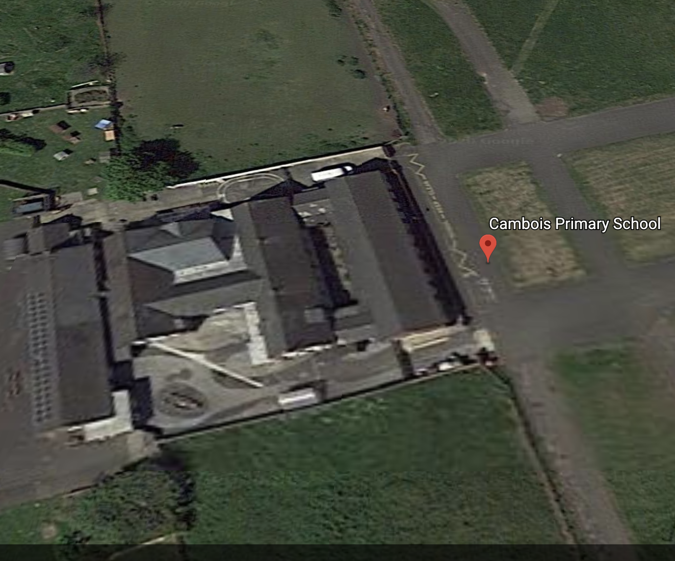
PARENTS MUST STAY AND PARK BEHIND HERE
TURTLES ENTRANCE – DROP OFF 8.45 A.M. PICK UP 11.40 A.M. PARENTS CAN BRING THESE CHILDREN IN TO THE TURTLE YARD AREA.
YEAR 3 AND 4 children – 8.55 A.M. AND 2.55P.M.
Year 1 AND 2 children - 8.50 A.M. AND 2.50 P.M.
ENTER BY THE DOOR BY THE BOYS TOILETS

YEAR 5 AND 6 children – 8.55 A.M. AND 2.55P.M.
ENTER THROUGH NURSERY GATE AND THEN THE DOOR BY THE GIRLS TOILETS.
MAIN ENTRANCE GATE

NURSERY GATE
NURSERY AND RECEPTION ENTRANCE AND LEAVE. 8.50 A.M.
NURSERY COLLECT FROM HERE 11.40 RECEPTION AND 30 HR NURSERY HERE AT 2.50 P.M.

