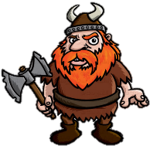
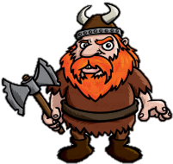
THE VIKINGS
KNOWLEDGE ORGANISER
Diagram – Map of Viking Routes |  |  | Life in the Viking Times
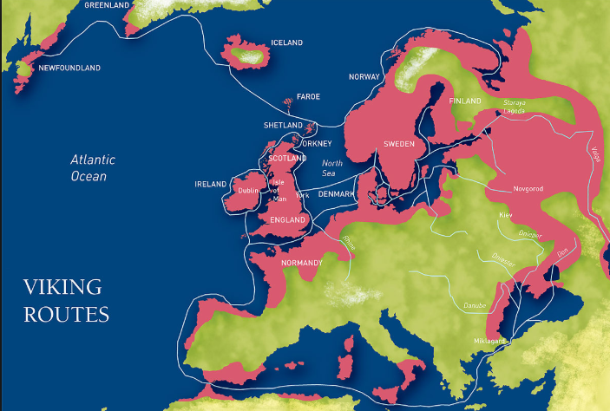  Map of Viking Routes  The Vikings came from the Scandinavian countries of Norway, Sweden and Denmark. The time between 787AD and 1050AD is known as the time of the Vikings. Initially, they settled in northern Scotland and eastern England, also establishing the city of Dublin in Ireland. Around 1000AD, some Vikings settled in North America, but did not stay long. They also travelled to southern Spain and Russia, and traded as far a Turkey. |  |  | Scandinavia | 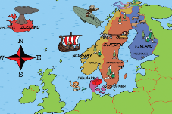 | The Vikings descended from all over Scandinavia (now Sweden, Norway, Finland, and Denmark). The terrain of Scandinavia was not great for farming, so Vikings left their homeland in search of more fertile lands. | Where?  Northern Europe | Key Fact:  The Vikings were also known by the name ‘Norsemen.’
 |  |  | Viking Longships | 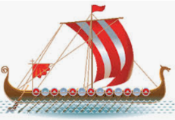 | The Vikings had advanced sailing and navigational skills for the time. They were aided by their longboats, which were long, narrow wooden vessels. These could be sailed in both deep and shallow water. | When?  The longship first appeared in the 9th Century | Key Fact:  The methods used in building longships are still used today!
 |  |  | Norse Runes | 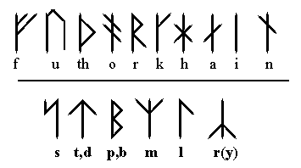 | The Vikings spoke in a language called Norse, and had their own alphabet system (futhark) made up of symbols called Runes. The original futhark had 24 letters, although this was later expanded. Runes were regarded as sacred. | How?  Vikings would scribe on wood, bone and stone. | Key Fact:  The word ‘futhark’ comes from the first 6 letters of the Viking alphabet.
 |  |  | Danelaw | 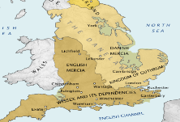 | King Alfred the Great defeated the Vikings in 878 AD, and had them sign a treaty, which governed that the Vikings stick to their own land in north and east England – this section of land became known as the Danelaw. | Where?  North and East England | Key Fact:  The Vikings did not give up on ruling all of England, and eventually did!
 |  |  | Jorvik | 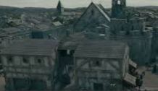 | The Vikings invaded York and renamed it Jorvik. Here, a settlement was formed, which reigned prosperously for over 100 years, until Eric Bloodaxe was expelled in 954 AD. | Where?  York, UK | Key Fact:  Many streets in York end in ‘gate’, the Viking word for ‘street.’
Famous Viking Leaders and Explorers
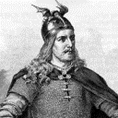  Ragnar Lodbrok (740/780-840 AD)  Ragnar Ladbrok is a legendary Danish and Swedish Viking leader, who is largely known from Viking Age Old Norse poetry and literature (there is debate as to whether he actually existed under this name). According to these accounts, he spent the 9th Century engaged in many conflicts with the British and French leaders. He was reportedly executed by Ella of Northumbria, who cast him into a pit full of snakes. | 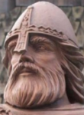  Ivar the Boneless (794-873 AD)  Ivar the Boneless was a notoriously ferocious Viking leader and commander who invaded what is now England. He was a son of the legendary Viking Ragnar Lodbrok. It is said that Ivar and his brothers led the ‘Great Heathen Army’ to attack Britain to avenge the death of their father. His ‘boneless’ nickname could have been for a number of reasons: impotence, a physical deformity, his lack of empathy, or his large stature. |  | Valhalla and Odin | 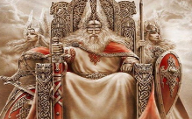 | Vikings believed that when they died in battle, half of them would go to an enormous, majestic hall called Valhalla. This is where the king of the gods lived, named Odin. | What?  Vikings believed the other ha | Key Fact:  The other half were believed to descend to goddess Freyja’s field: Folkvangr.
 |  |  | Battle of Stamford Bridge | 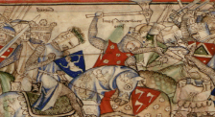 | This battle took place in the village of Stamford Bridge, in the east riding of Yorkshire. King Harold of England defeated a Viking army led by Harald Hardrada | When?  25/09/1066 –widely considered the end of the Viking era | Key Fact:  Harold’s army was defeated only 3 weeks later at the Battle of Hastings.
 |  |  | Viking Homes | 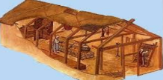 | Vikings lived in long rectangular houses made with upright timbers. They used woven sticks, covered with mud, to keep out the rain. They were often one room, with a central fire. | How?  Smoke escaped through a hole in the roof. | Key Fact:  Animals and people often lived at different ends of the same building.
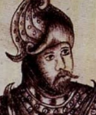  Erik the Red (950AD-1003AD)  Erik Thorvaldsson, known as Erik the Red, was a Norse explorer, famed for having founded the first settlement in Greenland. Before this, he was exiled from Iceland (around 980), reportedly for a number of violent conflicts and murders. Erik’s nickname was reportedly coined as a result of his dark, flowing red hair and beard, in conjunction with his volatile temperament. Erik eventually returned to Iceland, in 986, forming a colony. | 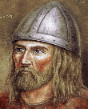  Leif Erikson (970AD-1020AD)  Leif Erikson was a Norse explorer from Iceland. The son of Erik the Red, Leif was the first European known to have set foot on continental America – hundreds of years before Christopher Columbus. He reportedly established a settlement at ‘Vinland’, what is now the northern tip of Newfoundland in Canada. He was reportedly a wise, strong, and considerate man, in contrast to his father’s more brash, brazen personality.
 |  |  | Weapons | 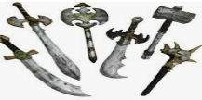 | According to custom, Vikings were permitted (and encouraged) to carry a weapon at all times. Weapons included bow and arrows, spears, knives, swords, axes and slings. | How?  Bow and arrows were made from yew, ash, or elm. | Key Fact:  Grand, well-finished weapons were seen as a sign of wealth and prestige amongst Vikings.
 |  |  | Life for Children | 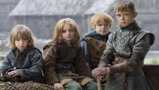 | In old Norse society, formal schooling for children did not exist. Boys worked on farms from a young age, and girls contributed to housework. Many died young. | What?  Viking children played with wooden toys. | Key Fact:  Some Vikings who could not support their babies left them out to die.
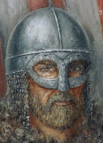  Bjorn Ironside (777BC–859AD)  Bjorn Ironside was another son of the legendary Ragnar Lodbrok, who is believed to have been the King of Sweden at some point in the 9th Century. He led numerous successful raids across Europe, mostly famously in France and across the Mediterranean Sea. He is known for founding the house of Munso, who ruled for many generations in Sweden. | 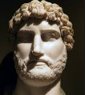  Eric Bloodaxe (885AD–954AD)  Eric Haraldsson, nicknamed Eric Bloodaxe, was a 10th Century Norweigian ruler. He is thought to have had short reigns as both the King of Norway and twice as the Kinng of Northumberland (c.947-948 and 952-954). He is said to have taken part in bloody raids across Europe from the age of just 12, quickly learning that violence was the best way to establish himself as distinguished Viking. |  | Food | 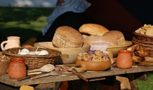 | Vikings ate whatever food they could grow, hunt, or make, for example leeks, nuts, berries, bread, porridge, spinach, deer, boar, trout, chicken, eggs, sheep and pigs. | How?  Vikings grew grains to make a number of foods. | Key Fact:  Vikings also ate honey from bees.
 |  |  | Clothes | 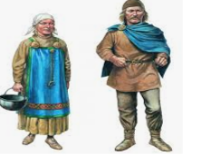 | The Vikings were skillful weavers, and women and children often made clothes for their families. They could also use natural dyes from plants to give colour. Men wore tunics and trousers, whilst women wore long dresses. | How?  Most clothes were made from wool and animal skins | Key Fact:  Vikings fastened their clothes with belts and brooches.

878-886 AD– King Alfred divides England under the Danelaw Act, granting Vikings north & east England.
1066 AD – The Vikings, led by Harold Hardrada, are defeated at Stamford Bridge.
1000 AD – Leif Erikson explores the coast of North America
1013 AD – The Danes conquer England. From 1028. Knut rules.
Viking Timeline
981 AD – Eric the Red discovers Greenland.
900-911 AD – The Vikings raid the Mediterranean, and found Normandy in France.
866 AD – Danish Vikings establish a kingdom in York, England.
840 AD – Viking settlers establish the city of Dublin in Ireland.
787-789 AD – The Vkings begin their attacks on Britain.

