We hope you have all had a lovely half term and are ready to return back to school. | Physical Development  Every Thursday afternoon this half term we will be doing football with NUFC, so we will need an outdoor kit each week.  We will also have another PE lesson on a Friday connecting to multi- skills. Children must have a PE kit in school all week as this may change depending on commitments that week. | Topic  Year 1 and 2s topic this term is the Toymaker. We will be looking into significant people of the past and how they have contributed to the changes in national life. Ks1 will also look into locational language and the key features of areas surrounding them.
Literacy  In Talk For Writing we are focusing on stories with fantasy worlds this half term. We will be learning the story Sir Scallywag and the Golden Underpants. Towards the end of the half term we will be looking at fact writing. We will use forest school to research and write facts about insects. | Seahorses  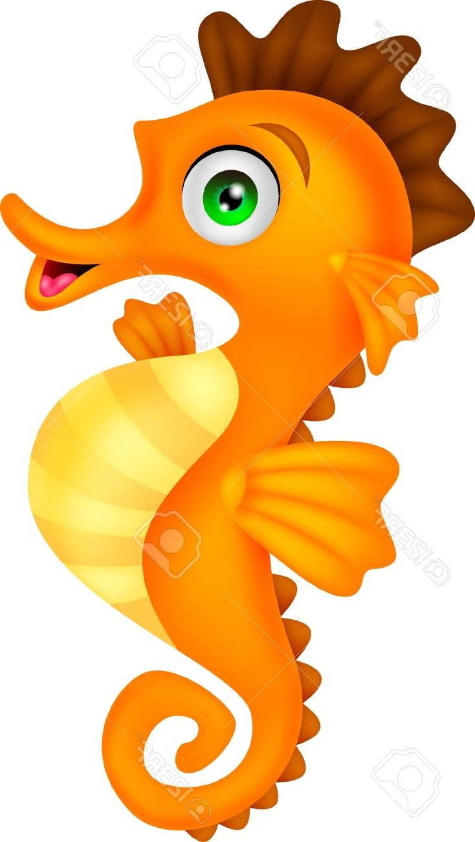 | Mathematics  Year 1 and 2 will be looking into a mastery approach in maths. We will be looking at, addition and subtraction and shape. We will be using a multi-sensory approach allowing children to interact with practical resources as well as looking at pictorial representations.
Homework and reading  Reading folders should be brought into school daily. Each day we read for 10 minutes and all children need their books for this.  Homework will be given on a Friday and is expected to return back into school on a Tuesday. Homework is now part of progress files so it is important to be completed. | Science  This half term we are looking into the basic needs of humans and animals. We will look into the importance of exercise and diet. | PE kit  Most of Year 1 and 2 will have football on Thursday and PE on Friday. Kits should be brought into school on the first day of term and we suggest you leave it until half term.  Remember they’ll need: a plain white t shirt, blue/black shorts, sandshoes / trainers.
Educational visits  You will be informed any further visits. | Important information  Miss Fawcett will have PPA on Thursday pm. The children will have football with Miss Mccloskey a student teacher during this time.
Supporting your child at home  Please remember to read with your child at home and sign their books twice a week at least. It is vital they are questioned about what they’ve read in order to improve their comprehension skills at this stage. |  | Follow us on Twitter and Facebook!    

