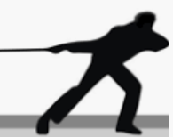
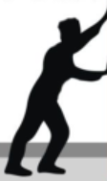
KNOWLEDGE ORGANISER
Y5

-Simple machines and mechanisms include pulleys, gears and levers. They can be used to turn a small force into larger forces. This means that we can use these machines to accomplish things more easily.
What you should already know… |  |  | Definitions of Forces  FORCES
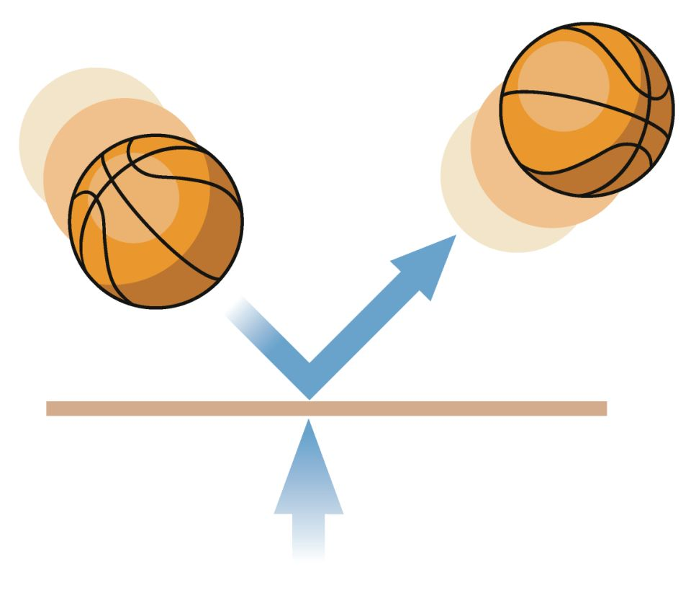  - Forces are pushes and pulls which make things move and stop moving.  -Most forces need contact between objects, but magnets can act at a distance.  -Magnets are made of materials that create a magnetic field (the area in space where the force of magnets can be detected).  -Forces are shown by arrows in diagrams. The bigger the arrow, the bigger the force.  -When forces are unbalanced, objects can speed up, slow down, or change direction.  - |  |  | Applied force | 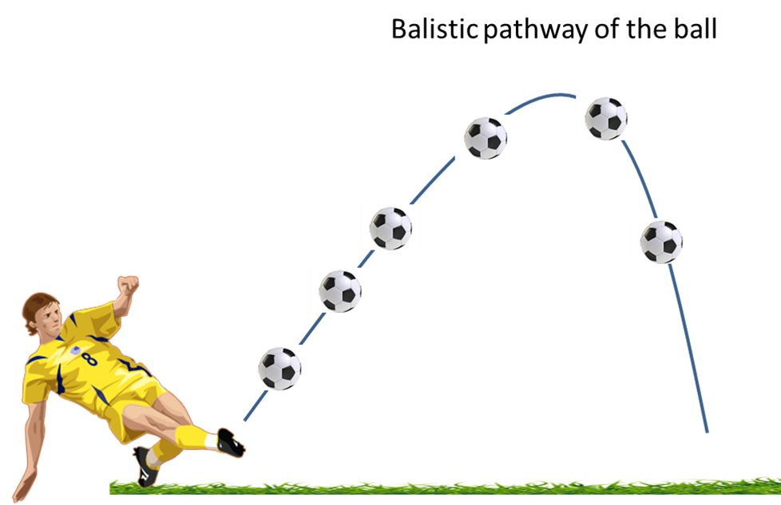  Air resistance | There are a number of different forces that affect us in our daily lives:  -Applied force: The force placed on an object by a living creature.  - (see ‘Gravity’ definition bottom left);  - Friction: the ‘sticking’ force that occurs when an object moves over another.  - Air resistance is a type of friction force that pulls against an object travelling through the air. Some objects are more ‘streamlined’, meaning that the air pulls on them less, and they travel faster.  - Water resistance is the friction force on objects floating or moving in water.  - Surface resistance is the friction force of objects moving across a surface.  Gravity
Gravity
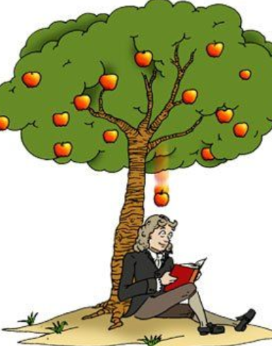
Gravity attracts all matter towards each other.
-It has been around since the beginning of the Universe, and applies to all matter in the Universe.
-The bigger an object’s mass, the more gravity it will have. The smaller the mass of an object, the less gravity it will be subject to.
-Without gravity we would fly right off the planet! The moon’s gravity causes our ocean tides on Earth. The Sun’s gravity keeps Earth in orbit around the Sun.
-We don't actually "feel" gravity. We only feel the effects of trying to overcome it by jumping or when we fall.
-Sir Isaac Newton discovered gravity around 300 years ago. The tale is that he saw an apple fall from a tree, and wondered what force made it fall to the ground.
 |  |  | Machines and Mechanisms
-Levers give us extra pushing or pulling force and help us lift greater weights.
-Gears are different sized cogs which work together to give a machine extra force.
-Pulleys are wheels and ropes that work together to life heavy objects.
 |  |  |  |  | 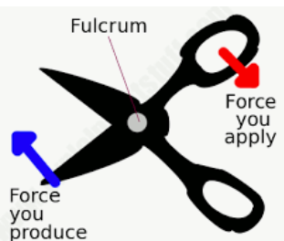

Machines and Mechanisms
Window Blinds
Exercise Equipment
Well
Shovels
Fishing rods
Wheelbarrows
Boat Oars
Brooms
Elevators
Scissors

