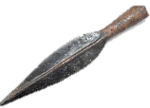
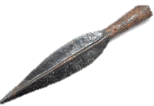
THE IRON AGE
KNOWLEDGE ORGANISER
Overview |  |  | Life in the Bronze Age
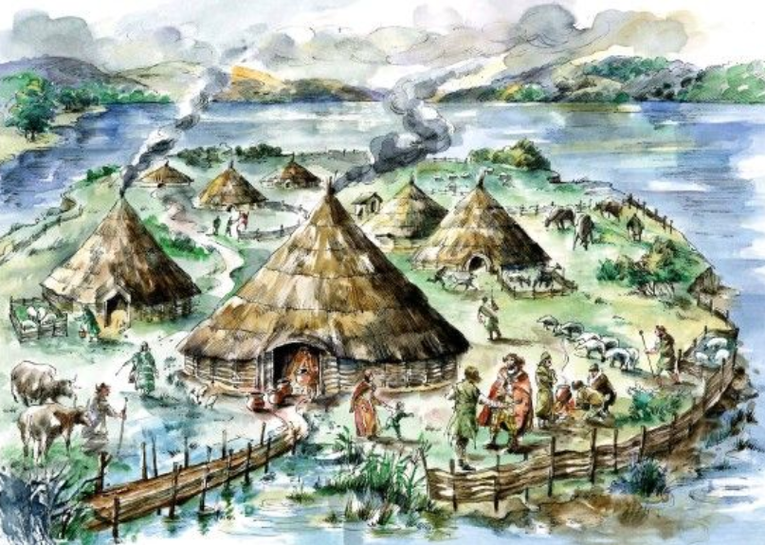  The Iron Age  The Iron Age is the name given to the time period in which iron became the preferred choice of metal for making tools. It followed the Bronze Age, which had followed the Stone Age.  The Iron Age began in the Ancient Near East (today the countries of the Middle East) around 1200BCE, spreading quickly to the Mediterranean basin and to South Asia. However, it did not reach central Asia until some time later, and did not reach Northern Europe until around 500 BCE. The Iron Age in Britain is defined as being between 800BCE and 43CE. |  |  | Iron | 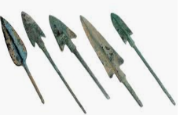 | From 1200BCE, ironworking by blacksmiths became increasingly popular in order to make tools and weapons. Iron was found in rocks called iron ore. Making iron from the iron ore required extremely high temperatures in charcoal-fired shaft furnaces. | Fact  Techniques for making iron were first developed in the Middle East around 1500BCE.
 |  |  | Agriculture | 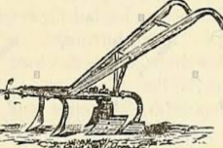 | Iron ploughs called ards were much tougher and more efficient than the earlier bronze or wooden ploughs. They were able to turn heavier soil, meaning that more widespread and difficult areas of land could be dedicated towards agriculture. | Fact  As farming became more productive, the population rose more quickly.
 |  |  | Rotatory Quern | 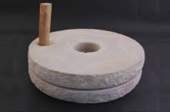 | The rotatory quern was one of the most important time-saving inventions of the Iron Age. It was used for grinding grain in order to make flour. It consisted of two circular stones – the top of which was rotated using a handle, which ground the grain in between. | Fact  Because of rotatory querns, bread became more widely available and popular.
 |  |  | Trade | 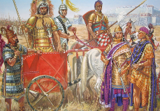 | Trade in the Iron Age was more intensive and far –reaching than had been achieved in the Bronze Age. For example, people of higher status could afford wine, which they would trade in return for high quantities of grain. Pottery from France was also popular. | Fact  The first evidence of widespread ship-building is dated from around this time.
 |  |  | Empire Building | 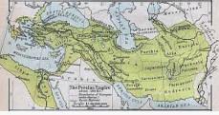 | An even greater range of travel options than in the Bronze Age period meant that many civilisations could now travel vast distance. Huge empires, for example the Persian and Roman Empires, flourished. | Fact  The Persian Empire is known as the world’s first superpower.
Iron Age Civilisations
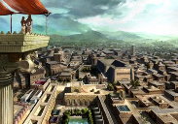  The Persian Empire  Around 600 BCE, a once nomadic population of farmers began to develop a state that became known as Persia (around the area that is now Iran). They used steel weapons that were sharper & stronger than those made from bronze, and were the first to attack with armoured men on armoured horses. At its peak, the Persian Empire was one of the largest in history, extending from Eastern Europe to India. | 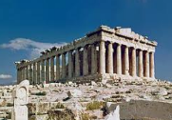  Greece  Greece had been a major cultural hub at the end of the Bronze Age, but mysteriously entered a period of turmoil known as the Greek Dark Ages throughout the early Iron Age. By the late Iron Age, however, Greece had recovered, and achieved a number of architectural, academic and cultural successes, e.g. the Parthenon was built and Socrates became a founder of western and moral philosophy. |  | Iron Age Britain - Housing | 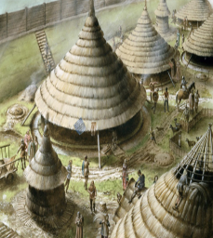 | Britain was a violent place throughout the Iron Age. People lived in clans and tribes, which would attack one another. As a result, many people lived in hill forts to keep themselves safe. Forts were surrounded by walls and ditches, and warriors were trained to defend villages from attack. Houses were typically one-roomed, with pointed thatched roofs and walls made from wattle and daub (a mixture of wood and twigs). | Fact  Many houses had a fire in the centre – smoke from this would leave through the top of the roof. Beds were made from straw, which was covered by animal skins.
 |  |  | Iron Age Britain - Religion | 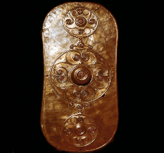 | People in Iron Age Britain were highly spiritual. They believed in powerful gods and spirits, which helped them to explain the world around them. They would often congregate in sacred places, such as on the edge of waterways, or forest clearings, in order to pay their respects to their gods. Surviving art and pottery from the time details some of their beliefs. | Fact  Druids were priests who held religious ceremonies. Sometimes, they would sacrifice animals (or even humans) as an offering to the Gods.
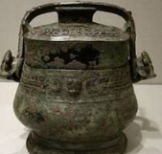  Iron Age China  The Iron Age in China began in 600BCE and lasted until the rise of the Qin Dynasty around 221BCE. Cast iron objects appeared in the Yangzi Valley towards the end of the 6th Century BC. Wars at the time drove the more widespread use of iron, utilised to make bigger and stronger weapons, which were helpful throughout the Warring States Period. | 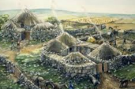  The Celts and Britain  The Celtic peoples travelled over to Britain from mainland Europe around 500BCE, and lived in dispersed tribes around the country. European links were reinforced by trade between the southern half of Britain and continental Europe. In 43CE Britain was invaded by the Romans – the following ‘Romanisation’ is generally considered to signal the end of the British Iron Age.
 |  |  | Wealth | 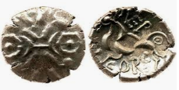 | Coins began to be used around this time. In the Bronze Age, those who made bronze were the wealthiest. However, as iron was so accessible, the rich were now those who making surplus food on their land. | Fact  It is thought that coins were first used around 600BCE by the Lydians.
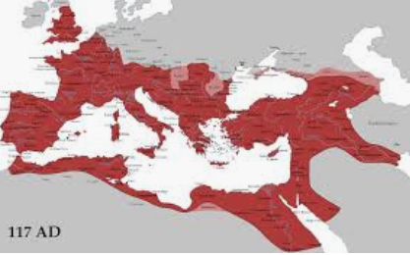  The Roman Empire  The Roman Iron Age took place long before Rome became a mighty empire, but it is partially thanks to the use of iron weapons that the Roman military was so effective. Towards the end of the second century BCE, Roman influence grew across the European continent, initially through trade. As the Romans than began to rapidly invade other civilisations and expand its empire, the Iron Age in these countries came to an end. The Roman Empire would go on to become one of the mightiest Empires the world has seen, extending over all of western and southern Europe, as well as the Mediterranean coastal regions of Africa. |  |  | Life Expectancy | 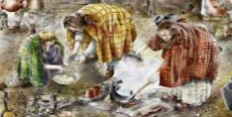 | Improvements in agriculture and diet meant that people lived longer. Due to childhood deaths, life expectancy at birth was only 26, but if someone lived to be 20, they could expect to live for another 30 years. | Fact  Because of this, the population of Britain grew to over 1 million!
 |  |  | Clothing and Fashion | 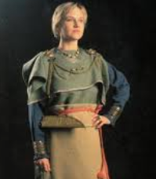 | Clothes varied from place to place, and tended to be made of local materials. They were similar in many ways to the clothes of the bronze age, but were of a better quality due to better looms and techniques. In colder Britain and Northern Europe, fur capes and heavy boots were worn by both men and women. | Fact  Women’s clothing was generally wool blouses, dresses and skirts, whilst men wore wool tunics.

43CE – Britain is invaded by the Romans.
54BCE – Julius Caesar arrives in Britain.
100BCE – The first coins are minted in Britain.
400-300BCE – Rotatory quern arrives in Britain.
500BCE – Celtic people arrive in Britain from Central Europe.
700BCE – Iron is now the material of choice across Britain.
800BCE – The first Iron Age hill forts are built in Britain.
800BCE – Iron becomes the main material for tools in Central Europe.
1100 BCE – The widespread use of iron quickly spreads along the Mediterranean.
1200BCE – The Iron Age begins in the Ancient Near East.
Iron Age Timeline

