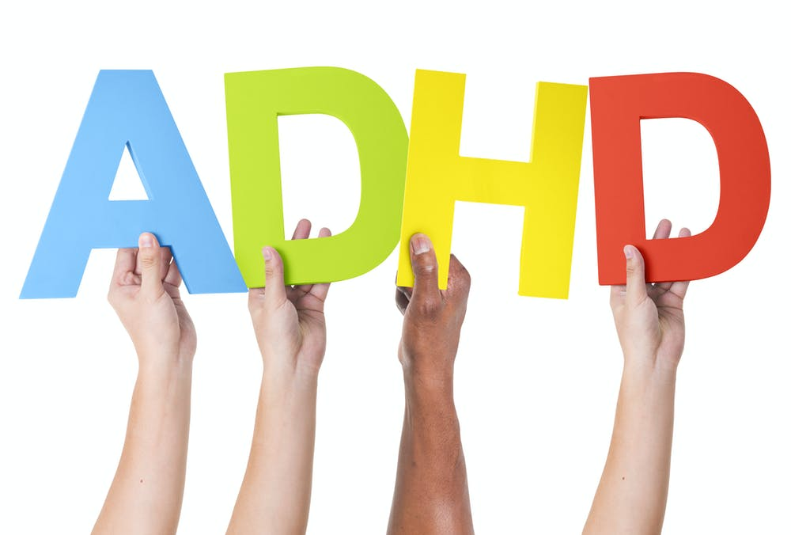
My sibling has…

For younger children

What does that mean?

If someone has ADHD, there are 3 things they find more difficult than other people:

1. Paying attention

2. Thinking before doing something

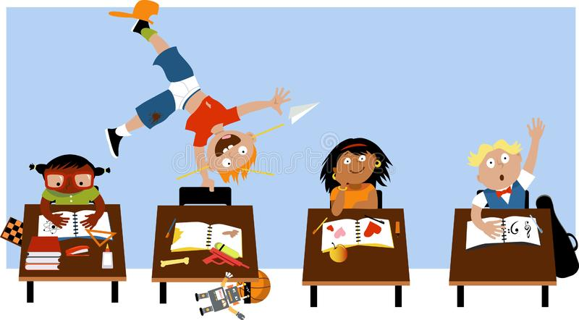
3. Staying still

1 – Paying Attention
Paying attention is when we need to focus on one thing.

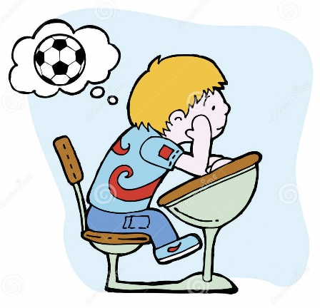
If a person has ADHD, they might be easily distracted, which means they might start thinking about something else before they’ve finished what they’re doing

If someone is easily distracted, they might not finish things because they’re thinking about too many things at once! They can’t choose 1 thing to focus on.
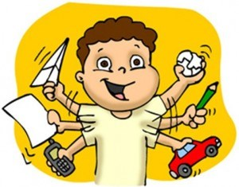

When do we have to pay attention?
Doing schoolwork
Crossing the road

Listening

Can you think of any other times when you have to pay attention?

2 - Thinking before you do something

When we want to do something, our brains go through something a bit like this:

Stop, I’ve got an idea!
Let me think about it…
Decision – YES or NO

This all happens very fast, so we usually don’t notice it.
When someone has ADHD, they don’t always go through the YELLOW light. Sometimes you’ll see them jump straight from RED to GREEN. Let’s see how that might look…

Here’s how it goes when we use our yellow light…

Ooh, look, dad’s left out his hair trimmer…I could give myself a haircut! | Should I do that without checking with mum and dad first? | No – I’ll ask mum and dad | Great, mum said the hairdresser will make it look just how I want!
And here’s how it goes when we don’t!

Ooh, look, dad’s left out his hair trimmer…I could give myself a haircut! |  | Great – I’ll just stand in front of the mirror and away I go! | Oh no!

We all have times where we make mistakes, but if someone has ADHD, they find it extra hard to use their yellow light, and that can make it hard to learn from their mistakes.
3 - Staying still

We all learn when it’s okay to be running around, climbing and jumping, and when we need to sit still.

Park
Garden
Playground
Classroom
Restaurants
Watching a film at home

Can you think of any more places where...
…you’re allowed to run and jump around?

…you need to sit still?

People with ADHD can understand this too, the same as other people. The difference is that their bodies find it harder to stay still even when they know they need to.

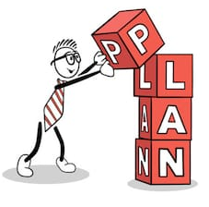
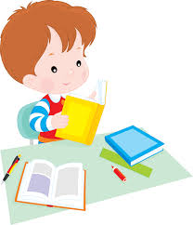
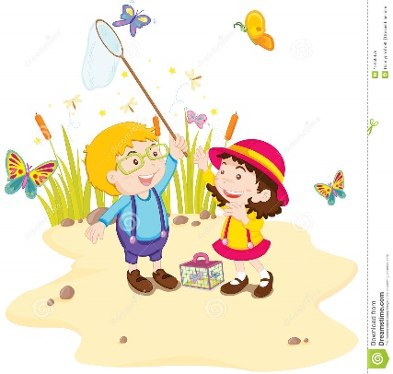
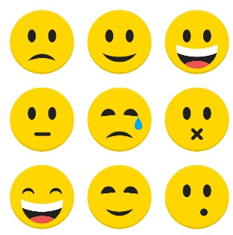
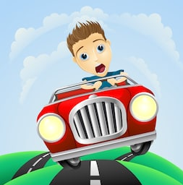
If someone has ADHD, their brain works a bit differently. Some people day it’s like having a car with a Ferrari engine and bicycle brakes.
The brakes are to do with paying attention, planning, organising, and choosing how to behave

The engine is to do with creativity, personality, feelings, and enjoying nature

If the engine is really powerful and the brakes are weaker, then the brain is going to find it hard to stop itself!
How can we help my sibling?
Some things might be different for you and for your sibling. This might sometimes seem unfair, but different rules are there so everyone can do their best. If your sibling has ADHD, some things might be different for them. Things like..
They might have more time to run around or play outside

They might have special toys that help them concentrate
They might have a timetable that helps them know what to do step by step

They might get extra help in making choices

They might take some medicine which helps them concentrate, think, and sit still

They might get more time to finish jobs

This is about everyone having what they need to do their best, which is different for everyone.
What about me?

It can be hard when your sibling has ADHD because there are times when they might need more help from your parents or teacher. Sometimes that can make you feel…

Left out
Ignored
Angry
Fed up
Frustrated
Sad

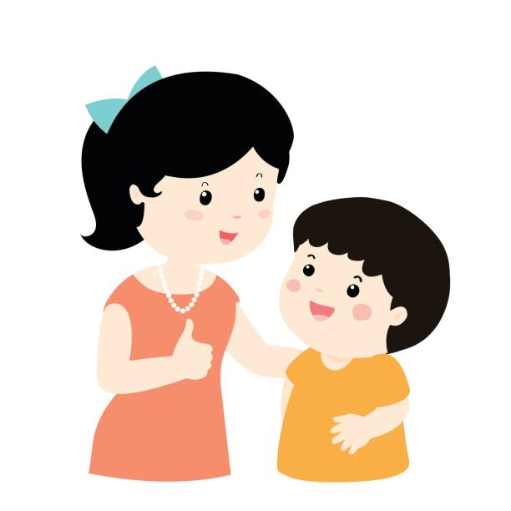
It’s very normal to feel these feelings, and everyone does at some point. The important thing is about what we do when we feel these things. Here are some important DOs and DON’Ts:

 | DO: |  | DON’T:
 | Tell someone how you’re feeling. Sometimes big unpleasant feelings can be hard to manage – adults want to help. If that’s hard you can try writing it down. |  | Keep your feelings inside – this will make you feel worse, and nothing will change!
 | Your favourite things. If you like Lego, drawing, or playing in the garden then do it! This can help you feel calm and happy

Remember the good things about ADHD

People with ADHD can be…
Brave
Helpful and kind
Full of energy
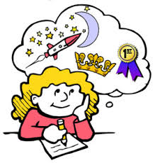
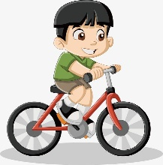
Clever

Great with animals
Imaginative
Great at solving problems

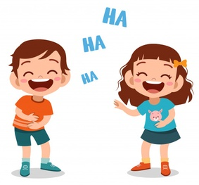

Funny

What things is your sibling good at? Write or draw them here:

One last thing…
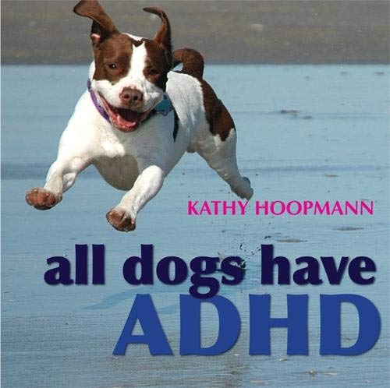
You and your sibling might enjoy this book. It explains lots of the good and difficult things about having ADHD.
All dogs have ADHD by Kathy Hoopman

