Cambois Primary School Science Policy

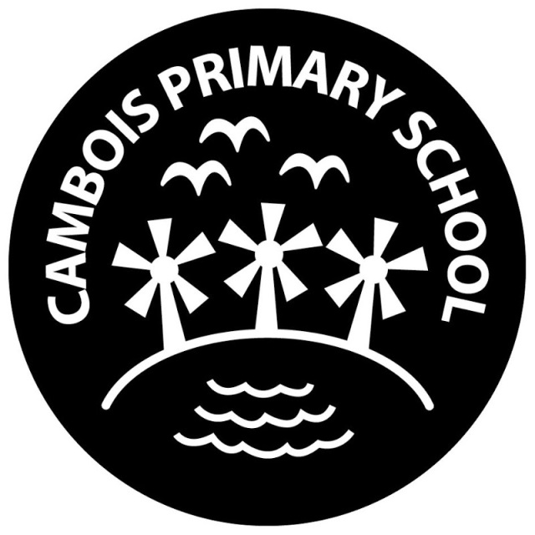

Introduction
Science is a core subject within the National Curriculum. This policy outlines the purpose, nature and management of Science taught Cambois Primary School. It reflects the consensus views of all the teaching staff and they are responsible for its implementation. This policy should be read in conjunction with the New Curriculum 2014 documentation which sets out in detail what pupils will be taught in different year groups as of September 2014.
Policy Statement
For children, science is the exploration of the world around them through investigation Science is the study of the physical world, involving a collection of facts from observations, physical experiments and working scientifically (Living Processes, Materials, Physical Processes) from which children form ideas of their world. Science has a heavy emphasis on investigation involving prediction, observation, testing and evaluation. We believe that it is good practice for children to be encouraged to actively learn, by developing their own investigations based on ideas given by the teacher, and their own ideas. These ideas will be increasingly founded in scientific knowledge and understanding.
Aims
We aim:
• To develop the natural curiosity of children about the world around them;
• To develop questioning and enquiring minds through a range of enjoyable and interesting experiences;
• To help children develop the skills to make systematic enquiries;
• To provide opportunities for children to apply theoretical ideas to the solving of practical problems;
• To enable children to develop an increasing attention to accuracy;
• To foster a positive attitude to science and increase pupils’ understanding of how science is used in the wider world;
• To provide a range of relevant experiences allowing pupils to acquire knowledge, skills and understanding in the key areas of Scientific Enquiry, Life Processes and Living Things, Materials and their Properties, and Physical Processes through a variety of teaching and learning strategies;
• To develop the accurate use of scientific vocabulary;
• To meet the needs of each child so that they will reach their full potential.
• To engender a sense of awe and wonder with Science.
Teaching and Learning
We use a variety of teaching and learning styles in science lessons. Our principal aim is to help develop children’s knowledge, skills and understanding.
• Sometimes we do this through whole class teaching, while at other times we engage the children in an enquiry based research activity.
• We encourage the children to ask, as well as answer, scientific questions.
• Children have the opportunity to use a variety of data, such as statistics, graphs, pictures and photographs.
• Children use ICT in science lessons where it enhances their learning.
• Children take part in discussions and present reports to the rest of the class.
• They engage in a wide variety of problem solving activities.
• Wherever possible we involve the pupils in ‘real’ scientific activities.
- When a practical lessons are taken place within science we record on Seesaw. This enable us as a school to record and evaluate within the lesson.
Leadership and Management Roles
The co-ordinator is responsible for:
• Understanding the requirements of the subject order.
• Preparing policy documents, curriculum plans, Schemes of Work for the subject.
• Encouraging staff to provide effective learning opportunities for all pupils
• Helping colleagues to develop their subject expertise.
• Ensuring common standards and formats for recording and assessment.
• Liaising with teachers of the subject in other phases.
• Communicating all developments in the subject, e.g. Through staff meetings, distributing information, using notice boards.
• Organising and monitoring professional development in the subject.
• Producing annual development plans
• Liaising with relevant organisations regarding the subject, e.g. Advisory teachers, inspectors, QCA, libraries.
• Organising and advising on the contribution of a particular subject to other curriculum areas including cross-curricular and extra-curricular ones.
Staffing
The class teacher is responsible for timetabling to ensure that the relevant sections of the Scheme of Work are covered during each half term.
Teachers will use a balance of:
• Teacher-prepared materials
• Published resources
• Practical tasks
• Visitors, e.g., parents, experts, etc.
• Educational visits
The classroom teacher is also responsible for monitoring the progress of the children in their class and reporting this on an half termly basis.
Entitlement
The following specific programmes of study must be taught during Key Stages 1 or 2.
• Scientific Enquiry
• Life and Living Processes
• Materials
• Physical Processes
At Cambois Primary School, it is expected that Science is taught for one and a half hours per week in KS1 and KS2.

Planning
Science is taught as a discrete subject. It has been agreed that our medium term planning will include the vocabulary to be taught in that unit of work, the skills that will be taught, opportunities for assessment and where relevant, differentiated activities on a common theme. Short term planning is used flexibly to reflect the objective of the lesson, the success criteria and notes of the next lesson. Science is taught in half termly blocks based on a theme.
Foundation Stage
We teach science also as a discrete subject. As the reception class is part of the foundation stage, we relate the scientific aspect of the children’s work to the objectives set out in the Early Learning Goals included in Knowledge and Understanding the World. Foundation Stage record a lot of practical lesson on Tapestry.
Assessment and Recording
Teachers will assess children’s work in Science from three aspects (short-term, medium-term and long-term). There will be a strong focus on Assessment for Learning (AFL) and children will be encouraged discuss verbally. Formative Assessment (short-term) Assessment is carried out informally during the course of teaching. It enables the teacher to identify a child’s understanding and progress in particular aspects, to inform their immediate teaching and to plan for their coming lessons.
This can take the form of:
• Small group discussions in the context of a practical task.
• Individual discussions with children to evaluate progress and to set new targets.
At the beginning of a unit of work, individuals complete a topic based assessment, which summarises their knowledge and understanding. These assessments are revisited at the end of the unit and new knowledge and understanding are added.
Cross-Curricular Links
As far as possible, the Science curriculum will provide opportunities to establish links with other curriculum areas:
English In particular, at Key Stage 1, the pupils are encouraged to use their speaking and listening skills to describe what they see and explain what they are going to do next. At key stage 2 the pupils are encouraged to develop their skills of writing to record their planning, what they observe and what they found out. The children develop their written skills by writing reports in science.
Maths At both Key Stages the pupils are expected to use their knowledge and understanding of measurement and data handling at appropriate levels. In science, they should be applying their maths skills at levels similar to those, which they are using in their maths work. Mathematical skills such as weighing and measuring are an important part of a Science lesson. Where appropriate, children record their findings using charts, tables and graphs.
Topical scientific issues are also discussed as appropriate. Personal, social and health education Health education is taught as part of the units on ourselves, health and growing, teeth and eating, moving and growing, keeping healthy and life cycles. It is also linked to becoming a global citizen. There are many resources within our school grounds which allow effective teaching of environmental science connecting to sustainability; including our wildlife area within forest school, outdoor classroom and pond area. As a result of teaching about the environment, every encouragement is given to the children to apply the principles of energy efficiency, water conservation, waste reduction and recycling and litter control. Additionally, there are many opportunities within science and other areas for children to learn about the choices they have and the impact that they can make on their environment.
Equipment and Resources
The science coordinator carries out an annual audit of the resources and reorders any consumables when necessary. New resources can be purchased through negotiation between class teacher and co-ordinator, within the amount allocated in the annual budget.
Health and Safety
The school’s Health & Safety Policy outlines the safe codes of practice for our school and provides the necessary guidance on the response and the reporting of all incidents. Children are encouraged to assess hazards and discuss the appropriate precautions. Children are taught the appropriate safe practice when using equipment. This will include:
• How to use equipment correctly and in accordance with health and safety guidelines
• To behave in a considerate and responsible manner.
A Risk Assessment will be completed for any educational visit.
ICT
Children use ICT in Science lessons where appropriate. The children have access to the internet to research information about their Science topics. Each classroom is fitted with an interactive whiteboard enabling the teacher to use video clips and demonstration programmes to enrich lessons. At Cambois we use Tapestry and Seesaw to record observations, recordings and experiments. We share this secure website with parents so they can view and comment on what their child has been doing throughout the school year.
E-Safety
When ICT is used in Science lessons, before every lesson the class teacher will remind children about how to use the internet safely and refer to the poster on display. They will monitor and report e-safety incidents in line with the AUP (Acceptable Use Policy).

