In LKS2 we currently stream across two classes – a main class and a small group. This is due to high SEND needs within the class and a small focused morning group.
Year 3/4 Mr Longstaff (main class setting)
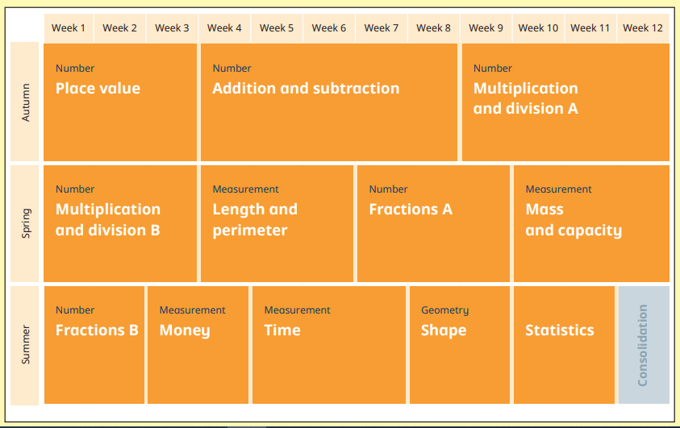
Year 4 Mrs Darbyshire (small group)
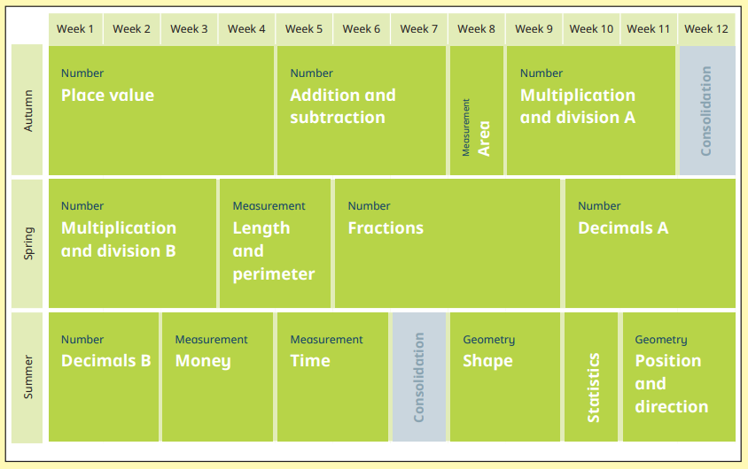

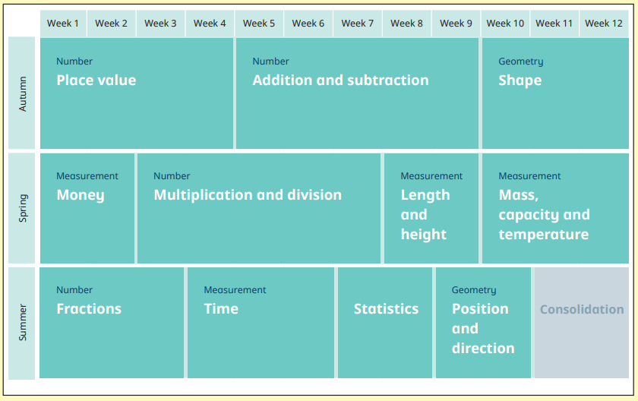
Year 2

