Transition Information September 2020

As we usually spend the last two weeks of the Summer two doing transition work, we have had to look at other ways to prepare your child for their class and teachers when they return to school.
This is a short document for you so that you can see who is teaching what class and some information about them for those who are new to the school as we have a few new children and families joining us in September

We have five classes in total.

We have a 2-year-old provision called Turtle Tots which runs each morning. 8.45-11.45 a.m.

Early years which is Nursery and Reception. From September we will be offering 3o hour placements for Nursery to any children who are entitled to them.

Year 1 & 2

Year 3 & 4

Year 5 & 6

MEET OUR STAFF

Mrs Allan – Headteacher, SENCO, PSHCE
Designated safeguarding lead.

Mrs Allan loves to laugh. She loves to spend time with her family and her two children. She has a new dog called Enzo who will be coming to school as our school dog.
She loves Maths and challenges.

This is Mrs Myers. She is the Assistant Headteacher in school. She teaches year 1 and 2 as well as leads on English, music and RE. She is deputy designated safeguarding lead. She loves to sing and dance in her spare time.

This is Miss Dorner who is the office manager. She works Monday – Thursday in school. She loves to spend time with her two little boys on family days out.

This is Mark Rutterford.
Mark is our Site manager and also our IT manager.
Mark is the person in school who fixes everything. No job he cannot do.
Mark loves cats and rock music.

This is Mrs Sample. Mrs Sample is our unit manager (also known as cook).
Mrs Sample loves spending time with her family and grandchildren. She has lived in Cambois and North Blyth all her life.
She is the person to go to if you need any information about the lunches we have in school. We use the Live Kitchen to order and manage lunches and we encourage parents to do this at home. Please ask your children what they would like for lunch. If you have any specific dietary requirements let her know.
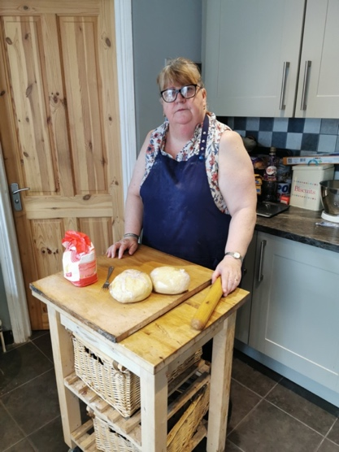

This is Miss McAllister. She is a new teacher to our school and she will teach year 5 and 6 in September.
Miss McAllister loves Science. At home she loves to keep fit and cook. She enjoys travelling.

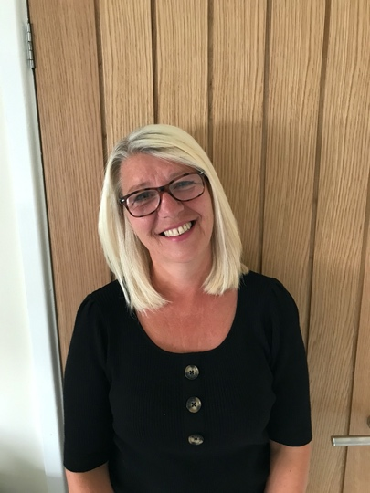
This is Mrs Beattie. Mrs Beattie works in Early Years. Mrs Beattie loves to organise things and spend time with her family.
She is always full of life and loves being in school.

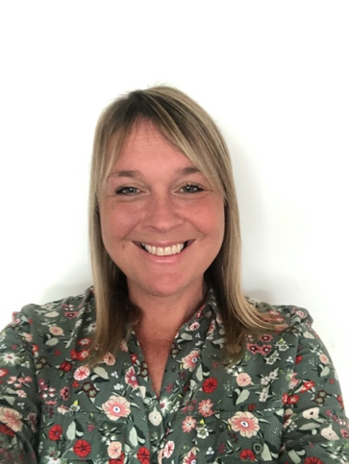
This is Mrs Rawlinson who works across Key Stage 2. Mrs Rawlinson loves to go for walks and watch crime programmes on T.V.
She will be supporting in year 3,4 5 and 6 in September. Mrs Rawlinson covers PPA and also leads on special educational needs interventions.

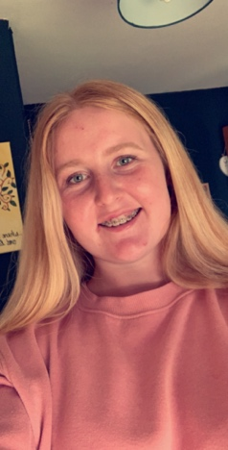
Miss Routledge is a teaching assistant in school. She runs the morning breakfast club and supports classes across school. She likes listening to music and baking.

This is Miss McCloskey. She works across school with a main focus on supporting children with additional needs. She loves to watch her daughters dance and spend time with her dog Vinnie.

This is Mr Driver. He is a new teacher to our school. He will be teaching year 5 & 6 in September. He loves sports like playing football and golf. He coaches youth teams and volunteers. He also loves cooking.

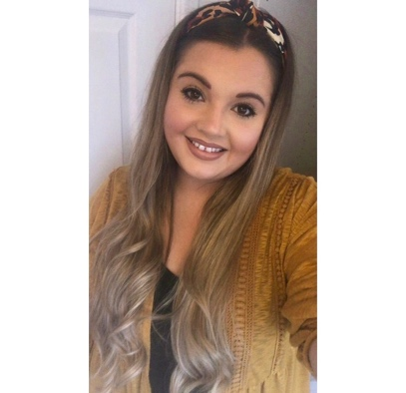
This is Miss Jackson. She will be teaching year 3 & 4 in September. Miss Jackson leads Science in school. She loves listening to music and binge watching t.v series.

This is Mrs Humble. Mrs Humble works in early years part time. She loves to shop and spend time with her family. She loves going on holidays.

This is Mr Allan. He is the Early Years leader and teaches Nursery and Reception. He is phonics lead, PE lead and EYFS lead.
He loves sport and especially football.
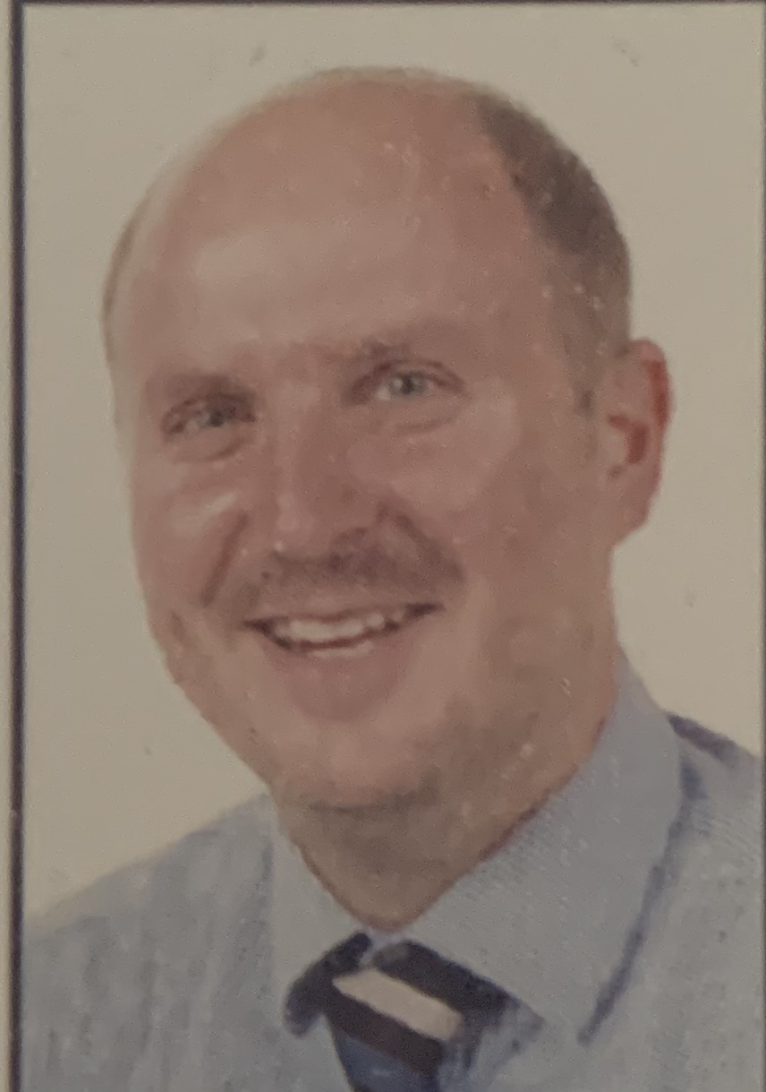

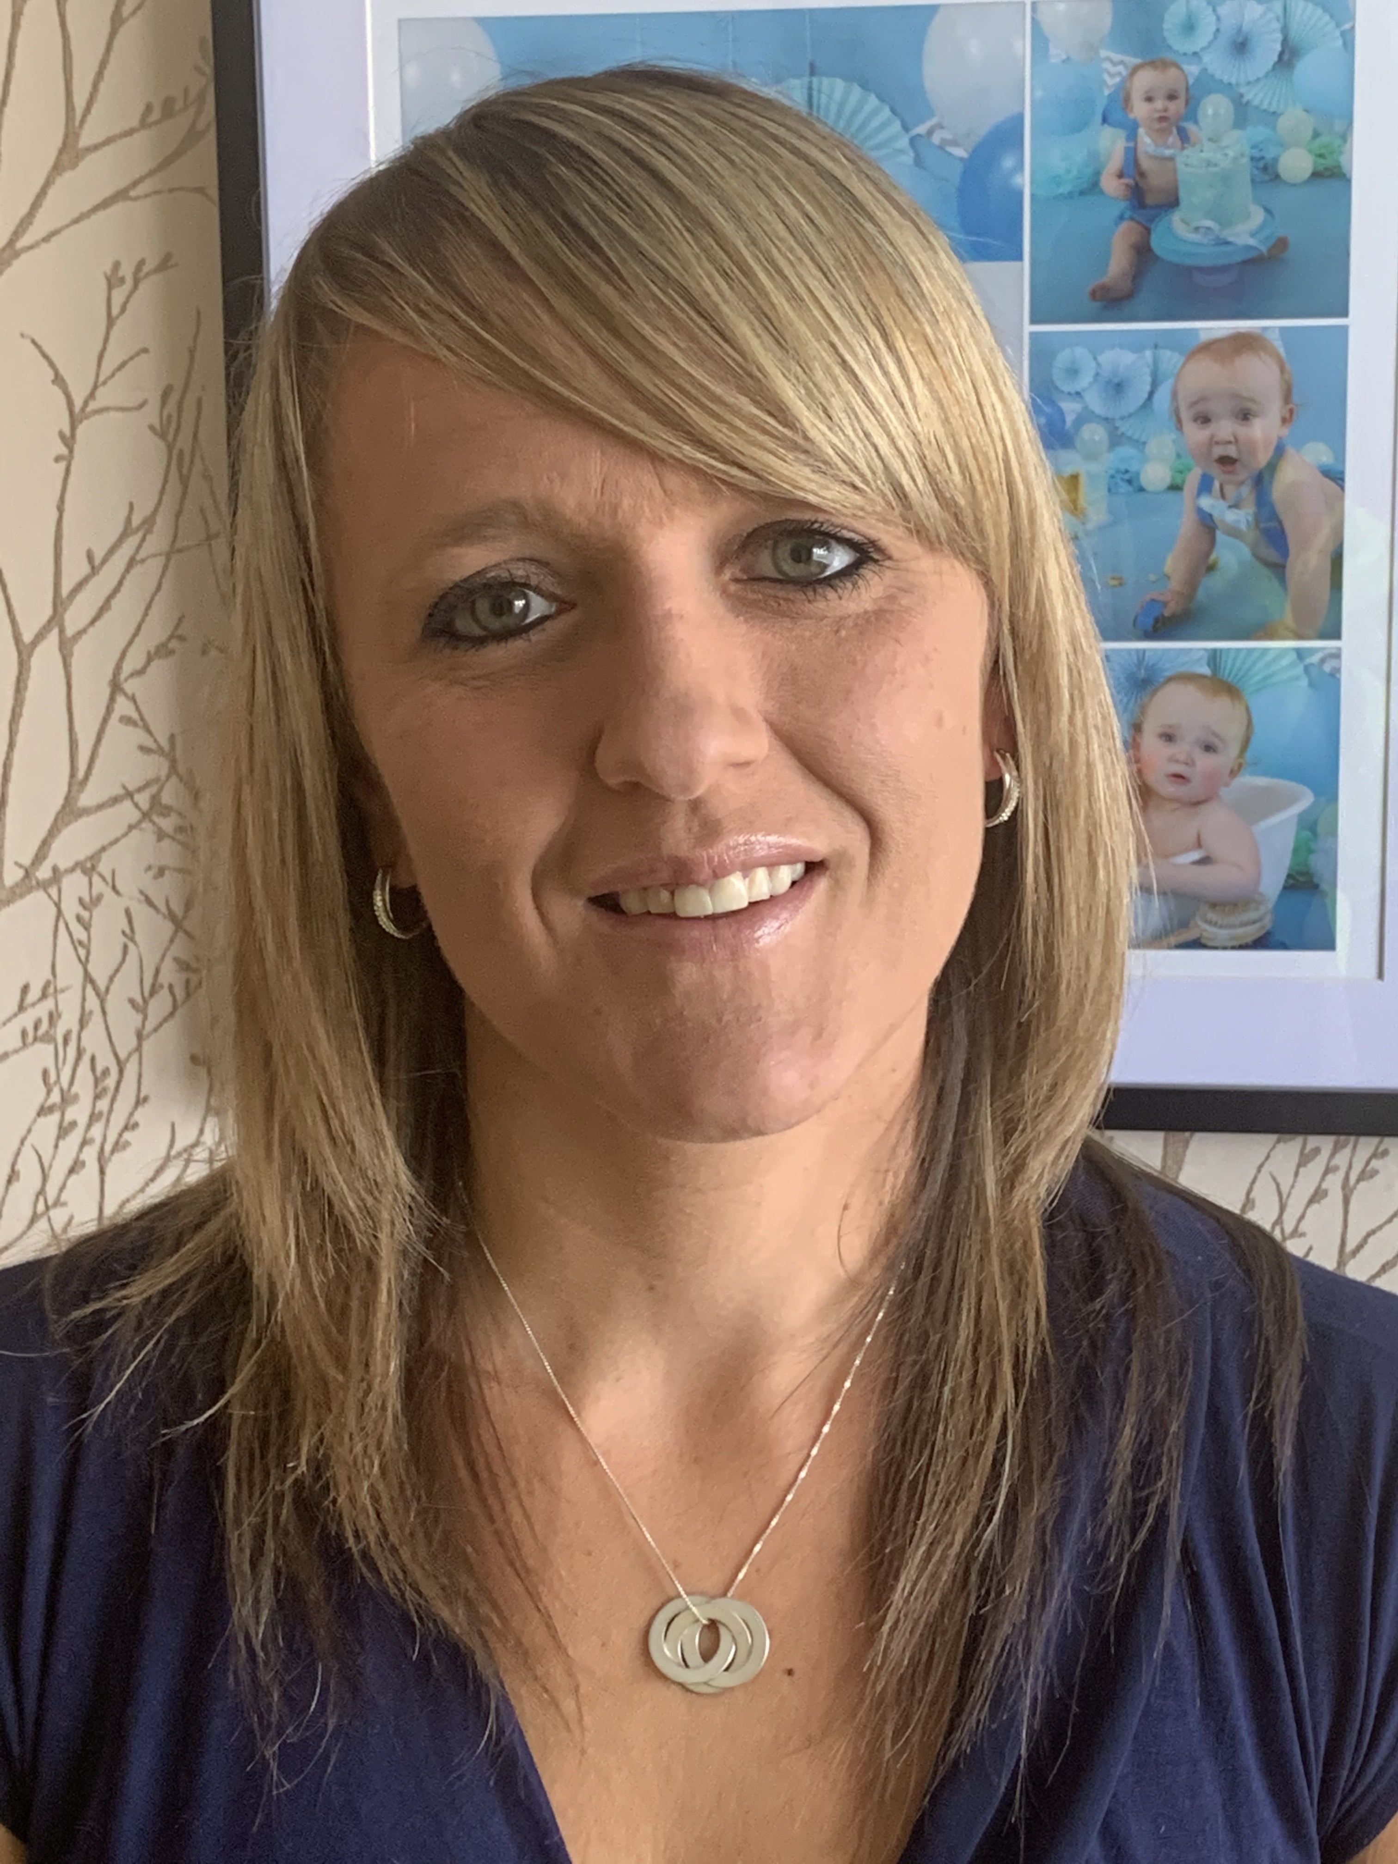
This is Mrs Darbyshire. In September she will teach the year 5 and 6 classes one day a week and cover some PPA in year 1 and 2. She is our Maths lead in school and Modern Foreign languages. She loves spending time with three children and enjoying family days out.

