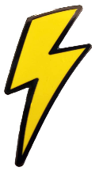
ELECTRICITY
KNOWLEDGE ORGANISER
Y4

Overview |  |  | Creation and Uses of Electricity
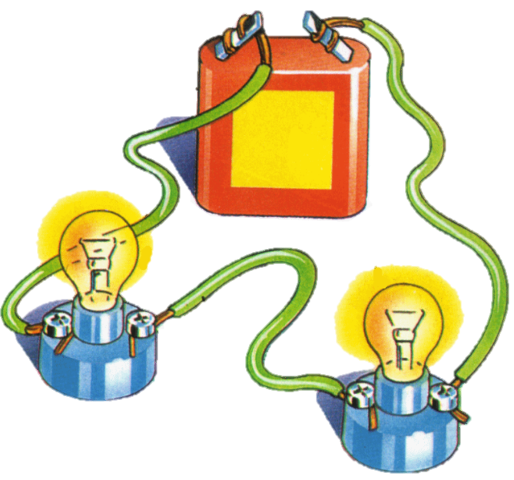  -Electricity is a type of energy.  -It is used to power lots of different things, including many items that we use in everyday life.  -Electricity can flow through wires and cables, and can be stored in batteries (sometimes called cells).  -Electricity can flow in simple series electrical circuits.  -Some materials conduct electricity, and others do not (insulators). |  |  |  | 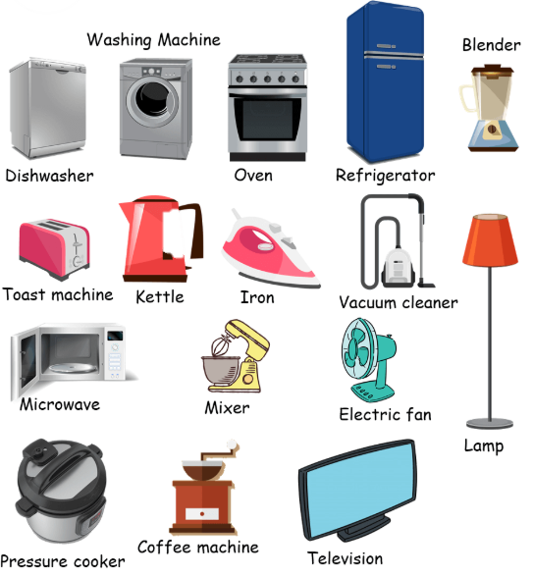 | Electricity can be created in a number of different ways, for example:  -Burning fossil fuels (oil, gas, etc.) in power stations;  -Using solar power generated from the sun;  -Using wind power from wind turbines;  -Using water power (hydropower).  Electricity is used to power numerous household appliances, for example laptops, TVs, fridges, microwaves, toasters, ovens and lights/ lamps. Life would be very different without it!
Simple Series Electric Circuits |  |  | Electrical Safety
This diagram shows a battery with wires connecting it to a battery (or cell).  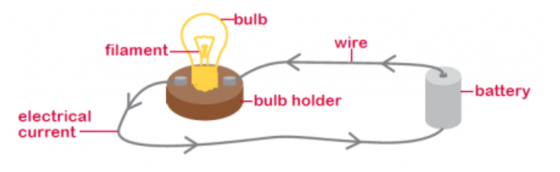 |  |  | 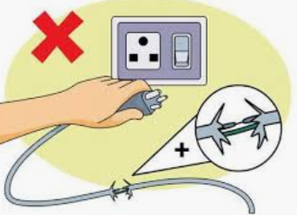  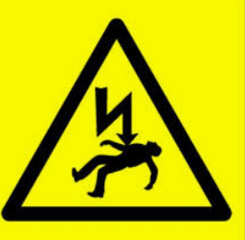  Electricity can be extremely dangerous if it is not used safely. It can cause burns, shocks, serious injury and (in extreme cases) even death.  There are many electrical dangers, both in the home and outdoors.  Some Important Electrical Safety Trips  -Do not put fingers and other objects in an outlet;  -Never use anything with a cord or plug around water;  -Keep metal objects away from toasters;  -Stay away from power stations and power lines;  -Never pull a plug out by its cord;  -Never touch or climb trees near power lines;  -Go indoors when there is thunder and lightning.  -Look out for signs like the one on the left.
Circuit  Current  Battery (Cell)  Wire/Cable  Conductor/Insulator | -A circuit is the path the electric current follows. It must have no breaks in it (a closed circuit) for electricity to flow.  -A current is the electricity flowing through the circuit.  -A battery (or cell) is something in which electricity can be stored.  -Wires and cables are thin flexible threads that transport electricity.  -Conductors allow electricity to flow through freely. Insulators do not allow electricity to flow through freely.
Insulators
Conductors
Dry Wood
Diamond
Oil
Glass
Rubber
Sea Water
Steel
Copper
Gold
Silver

