Focus Week  This ½ term’s focus week will be to learn about and understand the Islam religion. We will be learning about their beliefs and traditions, as well as looking at the Mosque as a religious building and its importance. It is really essential in today’s society that children truly understand this religion. | Physical Development  Every Thursday y5/6 will be taking part in two sessions with NUFC – one session classroom based and focusing on PSHE whilst the other session will be a physical education session. Y5 will continue going swimming every Wednesday this term so will need a swimming kit and £2 each week. Y5 will also be working with NUFC on a Friday afternoon. During these sessions Y6 will have interventions in preparation for the SATS. | Topic  Our topic for this term is Coasts. In this topic children will discover some of the ways in which the world is changing and understand what coastal erosion is and the affect it has. They will learn about the shape of the UK and how this has changed. They will be able to locate some of the UKs famous coastal areas as well as looking at our own coastline in Cambois and Blyth. See our medium term plan on the website for more details.
English  In English we will be reading the novel The Firework Maker’s Daughter by Phillip Pullman. During this novel we will be incorporating drama, different genres of writing (letters, persuasive texts, descriptive settings) before concluding in writing our own version of the well-known journey tale. | This is Me  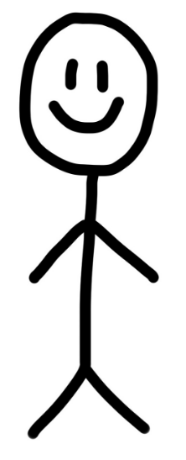 | Mathematics  Years 5 and 6 will be learning about Multiplication and division., ensuring we can use a written method for both and understand how to x and ÷ by 10, 100 and 1000. We will continue to use a variety of concrete, pictorial and abstract methods to ensure we get a deep understanding and ‘master’ this area. We will continue to link to reasoning and move to having a reasoning lesson each week to develop these very important skills.
Homework and reading  Reading folders should be brought into school daily. Each day we read for 10 mins and all children need their books for this.  They also receive maths / English homework on alternate weeks, which is due in on a Tuesday. | Science  We will be learning about the human body and in particular the circulatory system. We will look at how the heart works and how nutirents are transported around the human body. The children will then explore how a healthy lifestyle allows the body to function properly and the effects of different types of drugs and alcohol on the body. | PE kit  Year 5 and 6 will have PE on Thursday. Remember they’ll need: a plain white t shirt, blue/black shorts, sandshoes / trainers. Football kits and other clothing that re not school PE kit will not be seen as green for PE kit in progress files.
Important information  Mrs Darbyshire will have PPA on Thursday am whilst children have NUFC in. |  | Dates for the diary  17th Jan - Y5 only – Blyth Battery with Andy from BCHS
Supporting your child at home  Please remember to read with your child at home and sign their books twice a week at least. It is vital they are questioned about what they’ve read in order to improve their comprehension skills at this stage. |  | Follow us on Twitter and Facebook!    

