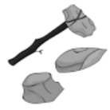
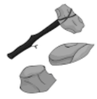
KNOWLEDGE ORGANISER
THE BRONZE AGE
Overview |  |  | Life in the Bronze Age
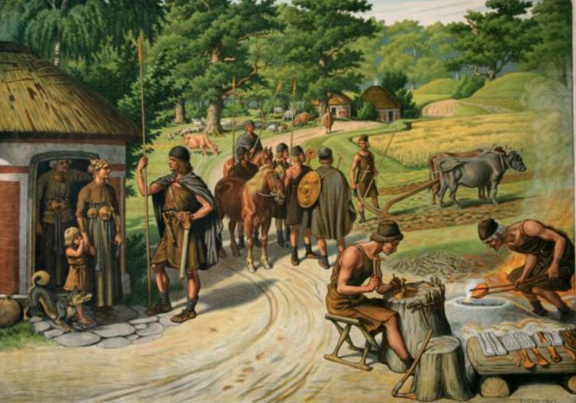  The Bronze Age  The Bronze Age is the name given to the time period when bronze replaced stone as the preferred material for making tools and weapons. This, along with other developments, helped to influence big changes in the ways that people lived.  The Bronze Age is the period of time between the Stone Age and the Iron Age. It is difficult to give an exact time period for when the Bronze Age occurred, as it bronze was discovered in different places at different times. However, most experts suggest that the Bronze Age started around 3300BCE and ended in most regions by 1200BCE. |  |  | Bronze | 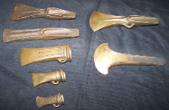 | Bronze was made by heating the metals tin and copper, and then mixing them together. They combined to form liquid bronze, which could be poured and moulded into different shapes. Bronze allowed for a greater range of tools and weapons. | Fact  Bronze is harder than both of the materials that it is made from.
 |  |  | Agriculture | 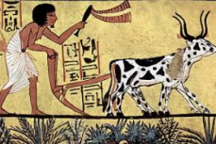 | Bronze age ploughs were more efficient than the earlier wooden ploughs, meaning that turning larger areas of soil was possible. Bronze axes were able to clear areas of forest more efficiently, meaning that larger areas could now be utilised for architecture. | Fact  Farming allowed for more people to live in area than could survive by hunter-gathering.
 |  |  | Trade | 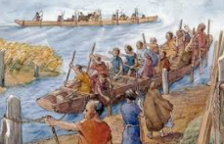 | Improved sailing skills and nautical understanding, along with better sailing equipment, meant that trade could take place over long distances. Early tracks and roads were able to support carts and wagons that were drawn by animals, such as horses. | Fact  Water systems, such as the Nile or Tigris, became busy trade highways.
 |  |  | Divided Society | 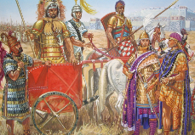 | Trade in bronze and other goods meant that some people in society became extremely wealthy and powerful. Over time, this led to a divided society, with kings and priests at the top, farmers and traders in the middle, and lowly slaves at the bottom. | Fact  Burial arrangements, and what people were buried with, were determined by the person’s wealth.
 |  |  | Empire Building | 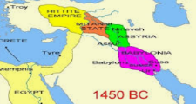 | A greater range of travel options (e.g. by chariot) and weapons (e.g. armour) allowed for raids and warfare of other settlements. In time, this led to empires being built. Many had an overriding king or emperor. | Fact  Amongst the largest were those in Egypt and the Indus Valley.
Bronze Age Civilisations
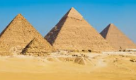  Ancient Egypt  The Ancient Egyptians are perhaps the most well-known of the Bronze Age civilisations. They settled around the Nile River (now Egypt) around 3100BCE right up until 332BCE. They built the pyramids that still exist today, and contributed a great deal to the fields of medicine, maths, and farming. They were also amongst the first to record information, using hieroglyphics drawn on paper made out of papyrus. | 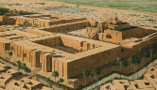  Mesopotamia  Mesopotamia is the region in which the rivers Tigris and Euphrates meet (mostly modern-day Iraq). Here, the Ancient Sumer civilisations lived – this was a number of city states which each had their own patron god/goddess and a ruling priest king. The Sumerians were around from before the Bronze Age (5300BCE) but survived right up until 1940BCE. They are credited with advancing writing, irrigation, laws and astronomy. |  | Bronze Age Britain | 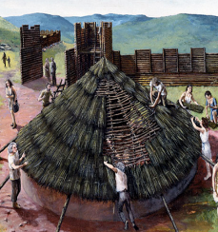 | The Bronze Age in Britain spanned from around 2500BCE until around 800BCE. One of the most common forms of Bronze Age housing in Britain was the roundhouse, which was built to a circular plan, and had walls posts built of wood or stone filled with ‘wattle’ and ‘daub.’ Spirituality grew in Britain at this time, with giant monuments (such as Stonehenge and Avery) being erected around this time. | Fact  Many historians believe that bronze was brought to Britain by the ‘Beaker People’ who travelled from Europe – so named as they drank from bell-shaped ‘beakers.’
 |  |  | Weaving | 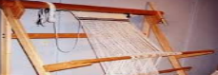 | People could now weave wool into cloth. There is evidence of looms from the era, and paintings from the time show people wearing more elaborate clothing. | Fact  Evidence of weaving is limited, as cloth perishes.
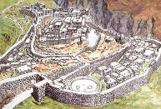  Mycenae  Mycenae was a Greek civilisation that was based around 75 miles south-west of modern day Athens. Mycenae is known for having a large palace complex, its trade with other civilisations and its pottery and jewellery. The period of Greek history between 1600BCE and 1100BCE is called Mycenaean because of the dominance of Mycenae. | 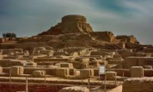  Indus Valley  The Indus Valley or ‘Harappa’ civilisation was the largest Bronze age civilisation, dating from 3300BCE to 1700BCE. There is still a lot for us to learn about these peoples, as they left behind few temples, palaces, or written works, and little evidence of their rulers or priests. We can see that they were very advanced, with streets built on a grid pattern and an effective sewer system.
 |  |  | Writing | 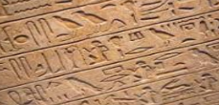 | Writing developed in many countries, meaning that important events and information and events could be recorded for the first time. This in turn led to the more structured establishment of laws. | Fact  Egyptian hieroglyphics used pictures to represent ideas in writing.
 |  |  | Law | 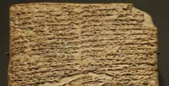 | As society developed from dispersed villages to larger, collective empires, laws were established in order to keep the peace. There is evidence of centralized governments overseeing the development of these laws. | Fact  There is some evidence of capital punishment used in some societies.
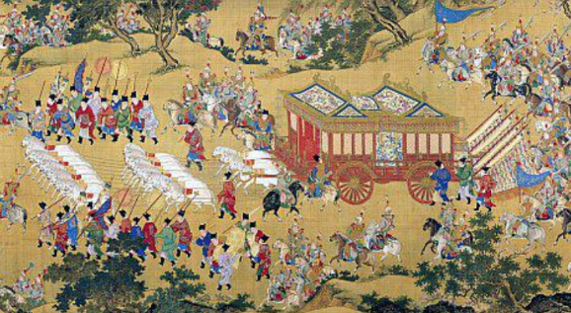  Shang Dynasty  The Shang Dynasty was the first Chines dynasty for which there is written and archaeological evidence. It appeared towards the end of the Bronze Age, between 1600BCE and 1046BCE, before it was succeeded by the Zhou Dynasty. It originally centred around the Yellow River in north-eastern China, however moved its capital several times over the years. The Dynasty had a number of master craftsman, which had made it famous for its bronze and jade work – many beautiful artefacts have been recovered from their tombs. They believed in a supreme god named Shang Di, and also in an afterlife. Their society was broken up into different social classes. |  |  | Roles/ Occupations | 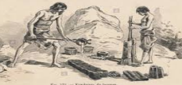 | Changes across society meant that there were now more refined jobs for different people to do. For example, some became skilled metal workers, whilst others would live their lives as tradespeople. | Fact  Exceptionally skilled metal workers were celebrated in their society.
 |  |  | Clothing and Fashion | 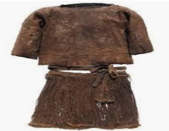 | During the Bronze Age, both men and women wore tunics – now deliberately weaved into shapes to cover their bodies. In many civilisations, people also began to wear hats, scarves, and leather shoes. As with many aspects of life, the clothes that a person wore depended a great deal upon their background and wealth. | Fact  Primitive razors meant that most Bronze age men in the UK were clean shaven. Most men and women had long hair.

Around 1200BCE – Bronze fades out as civilisations begin using iron predominantly.
1700BCE – Indus Valley era mysteriously ends.
1600BCE – The Mycenaean era begins in Greece.
1700BCE– The Shang Dynasty begins
3300BCE – The Bronze Age begins in Sumer.
3800BCE – Bronze is discovered in the Middle East.
3500 BCE – The first Ancient Egyptian cities appear.
3300BCE – The Indus Valley Civilisation begins.
2700BCE – The Sumerians begin writing.
1700BCE – The Nordic Bronze Age begins
2100BCE – The Bronze Age begins in Britain.
Bronze Age Timeline

