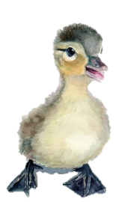
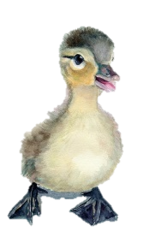
Y2
ANIMALS including Humans
KNOWLEDGE ORGANISER

What you should already know… |  |  | Reproduction
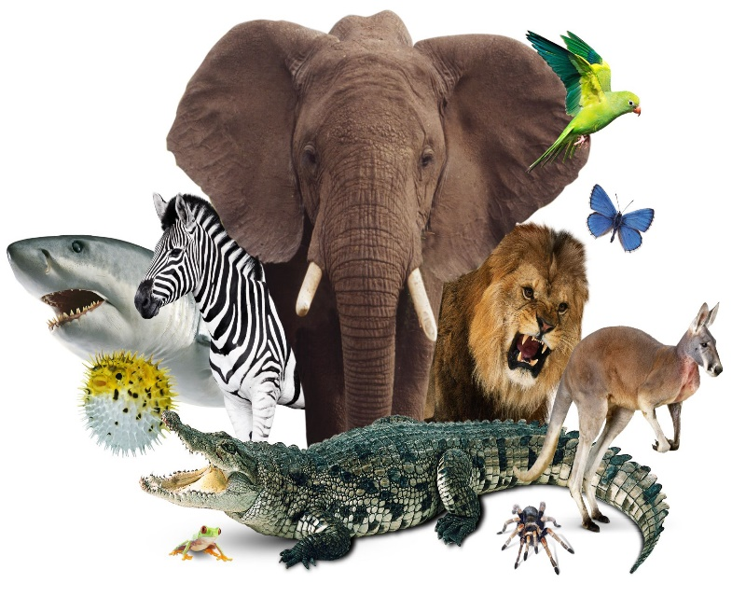  -Animals are living things which need food and water to live.  -Animals can be split into different groups – mammals, reptiles, birds, fish and amphibians. They have different structures to fit their needs.  -Some animals are carnivores (meat eaters), some are herbivores (eat plants) & some are omnivores (eat both).  -Animals use their senses to experience the world around them. |  |  |  | 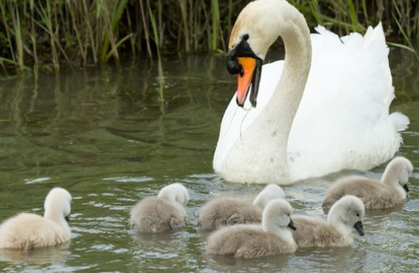  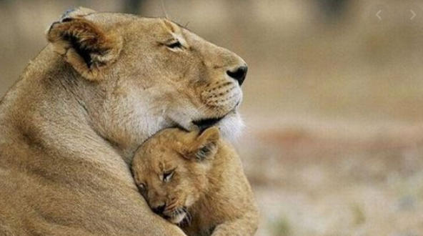 | -All animals reproduce. This means that they have offspring (e.g. humans have babies).  -For example, mammals give birth to live young, whilst fish lay eggs.  -All of these offspring must receive the basic needs of animals (below on the left) to grow into adults.  -When they are fully grown, they can also reproduce. And so, life goes on!
Basic Needs of Animals |  |  | Staying Healthy
Water  -Animals need water to make sure that they stay hydrated.  -Many animals drink water to survive. Other animals (e.g. fish) live in the water.  -Some animals get their oxygen from the water. Humans are made up of 70% water. |  |  | Exercise  -Humans (and many other animals) need to exercise. It builds our muscles and helps to pump blood around our body. Regular exercise makes us stronger and faster.  -Exercise also helps to keep our weight down. When we are too heavy and have too much fat, it is much harder to move, and puts a strain on our bodies.
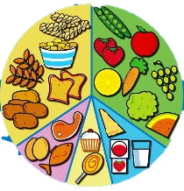
Eating a Balanced Diet

-It is also important that humans eat a balanced diet with all of the right nutrients – this helps us to grow bigger, stronger and healthier!

-Eating a balanced diet includes having fruit & vegetables, starchy foods such as breads and pastas, meats and fish (and other alternatives) and foods containing fats.

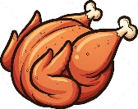  Food  -Animals use food to get the energy & nutrients that they need.  -Animals eat plants (herbivores), other animals (carnivores), or both (omnivores). | Shelter  -Shelter provides safety from weather/ predators and basic things that an animal needs to survive.  -Burrows, nests and dens are some examples.
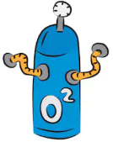  Oxygen  -All animals (including humans) need oxygen to live.  -Oxygen exists in the air, in the soil, and even in the water. Fish breathe oxygen through gills. | Temperature  -Sunlight and heat are vitally important to all animals. This gives animals the energy that they need.  Some animals need more heat than others. |  | 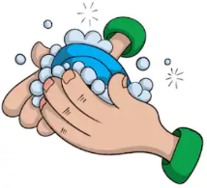  Hygiene  -It is important to be hygienic. This includes regularly washing our hair and bodies, washing hands before eating and brushing our teeth.  -Being hygienic stops the spread of germs, which can cause diseases.
Animal Life Stages
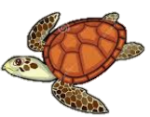
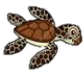
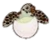
Reproduction
Growth
Death
Birth

