Personal, Social and Emotional Development  This half term our focus week will be centred around equality and acceptance of difference. We will look into the Paralympics message of ‘Yes we can’ whilst also linking to bullying and in particular cyber bullying and staying safe on the internet. | Physical Development  Once each week we will be having a yoga lesson with Debbie to carry on from last year. We will also be practising our invasion games skills of defending and attacking as well as team work in Tag Rugby. | Topic  Our topic this term is Comparing People and Places. We will begin by looking at our local area and exploring this before comparing both physical and human aspects of the area to other area around the world. Medium term overview available on our class page on our school website.
Literacy  We will begin our literacy with a fiction writing unit. We will develop our skills in order to improve our language. We will be aiming to write our own story which we then create a digital film of. | This is Me  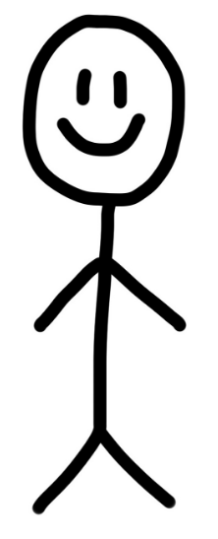 | Mathematics  We will use Maths Makes Sense to explore addition and subtraction written methods. In shape we will focus on 3D shape names and nets. Our reasoning will help us to explain our thinking.
Homework and reading  Reading folders should be brought into school daily.  The format of homework is changing this year; we will inform you of these changes in the coming weeks. | Science  We will be learning about electricity this half term and understanding circuits in order to create a Christmas decoration. | PE kit  Year 5 and 6 will have yoga on Monday and PE on Wednesday. Kits should be brought into school on the first day of term and we suggest you leave it until half term.  Remember they’ll need: a plain white t shirt, blue/black shorts, sandshoes / trainers.
Educational visits  You will be informed any visits. | Important information  Mrs Darbyshire will have PPA on Tuesday pm so will be out of the classroom. The children will have music first lesson then Andy Allman will continue transition activities with Mrs Rawlinson’s support. | Dates for the diary  30th Sept – ICT morning – creating digital stories  - Roald Dahl Day
Supporting your child at home  Please remember to read with your child at home and sign their books twice a week at least. It is vital they are questioned about what they’ve read in order to improve their comprehension skills at this stage. |  | Follow us on Twitter and Facebook!    

