Cambois Primary School Newsletter
October 2023

We are a school where learning is fun and everyone is welcome
Attendance  Please ensure children are in school for 8:30am to ensure they get the most out of their learning time.  After School Club & Childcare  A form will be sent out every Thursday for completion by you. This must be completed and filled in by Friday every week. You will no longer be able to ring up on the day and request a place for your child as we need to know numbers in advance. If money is not credited onto the account then unfortunately your child will not be able to stay in After School Club.  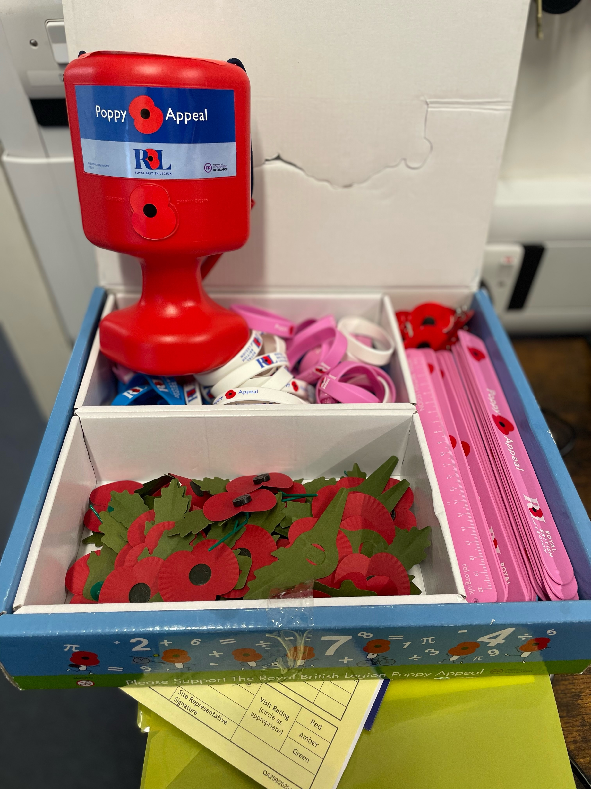  Poppy Appeal  We have Poppies to wear as a brooch, wristbands and snap band bracelets. These are available to purchase from the School Office.  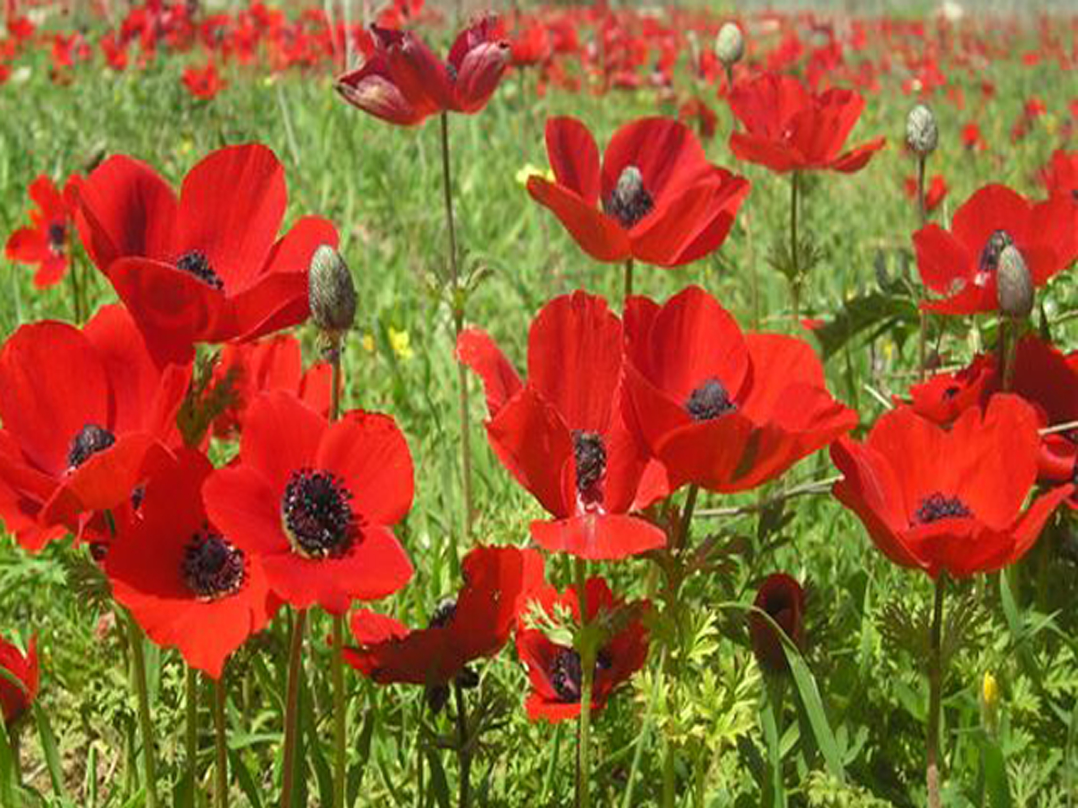  This Photo by Unknown Author is licensed under CC BY-SA |  | Whole school  School photo day is on the 20th November.  Reception-Year 6 are going on a cinema trip on the 10th November to see Lyle Lyle Crocodile.  Parents evening is on the 8th November 3-5:30pm

Key Information

Early Years
Early years have enjoyed their Balance bike lessons with Ian each Wednesday and their music sessions every Monday.

Children have been learning and retelling the story Mr Wiggle and Mr Waggle as well as the rhyme 5 Little Pumpkins.

PE sessions on Tuesdays and Fridays. Forest school on Friday.
Year 1&2
Children have been to Broxfield farm on the 26th and really enjoyed it.
They also watched Hocus Pocus on the 25th due to filling their first star of the jar of the year!
We have enjoyed attending beach school particularly finding and learning about the creatures in rock pools. Our DT project this term is Remarkable Recipes where we have looked at where food comes from, followed a recipe to make our own Eton mess and next week we'll be making our own healthy dessert which is Fruit Salad. Children have chosen which fruit they would like to include, and will prepare it from scratch, including peeling and chopping the fruit which they are looking forward to doing.
Year 3&4
Year 4 are taking part in the KATS project which is all about plastic pollution in the sea. They had a go at using GR headsets.
The class have also been learning about free verse poetry and writing their own poems. They have enjoyed writing and reading these for the rest of the class to hear.
Year 5&6
On Monday 23rd October, visitors from Durham Light Infantry museum will be visiting class to talk about personal stories from WW1 as well as the opportunity to handle some artefacts from the War.
On Thursday 26th October, Year5/6 will be watching the film War Horse in class as part of our topic study (after we have completed reading the novel). A permission form will be sent out for this as this film is rated PG-13.
On Monday 6th November scientists from the Centre for Life will be visiting Y5/6 with a planetarium.
Y5/6 will be following this up with visit to the Centre for Life for a full-day “Space Explorers” workshop on Thursday 16th November.

Awareness

To help raise awareness of the signs and symptoms of type 1 diabetes in children and adults, and the importance of spotting symptoms early to prevent diabetic ketoacidosis (DKA) which can be life threatening, and we want to reduce this risk as much as possible.

Private Scooters can only be used on Private Land
We are aware children will be writing Christmas lists soon and with these images from Northumbria Police, we hope it can help parents make an informed choice.

PTA

17th Oct - costume swap bring in old costumes and exchange 3-4pm
25th Oct - Halloween disco 3-4pm
26th Oct - Scary Hair or outfit or both all day
30th Oct - Halloween trail 5-8pm
6th Nov - colour without the bang (glow in the dark party) 3-4pm
