Communication & Language  Children will be taught the rules of listening – sit still, look at the person speaking, think about the words and wait for your turn to speak. They will practice their listening skills by playing fun games.  Children will have opportunities to respond with questions, comments and actions in whole class discussions and in their play  Speaking  Children will have opportunities to take part in whole class and group discussions and be given time to explain why things happen/ might happen.  Children will be taught vocabulary from stories, non-fiction, rhyme and poems and encouraged to use these in a variety of contexts.  Children will be given opportunities to express their ideas and feelings throughout the day. | Physical Development  Fine motor  Children will be learning to use one-handled tools such as scissors, pencils, paintbrushes and cutlery. Children will take part in a range of activities to refine their fine motor skills.  Gross Motor  Children will have PE and dance sessions weekly as well as daily opportunities to revise and refine the fundamental movement skills they have already acquired: rolling, crawling, walking, jumping, running, hopping, skipping, climbing.  Children will complete a series of sessions to improve their skills when using balance bikes.  Children will develop their throwing, catching, kicking and aiming skills using a range of different equipment. | Personal, Social & Emotional development  Jigsaw unit – Relationships  Children will be introduced to the key relationships in their lives. They will learn about families and the different roles people can have in a family. They explore the friendships they have and what makes a good friend. They are introduced to simple strategies they can use to mend friendships. The children also learn about Jigsaw’s Calm Me and how they can use this when feeling upset or angry. Children will continue to take part in ‘tapping’ to support relaxation. https://www.youtube.com/watch?v=x7jqP8E6Xn8
Literacy  Children will be learning new stories and have opportunities to retell known stories and innovate stories.  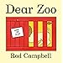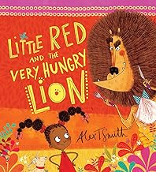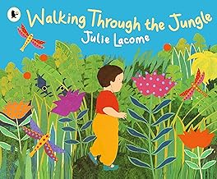  They will take part in conversations about the characters, settings and events in stories and learn new vocabulary. Theu will use pictures to sequence familiar stories.  Children will listen to and be encouraged to join in with a range of nursery rhymes, poems and songs.  Children will be taught to identify print in the environment and to recognise their name. They will be encouraged to tell their own stories.  Children will be encouraged to give meaning to the marks they make and to write their name. Many children in reception will be taught to write captions and sentences | Summer 2024  Theme: Animal Safari & Creep, Crawl & Wriggle  We are a school where learning is fun and everyone is welcome.' The vision for our school is; 'We have high expectations in all that we do to create lifelong learners with high aspirations. Leaders of tomorrow.'  Our ethos and values are about having a 'can do' attitude and aiming high. We have high expectations in all aspects of school and we encourage our children to take risks and aim high. We promote resilience and persistent as essential tools for success. We teach children to have a growth mindset - you can't do it...yet! | Maths – Children will learn  To sing number rhymes and say number names in order to 10.  To subitise arrangements to 5. To count sets of objects. To recognise numerals.  To sort and describe a range of objects.  To copy extend and make repeating patterns.  To use shapes to make pictures and patterns.  In addition Reception aged children will learn to  .To count on and back from numbers to 20  To recognise and name numerals to 20 and beyond.  To represent and compare and understand composition of numbers beyond 10  Stories will be used to support learning in maths.  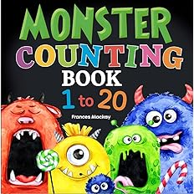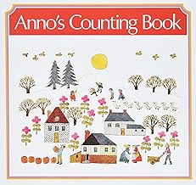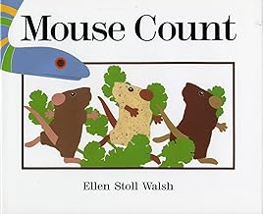
KUW  Children will learn about incredible animals that live worldwide. They will explore various animal habitats and compare the animals that live there with animals in their locality. They will learn how to care for pets and what all animals need to grow, survive and stay happy and healthy. They will explore animal features and find out how they survive in the wild. They will compare the ways that animals are similar and different.  Children will learn about minibeasts. They will observe minibeasts in their natural habitats and create shelters for them to live in. They will learn about the life cycle of a butterfly and explore what minibeasts, such as snails and worms, need to survive. They will compare the features of minibeasts and learn the names of their body parts.  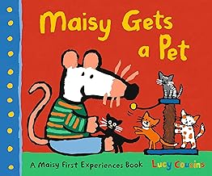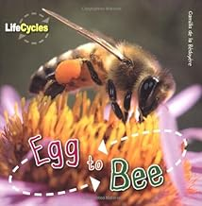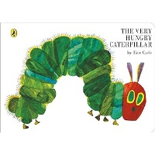  RE  This unit of learning is thematic, focusing on Christianity, Hindu Dharma and Islam. Within this unit, the children will reflect upon the things that are special to them and why they value these things. The children will learn about key religious symbols for Christians, Muslims and Hindus. They will find out about why many Christians believe that children are special to God and learn about the story of Jesus and the children. The children will also find out about the welcoming ceremonies that many Muslims and Christians have for a new baby. The children will learn out about how Hindu brothers and sisters might show their love and respect for each other at Raksha Bandhan.  . | Phonics-  Children will join in with familiar nursery rhymes. Children will develop phonological awareness by discriminating sounds - environmental, instrumental and body percussion. They will tap out syllables in words and take part in activities to support them being able to identify rhyme.  In addition Reception aged children will learn  To read single-letter Set 1 sounds and ‘special friends sh ch th qu ng nk. When confident they will learn set 2 special friends ay ee igh ow oo  To blend sounds into words to read them.  Parents – How to say the sounds (click on link)  https://schools.ruthmiskin.com/training/view/tzgrE0pK/nY5ZSo47 | EAD  Children will have the opportunity to create individually and collaboratively, share ideas and use a variety of resources to make products inspired by existing products, stories or their own ideas, interests or experiences.  Children will have opportunity to discuss similarities and differences in their own and others' work, linked to visual elements, such as colour, scale, subject matter, composition and type.  A specialist music teacher will be coming in to lead a music session each Monday morning.  Charanga Song – Big Bear Funk  Children will be  Listening and appraising Funk music  Learning to sing Big Bear Funk and revisiting other nursery rhymes and action songs.  Playing instruments within the song.  Improvise using voices and instruments  Share and perform the learning that has taken place

We will ensure that all children learn and develop well and are kept healthy and safe at ALL times.  Children develop at different rates - we must be aware of children who need greater support than others | Characteristics of Effective Learning  Playing and exploring: - Children investigate and experience things, and ‘have a go’. Children who actively participate in their own play develop a larger store of information and experiences to draw on which positively supports their learning  Active learning: - Children concentrate and keep on trying if they encounter difficulties. They are proud of their own achievements. For children to develop into self-regulating, lifelong learners they are required to take ownership, accept challenges and learn persistence. Creating and thinking critically: - Children develop their own ideas and make links between these ideas. They think flexibly and rationally, drawing on previous experiences which help them to solve problems and reach conclusions.
We understand that children learn best when they are absorbed, interested and active. We understand that active learning involves other children, adults, objects, ideas, stimuli and events that aim to engage and involve children for sustained periods. We believe that Early Years education should be as practical as possible and therefore, we are proud that our EYFS setting has an underlying ethos of Learning through play. PLAY is essential for children’s development across all areas. Play builds on children’s confidence as they learn to explore, to relate to others around them and develop relationships, set their own goals and solve problems. Children learn by leading their own play and by taking part in play which is guided by adults.
As an EYFS team we will provide high quality interactions to develop and deepen the children’s learning opportunities. We will deliver our curriculum through a balance of adult led and child- Initiated activities based on the EYFS Framework 21’ & our children’s needs, experiences and interests.
Playing and exploring | Active learning | Creating and thinking critically
- I can recognise that my actions have an effect on the world, so I like to repeat them.  - I can make choices and explore different resources and materials.  - I can plan and think ahead about how I will explore or play with objects.  - I can guide my own thinking and actions by talking to myself as I play.  - I can make independent choices.  - I can bring my own interests and fascinations into early years settings.  - I can respond to new experiences when they are brought to my attention. | - I can begin to predict sequences because I know routines.  - I can participate in routines.  - I can show goal-directed behaviour.  - I can keep on trying when things are difficult. - I can begin to correct my mistakes. | - I can take part in simple pretend play.  - I can sort materials.  - I can review my progress to achieve a goal.  - I can solve real problems.  - I can use pretend play to understand another perspective.  - I feel confident coming up with my own ideas.  – I can make more links between my ideas.  - I can concentrate on achieving something that is important to me.  - I can give my attention to tasks and ignore distractions with increasing control.

