Focus Week  This ½ term’s focus week will be bullying to link in with National Anti- bullying week. We will focus on what bullying is, the various different types of bullying, how it feels to be a victim of bullying and what to do if you are being bullied. | Physical Development  Every Tuesday we will have rugby with a coach from the Cramlington Rockets. This was excellent last year and all of our children enjoyed this. They will need outdoor kit and trainers.  We will also be going swimming every Wednesday this term so we will need a swimming kit and £2 each week. | Topic  Our topic this term is Rainforests. This links in with our English and Science curriculum. We will be finding out about the rainforests in the world and where they are, the problems they face, the animals who live there and why they are so important for us even though we do not live near them. We will be linking in art, computing, d&t, music, geography and history. See our medium term plan on the website for more details.
Literacy  In Talk For Writing we are focusing on adventure stories this half term, in particular those with a survival theme. We will be reading the fantastic novel of Kensuke’s Kingdom by Michael Morpurgo and comparing this to other survival stories in order to magpie their techniques and create our own survival story. | This is Me  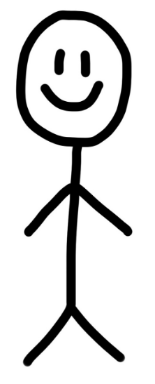 | Mathematics  Years 5 and 6 will begin the year with a strong focus on Place Value as a good understanding of this is vital for all areas of mathematics. We will be continuing with our mastery approach and will therefore be looking at using concrete resources as well as pictorial representations before moving onto the abstract so that we have a deep understanding. We will also be looking at Roman numerals.
Homework and reading  Reading folders should be brought into school daily. Each day we read for 10 mins and all children need their books for this.  The format of homework will remain as an optional format in order to receive praise points. | Science  We will be learning about animals and their habitats. We will begin by looking at plants and how they reproduce before moving onto the life processes of humans and animals. We will be learning about life cycles and habitats which links into our rainforest topic. | PE kit  Year 5 and 6 will have PE on Tuesday. Kits should be brought into school on the first day of term and we suggest you leave it until half term.  Remember they’ll need: a plain white t shirt, blue/black shorts, sandshoes / trainers. Football kits and other clothing that re not school PE kit will not be seen as green for PE kit in progress files.
Educational visits  October 19th – Y5/6 biking (full day) | Important information  Mrs Darbyshire will have PPA on Wednesday pm. The children will be going swimming at this time with Mrs Campbell and Miss Ireland. | Dates for the diary
Supporting your child at home  Please remember to read with your child at home and sign their books twice a week at least. It is vital they are questioned about what they’ve read in order to improve their comprehension skills at this stage. |  | Follow us on Twitter and Facebook!    

