PROPERTIES AND CHANGES OF MATERIALS
KNOWLEDGE ORGANISER
Y5
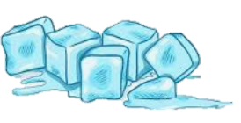
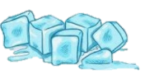

What you should already know… |  |  |  |  | Solutions and Separation
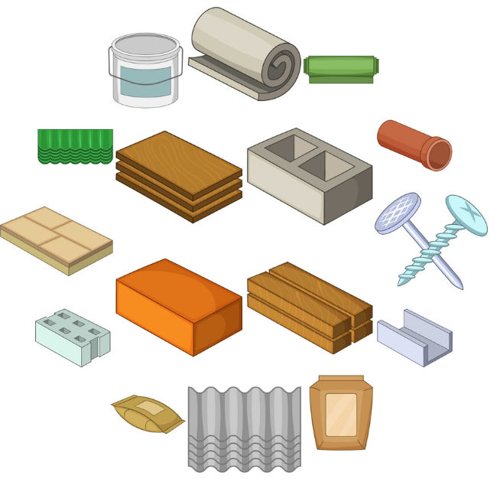  -Materials are the substances that things are made from.  -The properties of materials make them useful for different purposes.  -Materials have more than one property and can be natural or man-made. Properties can include the hardness, whether it conducts electricity, the shininess, or whether it is magnetic.  -There are three main states of matter – solids, liquids, and gases.  -The state of matter of materials can change, through processes such as freezing and melting. |  |  |  |  | A solution is a specific type of mixture where one substance is dissolved into another.
-A solvent is a substance that dissolves a solid, liquid, or gaseous solute.
-A solute is the substance dissolved in the solvent. When it dissolves, it looks as though it has disappeared, but in fact it has been broken down to become a part of the liquid.
-One example of a solution is salt water. You cannot see the salt, and the solution will remain if left alone.
-Some mixtures and solutions can be separated, e.g. through processes such as sieving, filtering & evaporating. Salt and water can be separated by evaporation.

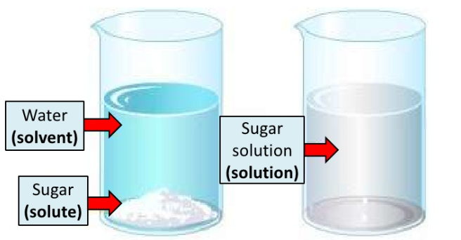
Grouping Materials by Properties |  |  |  |  | Reversible and Irreversible Changes
PROPERTY |  | YES | NO |  | REVERSIBLE CHANGES  -There are many ways in which materials can be changed, for example through heating, cooling, or mixing with other substances.  -Some changes can be reversed (e.g. the material can be returned to its previous form). These are known as reversible changes. An example of this is the freezing of water into ice – it can be melted to become water again.  -Other changes are irreversible. This means that that the changes cannot be ‘undone.’ Examples of this include cooking, baking, frying and burning materials. For example, you can fry a raw egg to cook it. You can’t return it back to a raw egg again.  - Changes that involve the formation of new materials (e.g. mixing cement) are not normally reversible.  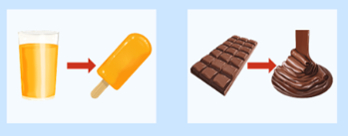  IRREVERSIBLE CHANGES  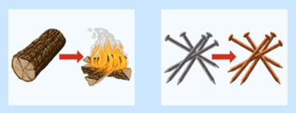
ELECTRICAL CONDUCTOR |  | Copper, aluminum, gold, silver, steel, sea water | Glass, air, plastic, rubber, wood, oil, diamond
MAGNETIC |  | Steel, nickel, cobalt, iron, uranium, platinum | Paper, glass, plastic, rubber, wood, wool
TRANSPARENT |  | Glass, water, clear plastic | Wood, rubber, oil, steel, copper, iron, silver
WATERPROOF |  | Plastic, rubber, metal, glass | Tissue, sponge, fabric

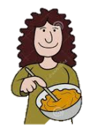
Rusting
Changes of State
Decaying
Burning
Mixing
Irreversible Changes
Reversible Changes
Dissolving

