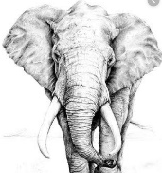
LIVING THINGS and their habitats
KNOWLEDGE ORGANISER
Y5

What you should already know… |  |  |  |  |  | Naturalists and Animal Behaviourists
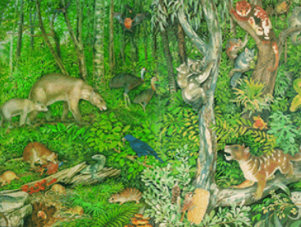  -There are seven common features of living things – Movement, Respiration, Sensitivity, Growth, Reproduction, Excretion & Nutrition.  -Animals can be grouped into vertebrates (have backbone) and invertebrates (have no backbone). They can be grouped into further categories, e.g. mammals, reptiles, birds, etc.  -Plants can also be categorised in many different ways, e.g. flowering and non-flowering plants.  -Animals are often adapted to the habitats they live in. Both natural and man-made events can change habitats over time, placing animals in danger. |  |  |  |  |  | Naturalists  A natural scientist, or naturalist, studies animals and plants by observation, rather than by experimenting.  One example of a naturalist is Sir David Attenborough, who is known for presenting information and findings about animals through innovative and engaging television programmes.  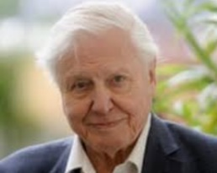  Other naturalists include:  -Charles Darwin  -Alfred Russel Wallace  -Steve Irwin | Animal Behaviourists  Animals behaviourists make scientific studies of everything that animals do, from observations to experimentation.  One example of an animal behaviourist is Dr Jane Goodall, who is best known for her 55-year study of the behaviour of chimpanzees. She is the founder of a conservation institute.  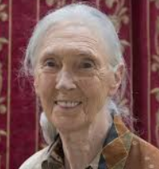  Others include:  -Karl von Frisch  -Konrad Lorenz  -Nikolaas Tinbergen.
Animal Life Cycles |  |  |  |  |  | Plant Life Cycles
A life cycle is the series of changes that an animal goes through in its life, including reproduction. |  |  |  |  |  | Plants are able to reproduce in two ways – sexual reproduction and asexual reproduction.  Sexual reproduction in plants is cyclical, following this process:  1.Germination -The plant begins to grow from a seed. Roots form under the soil and a stem, leaves and flower shoots above the surface.  2.Pollination – Pollen produced by the flower is carried by insects or blown by the wind to another flower.  3.Fertilisation – The pollen reaches another flower and makes its way to the ovary, where it is fertilised.  4.Dispersal – The seeds are scattered by animals or the wind.  Asexual reproduction involves plants producing an identical copy of themselves.  This can happen in a number of different ways. Some plants are able to produce bulbs (e.g. daffodils and snowdrops). Others, like potatoes produce tubers. Tubers lie below the soil, and grow into plants the next year.  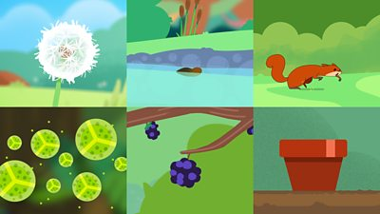
Mammals  -Mammals have a 3-stage life cycle:  -Stage 1: The gestation period - the embryo grows inside the mother & is dependent on her.  -Stage 2: The young mammal grows and develops independence.  -Stage 3: Adult mates in order to reproduce.  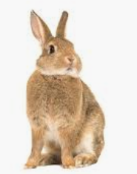 |  | Amphibians  -Many amphibians have a 5-stage life cycle:  -Stage 1: Female lays eggs, fertilized by the male.  -Stage 2:Tadpole breathes in water through gills.  -Stage 3: Grows fins and develops lungs.  -Stage 4: Tadpole grows front legs. Jumps from water onto land.  -Stage 5: Starts to eat insects/plants. Takes 2-4 years to become adult. | Insects  -Most insects undergo metamorphosis and have a life cycle of 4 stages:  -Stage 1: Eggs laid by female insect.  -Stage 2: Eggs hatch into larva, e.g. caterpillars, maggots, grubs.  -Stage 4: The pupa (hard coating) is formed. Inside this, the larva transforms.  -Stage 5: The adult breaks out of the pupa and matures. | Birds  -Birds have a 3-stage life cycle:  -Stage 1: Eggs laid by the mother. Parents care for the egg until hatching.  -Stage 2: Mother and father feed the bird until it is independent.  -Stage 3: Adult mates in order to reproduce.  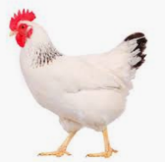
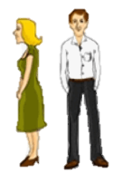
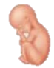
Childhood
Embryo
Adulthood – can reproduce
Baby
Embryo
Human Life Cycle

