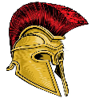
KNOWLEDGE ORGANISER
ANCIENT GREECE
Diagram – Map of Ancient Greece |  |  | Places, People, and Daily Life in Ancient Greece
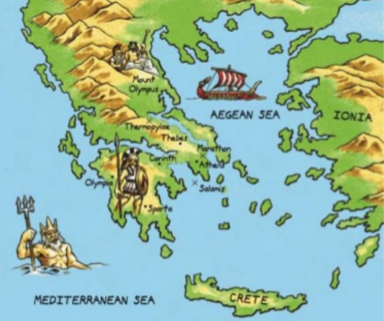  Map of Ancient Greece  Greece’s position next to the sea (there are over 1400 islands) meant Ancient Greeks were a seafaring people. Trade between the islands led to the creation of ‘city-states’ (polis). Each city-state was ruled by a powerful city, led by a ruler or (later) government. Greece is a warm country, but winds from the Mediterranean, and rains from the north, kept temperatures livable and created fertile farming conditions. |  |  | The Acropolis | 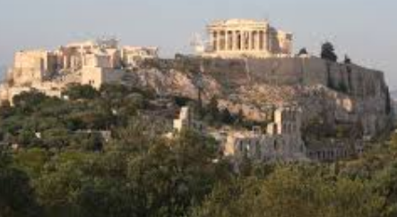 | The Acropolis of Athens is the best known acropolis in Greece – an acropolis is a settlement built on high ground. It was built during the rules of Pericles, a golden age for Athens, as a monument to the city’s greatness. | Where?  Athens | Key Fact:  The Acropolis is on a flat-topped rock that rises 150m above sea level
 |  |  | The Parthenon | 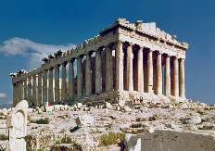 | The Parthenon is a temple in the middle of the Acropolis in Athens. It was a temple to Athena, the goddess of wisdom, and originally had a statue to her. It has now stood for nearly 2,500 years, a superb architectural achievement! | Where?  Athens | Key Fact:  The building used 22,000 tonnes of marble!
 |  |  | Mount Olympus | 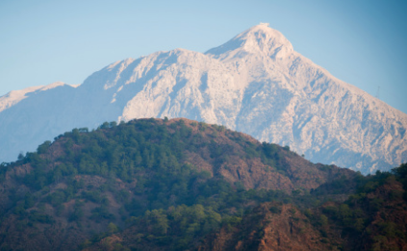 | Mount Olympus is the highest mountain in Greece. It was believed in Ancient Greek times that when things needed to be decided in the mystical world, the 12 main Gods would gather at Mount Olympus, and that many lived there. | Where?  50 miles southwest of Thessaloniki | Key Fact:  Mount Olympus rises to 2,918m
 |  |  | Knossos Palace | 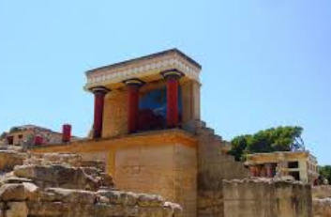 | Knossos Palace is positioned in what was the capital of Minoan Crete. It is the site of a beautiful and expansive palace, which is supposed to be the same location as the fabled labyrinth in which the minotaur dwells! | Where?  Northern Crete | Key Fact:  The Knossos Palace was rumoured to originally hold 5000 rooms!
 |  |  | Socrates | 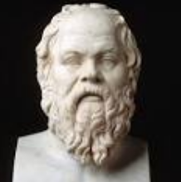 | Socrates was a famous philosopher, who taught others to question things. This led to his downfall, as he questioned the Gods and was arrested for influencing the young. | When?  Socrates was born around 470BC | Key Fact:  Socrates died when he drank poison in prison.
Ancient Greek Gods
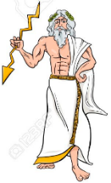  Zeus  Zeus was the king of the Greek gods, who lived on the Mount Olympus. He was also the god of the sky and the god of thunder. He was married to the goddess Hera and his symbol was the lightning bolt. Zeus was believed to be able to control the weather, creating huge storms. It was thought that he could change people into animals as punishment. His two brothers were Hades and Poseidon. | 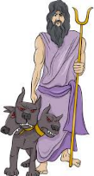  Hades  Hades (brother of Zeus and Poseidon) was the God of the Underworld. He was normally depicted as having a pitchfork and his three-headed dog, Cerberus. He rode a chariot pulled by black horses. The Underworld was where dead people went in Greek Mythology. Hades originally wasn’t happy about this, until Zeus reminded him that it meant that all people would eventually be his subjects! |  | Plato | 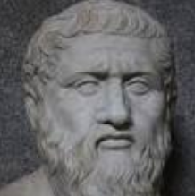 | Plato, a philosopher, was a student of Socrates. After Socrates’ death, Plato founded the first university, called the Academy. He believed a philosopher’s job was to seek the truth. | When?  Plato was born around 428BC | Key Fact:  Plato was one of the first to argue that women should receive the same education as men.
 |  |  | Aristotle | 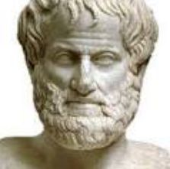 | Aristotle was a philosopher and scientist. At the age of 17, he travelled to Athens to attend Plato’s university. He began to dissect animals to learn more about their anatomy. | When?  Aristotle was born around 384BC | Key Fact:  Aristotle was the private tutor of Alexander the Great!
 |  |  | Alexander the Great | 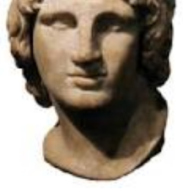 | Alexander the Great gained a strong and united Greece when he became King. He used his military genius to then win battle after battle, conquering eastern Europe and Egypt. | When?  356-323BC | Key Fact:  He died aged only 32. He accomplished a lot in his short life!
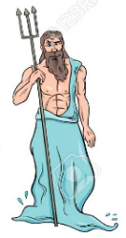  Poseidon  Poseidon (brother of Zeus and Hades) was the God of the sea, earthquakes, and horses. Along with his brothers, he was one of the three most powerful gods. As god of the ocean, he was especially important to sailors and fisherman. He was usually pictured with a trident, curly hair, and a beard. It was thought that Poseidon could create sea storms to ruin ships, or clear weather to help them along. | 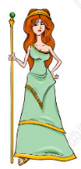  Hera  As the wife of Zeus, Hera was considered as the queen of Mount Olympus. She was most often considered to be the goddess of women, marriage and childbirth. She was normally pictured wearing long flowing robes and a crown, and holding a scepter. The women of ancient Greece prayed to Hera during childbirth, and to aid them through their marriages. As wife of Zeus, she also had power over the skies.
 |  |  | Greek Homes | 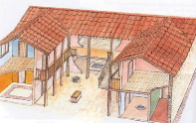 | Ancient Greek homes were built around a courtyard, which was the centre of activity. Around the courtyard were the rooms of the house, including work rooms and bedrooms. | How?  Homes were made of sun-dried bricks. | Key Fact:  Most houses had an ‘andron’ – a room just for men.
 |  |  | Childhood | 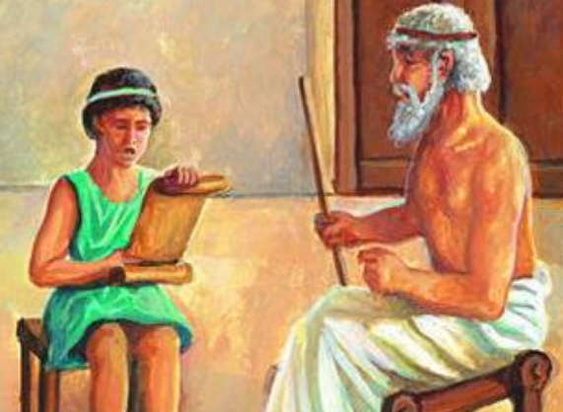 | When a child was born, a father could decide whether to keep or abandon the child. At age seven, the child could start school, learning maths, reading, and writing. | How?  Sometimes, children also studied music. | Key Fact:  Children were considered adults at only 13!
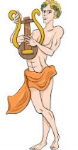  Apollo  Apollo was the Greek God of music, poetry, light, prophecy and medicine. He was often pictured as a handsome athletic youth with curly hair. Items associated with him are his bow and arrow and his lyre. It was believed that he could see into the future, and heal people. As a punishment, he could bring people illness and disease. | Aphrodite  Aphrodite was the Greek God of love and beauty. She was famous for being the most beauiful of all of the Goddesses. She was often shown as being a beautiful young woman with an apple, scallop shell, dove or swan. It was said that Aphrodite had a belt, which made people fall in love with the wearer. Fighting couples would look to Aphrodite to help them fall in love again. |  | Food | 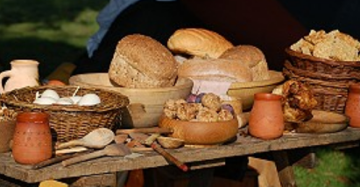 | The Ancient Greeks mostly ate bread dipped in wine, cheeses, fish, olives, and vegetables. Meat was eaten on rare occasions, such as festivals. Watered down wine was the main drink. | How?  Foods/wines were traded between cities. | Key Fact:  Many food festivals were for men only!
 |  |  | Clothes | 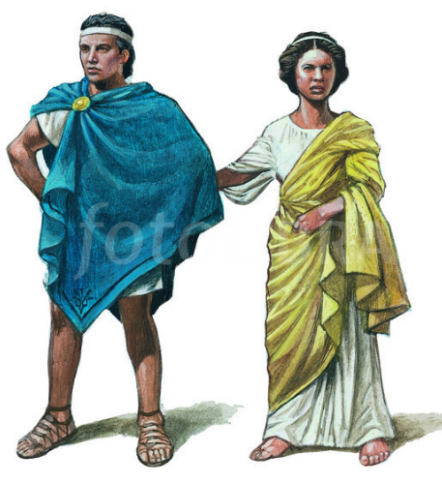 | The Ancient Greeks wore a tunic called a ‘chitin’ – worn by both men and women. These were fastened together at different places, and a belt was also normally worn at the waist. Chitins came in many sizes and colours. | How?  Chitins were generally made out of a thin wool material | Key Fact:  The rich could afford linen and silk chitins.

432 BC – The Parthenon, the most famous building in Athens, is completed
570 BC – Pythagoras is born. He made major breakthroughs in science and maths
600 BC – The first Greek coins are used to buy and sell goods
776 BC – The first Olympic games take place in honour of Greece
146 BC – Rome conquers Greece, making it a part of the Roman Empire.
336 BC– Alexander the Great is King and completes many conquests
400-300 BC – Socrates, Plato and Aristotle live, advancing learning
508 BC– Democracy begins in Athens, giving greater power to the people
Ancient Greece Timeline

