Breadth map for Geography

IGeography lessons will take place every two weeks over a ten week term.

 | Term 1 | Term 2 | Term 3
Week 1 | Cambois, UK | New York, USA | Cardiff, UK
Week 3 | Sydney, Australia | Edinburgh, UK | Havana, Cuba
Week 5 | London, UK | Mumbai, India | Belfast, UK
Week 7 | Beijing, China | York, UK | Buenos Aires, Argentina
Week 9 | Newcastle, UK | Ankhor Wat, Cambodia | St Ives, UK
The places that will be studied in Key Stage 1, cycle A are:

The places that will be studied in Key Stage 1, cycle B are:
 | Term 1 | Term 2 | Term 3
Week 1 | Rio, Brazil | Stonehenge, UK | Moscow, Russia
Week 3 | Liverpool, UK | Cape Town, South Africa | The Lake District, UK
Week 5 | Los Angeles, USA | Giants Causeway, UK | Mexico City, Mexico
Week 7 | Manchester, UK | Cairo, Egypt | Norwich, UK
Week 9 | Niagara Falls, USA | The Scottish Highlands, UK | Tokyo, Japan

Version 1 - (no explicit themes)

Lower Key Stage 2, cycle A
 | Term 1 | Term 2 | Term 3
Week 1 | Rivers of the UK | European cities | Landmarks of the UK
Week 3 | Rivers of the UK | Ports (land sea and air) of UK | Landmarks of the UK
Week 5 | Major Rivers of Europe and the world | Ports (land sea and air) of UK | Landmarks of Europe
Week 7 | Major Rivers of Europe and the world | Ports (land sea and air) of Europe | Landmarks of Europe
Week 9 | European cities | Ports (land sea and air) of Europe | Cities of the UK

Lower key Stage 2, cycle B
 | Term 1 | Term 2 | Term 3
Week 1 | Canals of the UK | Physical processes: erosion and deposition | Earthquake and tsunami
Week 3 | Canals of the UK | Physical processes: erosion and deposition
Week 5 | Canals of the world | Volcanoes of the world
Week 7 | Canals of the world | Volcanoes of the world
Week 9 | The water cycle | Earthquakes and tsunami

Version 2 (arranged around physical and human processes)

Background information on the physical and human processes
There are four main Physical processes:
• Physical processes that affect the lithosphere (land): tectonic movement; volcanic activity; erosion (wind and water) deposition; soil formation.
• Physical processes that affect the atmosphere (air): The water cycle.
• Physical processes that affect the hydrosphere (water) :The circulation of oceans.
• Physical processes that affect the biosphere (plants, animals and humans): Ecosystems; plant and animal communities. This is covered both through biology in the science curriculum and through the study of biomes in upper Key Stage 2. The biosphere is, therefore, not included in the lower Key Stage 2 geography curriculum.

There are many Human processes - these are the easiest understood for primary age students:
• Transportation - how people move from one place to another
• Settlements - where people settle, how this is affected by the physical features, different patterns of settlements.
• Trade- how communities trade with each other in natural resources and manufactured goods.
- The impact on humans from physical processes.

The processes outlined above form the basis for the following breadth maps for Cycle A and B

Lower Key Stage 2, cycle A
 | Term 1 | Term 2 | Term 3
Week 1 | Physical processes that affect the lithosphere:  Erosion and deposition.  Example 1: Rivers. (main features and processes) | Human processes: trade.  Example 1: food - main foods in UK supermarkets and where they are sourced. | Physical processes that affect the atmosphere: the water cycle.  Evaporation, condensation, precipitation, run-off.
Week 3 | …continued | …continued | Example 1: types of precipitation
Week 5 | Rivers of the UK. | Example 2: fossil fuels - oil and its trade between countries. | Example 2: types of clouds
Week 7 | Example 2: Coasts. (main formations - caves, arches, stacks, loss of land) | Human processes: settlements.  Example 1: settlements in urban areas (patterns and features) | Example 3: extreme precipitation - monsoon, hurricane (cyclone)
Week 9 | Coastal erosion problems in the UK. | Example 2: settlements in rural areas (patterns and features) | The human effects of monsoon and hurricane (Case studies of Bangladesh and Haiti)

Lower Key Stage 2, cycle B
 | Term 1 | Term 2 | Term 3
Week 1 | Human processes: transportation.  Example 1: movement within cities.(walking, cycling, buses, trams, cars) | Physical processes that affect the lithosphere: earthquakes and volcanoes.  Example 1: plate tectonics introduction. | Physical processes that affect the atmosphere: climate change.  Example 1: An introduction to the difference between weather and climate. The theory and evidence of climate change caused by human behaviour.
Week 3 | Example 2: movement within a country (cars, trains, coaches, aeroplanes, canal boats plus examples from around the world - e.g. rickshaw) | Example 2: location of the majority of the world’s volcanoes. | Examples of the effects of climate change: Glaciers, sea levels and temperatures.
Week 5 | …continued | The human effects of volcanic eruptions. | …continued
Week 7 | Example 3: movement between countries. (trains for continental; aeroplanes and ships for island to island or inter-continental) | Example 2: location of the majority of the world’s earthquakes. | Physical processes that affect the hydrosphere: ocean circulation.  Example1 - ocean currents.  Example 2 - Plastic pollution.
Week 9 | …continued | The human effects of earthquakes. | Human attempts to slow climate change and to reduce plastic pollution.

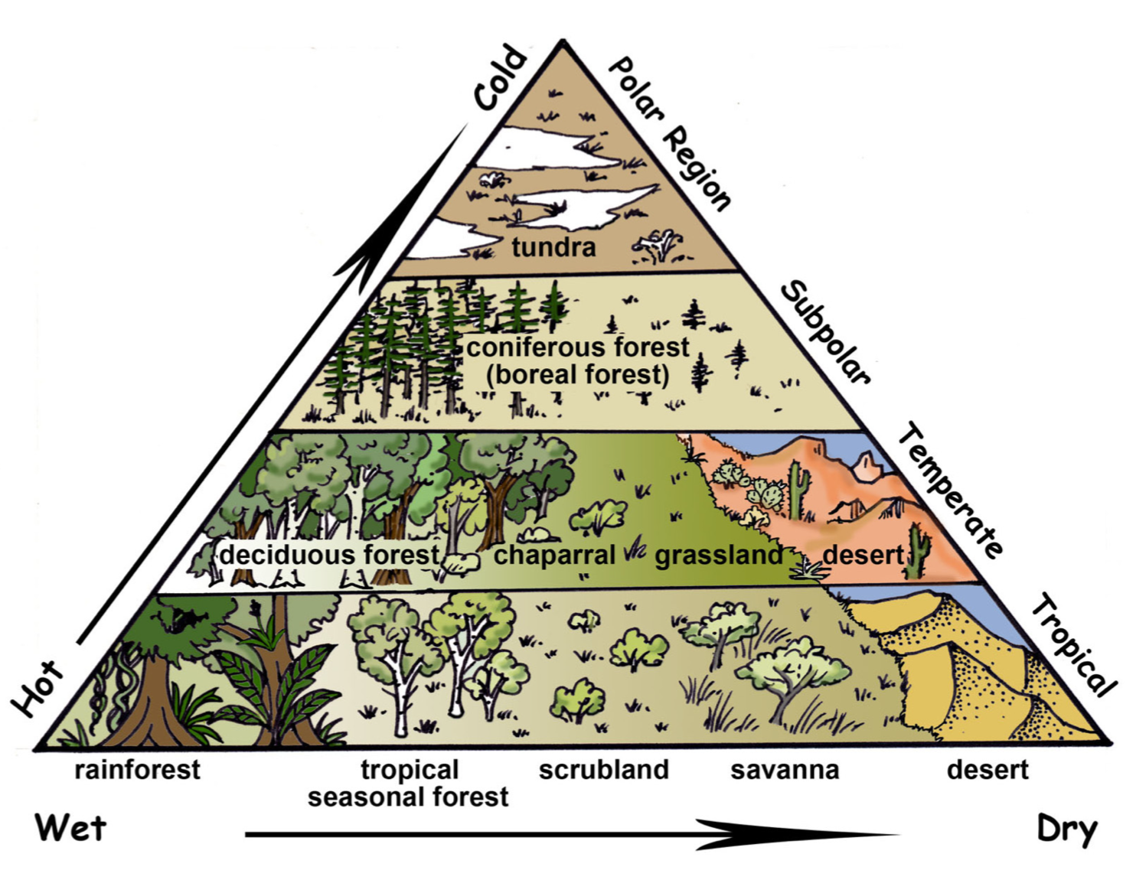
Notes on the rationale for breadth in upper key Stage 2
Two main biomes drive the curriculum in Upper Key Stage 2: terrestrial and aquatic. The aim is that students gain a greater world knowledge by looking at the biome, locations of them in both the northern and southern hemisphere; physical and human features of those locations.

The diagram opposite shows an overview of the main terrestrial biomes.

Upper Key Stage 2, cycle A
 | Term 1 | Term 2 | Term 3
Week 1 | Introduction to biomes terrestrial | Grassland (Eurasia -Steppes; South America- Pampas; South Africa- Veldts) | Tropical Desert
Week 3 | Tundra | Temperate Dessert | Tropical Deciduous rainforest
Week 5 | Taiga (boreal forest)  The largest biome on land with conifers (covering high latitudes of the northern hemisphere) | Alpine (mountainous) | …continued
Week 7 | Temperate Deciduous forest | Scrubland | Tropical rainforest
Week 9 | Chapparal | Savanna | …continued

Upper Key Stage 2, cycle B
 | Term 1 | Term 2 | Term 3
Week 1 | Introduction to biomes aquatic | Marine: Oceans and seas | Estuaries:
Week 3 | Freshwater: lakes and ponds | …continued ( included the human processes of fishing and the human impact of overfishing) | …continued (including some of the major estuaries in the UK and around the world)
Week 5 | The great lakes of North America | …continued (including the human behaviour that leads to pollution and attempts to manage it) | … continued (including how estuaries are changing shape from human pollution e.g. wet wipes)
Week 7 | Freshwater: rivers and streams | Coral Reef (Great Barrier Reef) | Pacific atolls ( ink to coral reefs)
Week 9 | Rivers of the world | …continued (including the human impact of coral bleaching) | Deep sea environments

