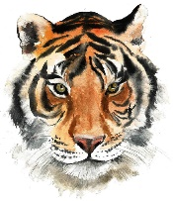
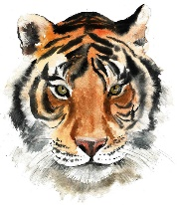
Y6
ANIMALS including Humans
KNOWLEDGE ORGANISER

What you should already know… |  |  | The Circulatory System
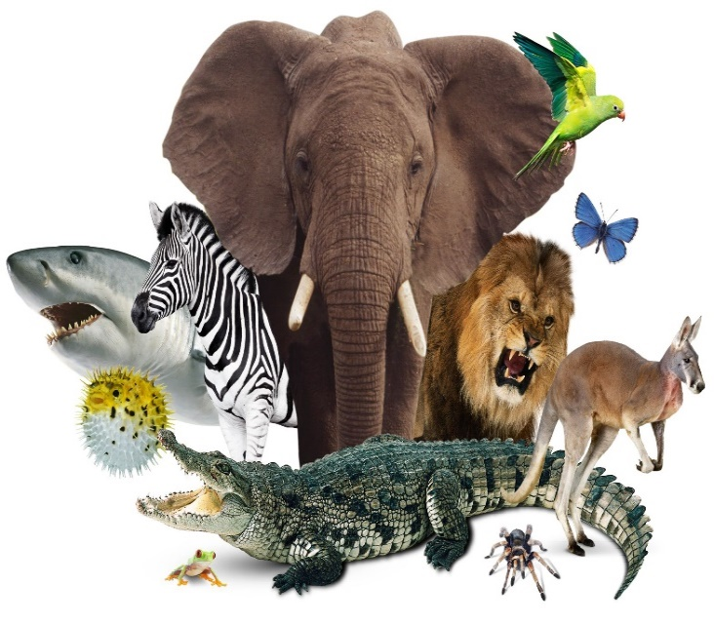  -Humans and animals go through life stages, including birth, growth, reproduction and death.  -Humans go through puberty as they move beyond childhood into adulthood, and their bodies age as they get older. You should know the different changes that take place.  -Different foods contain various quantities of carbohydrates, fats, proteins, fibre, vitamins and minerals. It is important to have the right balance.  Humans (and many animals) have skeletons, muscular systems and digestive systems. You should know the basic parts and purposes of these systems for humans. |  |  |  | 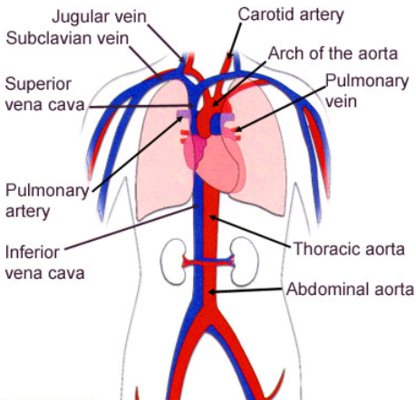
-The circulatory system is your body’s delivery system. It is made up of your heart, blood and blood vessels.
-The human body needs a constant supply of blood to keep working. Blood delivers oxygen to all of the body’s cells – without this, cells would die. The circulatory system gets blood (and the oxygen) all around your body.
-The heart pumps blood to the lungs via the pulmonary artery, where it picks up oxygen. It is then returned to the heart through the pulmonary vein.
-The heart then pumps the oxygenated blood to the rest of the body through the aorta and the other arteries.
-Veins are vessels that bring blood back to the heart.
Impact of Diet, Exercise, and Drugs |  |  | The Heart
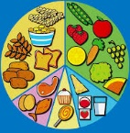  Diet  -A healthy, balanced diet can have a huge effect on a person’s health. People who eat the right balance of fresh, healthy foods are less prone to chronic illnesses and diseases.  -Carbohydrates are used by the body to create glucose, the body’s main energy source. Fat is also helpful for energy, but too much fat in a person’s diet causes them to gain weight. Protein helps to build and repair muscles, but too much can cause indigestion and intestinal problems. |  |  | 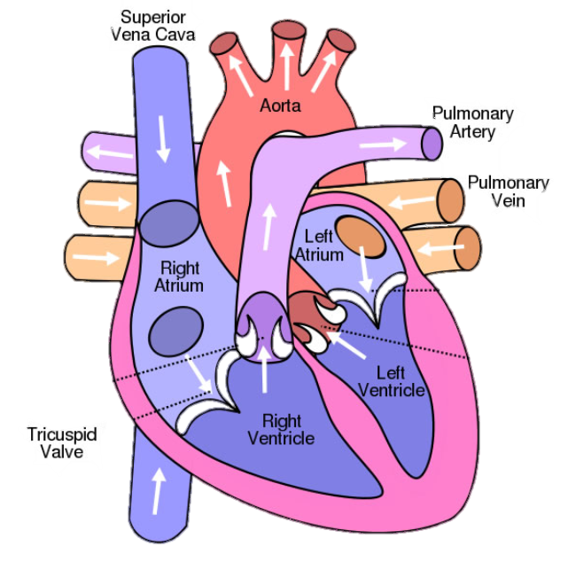  -The circulatory system is centred on the heart, an organ that works constantly to pump blood around the body.  -The heart is made up of four sections, called chambers. There are two sides to the heart (right and left) each of which have an atrium (at the top) and a ventricle (at the bottom).  -The job of the ‘atria’ (the word for the two atriums) is to fill with the blood returning to the heart before pushing it to the ventricles.  -The left atrium receives blood from the lungs and the right atrium receives it from the rest of the body.  - The job of the ventricles is to push the blood out of the heart. The left ventricle pushes blood to the lungs and the right ventricle pushes blood to the rest of the body.
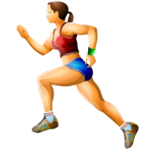  Exercise  -As we exercise, our muscles need more oxygen. So, we breathe quicker, helping our lungs to take in more oxygen.  -Our heart needs to pump blood more quickly to get all of the oxygen around the body. In order to do this, our heart rate increases.  -Regular exercise helps our bones and muscles to become stronger. It also helps the heart and lungs to become healthier. | 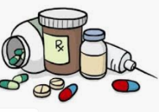  Drugs  -A drug is a chemical that has an effect on your body.  -Some drugs are prescribed by doctors to make people healthy. Other, illegal drugs can have a dangerous effect on our health.  -Alcohol is a depressant. Alcohol can cause damage to the liver and brain. Cigarettes contain nicotine, which is a stimulant, and is addictive. Cigarettes cause damage to the lungs and heart.
Transportation of Water in the Body
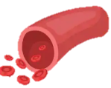
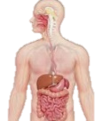
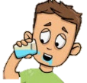
Excretion – waste water is passed out as urine.
Transportation – water is taken in blood to different parts of the body.
Absorption – water is absorbed by the intestines and is carried in the bloodstream.
Rehydration – water is drunk through the mouth.

