Personal, Social and Emotional Development  This half term our focus week will be centred around equality and acceptance of difference. We will look into the Paralympics message of ‘Yes we can’ whilst also linking to bullying and in particular cyber bullying and staying safe on the internet. | Physical Development  Once each week we will be having a rugby lesson with Steve Beaty from Cramlington Rockets.  We will also be going swimming each Wednesday. | Topic  Our topic this term is Ancient Greece. We will be learning about life in Ancient Greece and how it has had an impact on Modern Day life across the world. Medium term overview available on our class page on our school website.
Literacy  We are beginning a new style of English lessons this term called Talk for Writing. Please keep a check on our class page for examples of our work – both written and oral. | This is Me  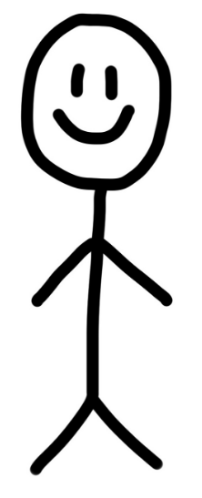 | Mathematics  We are changing our approach to teaching maths and will be focusing on ‘Mastery’ meaning we will be looking at the key areas of fluency, reasoning and problem solving. Our reasoning will help us to explain our thinking.
Homework and reading  Reading folders should be brought into school daily.  The format of homework will remain as an optional format in order to receive praise points. | Science  We will be learning about light and how we see things. This unit will allow us to develop our scientific enquiry and plan and carry out fair tests in order to draw conclusions. | PE kit  Year 5 and 6 will have PE on Tuesday and Swimming on Wednesday. Kits should be brought into school on the first day of term and we suggest you leave it until half term.  Remember they’ll need: a plain white t shirt, blue/black shorts, sandshoes / trainers. Swimming will cost £2 each week.
Educational visits  - Pizza Express trip – 10th Jan  You will be informed any further visits. | Important information  Mrs Darbyshire will have PPA on Tuesday pm so will be out of the classroom. The children will have music first lesson then Andy Allman will continue transition activities with Mrs Rawlinson’s support. | Dates for the diary  - Y5 biking 12th Jan and 26th Jan
Supporting your child at home  Please remember to read with your child at home and sign their books twice a week at least. It is vital they are questioned about what they’ve read in order to improve their comprehension skills at this stage. |  | Follow us on Twitter and Facebook!    

