

Meet your teachers in Early Years
Miss Chandler
I am Miss Chandler and I teach nursery and reception.
I’m passionate about giving our children the best start to their education and watching them thrive in an inclusive learning environment where they are nurtured. Outside of school, I enjoy spending my time with friends and family and walking my dog called Teddy. I also volunteer my time teaching freestyle dance to children. I love to sing and dance.


Mrs Atkinson
I am Mrs Atkinson and I teach nursery in the mornings and run forest school in the afternoons. I’m passionate about creating a nurturing engaging environment where children can grow, learn and thrive. Outside of work, I value quality time with my family and enjoy spending time with them. I also enjoy spending time outdoors.

Miss Williamson
I am Miss Williamson and I support in reception. Outside of work, I love to spend quality time with my two children and enjoy going for walks and going on adventures.

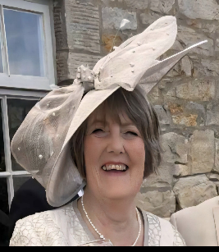
Miss Shennan
I am Miss Shennan and I support in early years. When I’m not at work, I enjoy spending time with my family and friends, reading a good book and attending musical events.

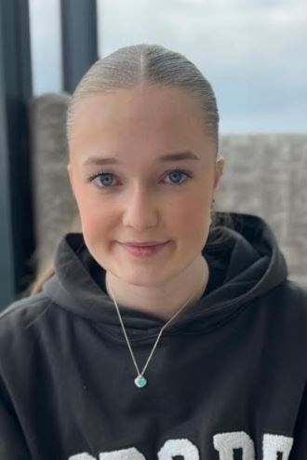
Miss Leigh-Sowerby
I am Miss Leigh-Sowerby and I support in nursery each morning and reception in the afternoons. Outside of work, I enjoy spending quality time with my family and friends. I dance and compete regularly and have been part of many Christmas pantos.


Miss Hall
I am Miss Hall and I support in nursery each morning and reception in the afternoons. Outside of work, I enjoy doing competitive dancing, socialising with my family and friends. I love long walks along the beach too.

Reading Books

Reading and phonics books are to be brought in weekly on a Thursday to be changed.
P.E. Days
P.E days are Tuesday and Thursday.
Children are to come into school each Tuesday and Thursday in P.E. kit. Please ensure any earrings are taken out or covered on these days.

If you have any questions please don’t hesitate to get in touch. We are more than happy to help.
School timings
Children come into school at 8:30am. The door will close at 8:35am ready for the school day beginning at 8:40am.
Children should come into school via the two sets of gates at the right hand side of the school where they will be met by members of the early years team.

Children in Nursery (15 hours) school times: 8.30am– 11.30am

Children in Nursery (30 hours) and reception, school times: 8.30am– 3.00pm

Tapestry
We use tapestry to upload any observations of your child and share their learning with you. We also ask that you upload tapestries of your children at home and activities or achievements so we can share these with the class.

