Focus Week  This ½ term’s focus week will be a Science week. Suring this time we will have a visit from a scientist to allow us to create some fantastic experiments, including slime making. We will study a scientist and their work, before conducting our own experiments. | Physical Development  Every Thursday y5/6 will have two sessions with NUFC – one session classroom based and focusing on PSHE whilst the other session will be a physical education session. Y5 will continue going swimming every Wednesday this term so will need a swimming kit and £2 each week. Y5 will also be working with NUFC on a Friday afternoon. During these sessions Y6 will have interventions in preparation for the SATS. | Topic  Our topic for this term is Coasts. Following on from the geography based learning of last ½ term , we will now move onto producing our own artwork linked to the coast. We will also be looking at the role of the coastguard, the safety aspects of living near a coast and charity work involved with the RNLI. See our medium term plan on the website for more details.
English  In English we will begin by focusing on non-fiction writing in the form of persuasion texts. This will be linked to a current topic in our news at the moment – the use of plastic bags and packaging in supermarkets. We will be looking at writing letters to our local MP and supermarkets. Towards the second half of the term we will be reading the legend of Sir Gawain and the Green Knight by Selina Hastings. | This is Me  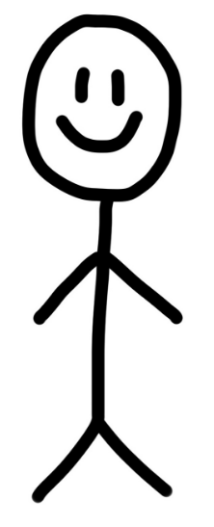 | Mathematics  Years 5 and 6 will be split for maths lessons over the next half term as we move to revision for the year 6 in preparation for the SATs. Year 6 will begin with fractions before revising many different topics with Mrs Darbyshire. Year 5 will be taught by trainee teacher Miss Beckworth and supported by Miss Baxter. They will be learning about fractions through use of concrete, pictorial and abstract methods to lead to ‘mastery’.
Homework and reading  Reading folders should be brought into school daily. Each day we read for 10 mins and all children need their books for this.  They also receive maths / English homework on alternate weeks, which is due in on a Tuesday. Reading should be completed before a Friday morning as this will not count for ‘green’. | Science  We will continue to learn about the human body and in particular the circulatory system. We will look at what blood is made of and the importance of blood donors. The children will then explore the effect of exercise on the body and use this to plan a fair test before learning about the effects of different types of drugs and alcohol on the body. | PE kit  Year 5 and 6 will have PE on Thursday. Remember they’ll need: a plain white t shirt, blue/black shorts, sandshoes / trainers. Football kits and other clothing that re not school PE kit will not be seen as green for PE kit in progress files.
Important information  Mrs Darbyshire will have PPA on Thursday pm whilst children have NUFC in. |  | Dates for the diary  7th March – St James Park visit  14th March – Parent’s evening  19TH March – author visit at Mowbray Primary
Supporting your child at home  Please remember to read with your child at home and sign their books twice a week at least. It is vital they are questioned about what they’ve read in order to improve their comprehension skills at this stage. |  | Follow us on Twitter and Facebook!    

