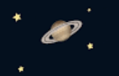
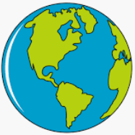
KNOWLEDGE ORGANISER
EARTH and SPACE
Y5

Overview |  |  | The Sun and the Moon
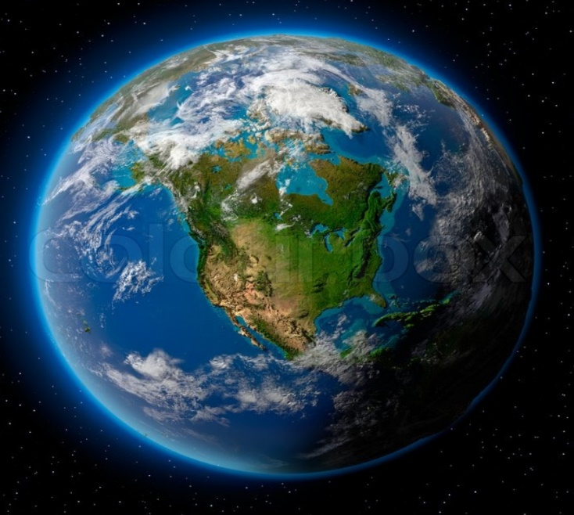  -The Earth (our planet) is a part of the Solar System. At the centre of the Solar System is the Sun. The Sun is a star.  -There are 8 planets and 5 dwarf planets in the Solar System, which orbit (go around) the Sun.  -It takes Earth just over 365 days to go around the Sun (one year).  -The Earth rotates on its axis once every 24 hours (one day). This causes day and night, as different parts of the planet face the Sun.  -The Moon orbits around the Earth. The Sun, Earth and Moon are all roughly spherical. |  |  | 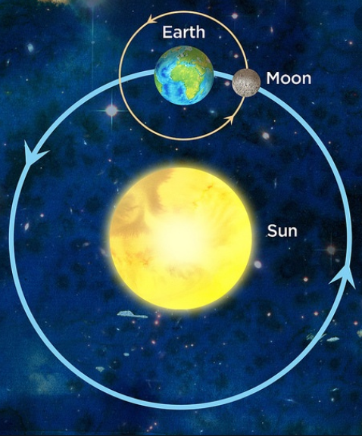 |  |  |  | -The Sun is a star: a huge ball of hot gas that gives off light & heat. The Earth (and all of the planets in the Solar System) orbit the Sun.  -It takes the Earth just over 365 days to make one complete orbit around the Sun – this is one year. The Earth and other planets are held in place around the Sun by gravity – the same force that keeps you on the Earth!  -The Earth is always spinning around. When a point on Earth is facing the Sun, it is daytime. When facing away, it is nighttime. It takes 24 hours for the Earth to complete a spin (one day).  -Some objects orbit around the planets. These are called moons. The Earth has one moon (just called The Moon). The Moon is much smaller than the Earth, and takes one full day to complete an orbit around the Earth.
The Solar System |  |  | Planet Facts
-The Solar System includes the Sun and all of the objects that orbit around it due to gravity.  -The Earth is one of eight planets that orbit the Sun. It is the third closest to the Sun.  -The planets are (from closest to furthest away from the Sun) Mercury, Venus, Earth, Mars, Jupiter, Saturn, Uranus and Neptune. Jupiter is the largest planet and Mercury is the smallest.  -There are also five dwarf planets: Haumea, Makemake, Ceres, Eris and Pluto.  - Earth is the only known planet in the Solar System where there are living things. The planets closer to the Sun are thought to be too hot, whilst some of those further away are too cold.  -You could fit about 1,321 Earths inside Jupiter. You could fit 1.3 million Earths into the Sun!  -Many of the planets (including Earth) have moons which orbit them. Jupiter has around 80 moons!  - The Sun is gigantic, but it is just one of billions of stars in our galaxy: The Milky Way. The Milky Way is just one of billions of galaxies in the Universe! |  |  | Mercury | Venus |  | Earth |  | Mars | Jupiter | Saturn |  | Uranus | Neptune
 |  |  | Area:  0.147 Earths  8th Largest  Moons:  None  Length of Day:  1,408 hours  Length of Year:  88 days | Area:  0.902 Earths  6th Largest  Moons:  None  Length of Day:  5,832 hours  Length of Year:  225 days |  | Area:  1 Earth!  5th Largest  Moons:  1 moon  Length of Day:  24 hours  Length of Year:  365 days |  | Area:  0.284 Earths  7th Largest  Moons:  2 moons  Length of Day:  25 hours  Length of Year:  687 days | Area:  121.9 Earths  1st Largest  Moons:  Around 80 moons  Length of Day:  10 hours  Length of Year:  12 Years | Area:  83.7 Earths  2nd Largest  Moons:  Around 65 moons  Length of Day:  11 hours  Length of Year:  29 Years |  | Area:  15.91 Earths  3rd Largest  Moons:  Around 30 moons  Length of Day:  17 hours  Length of Year:  84 Years | Area:  14.98 Earths  4th Largest  Moons:  Around 15 moons  Length of Day:  16 hours  Length of Year:  165 Years
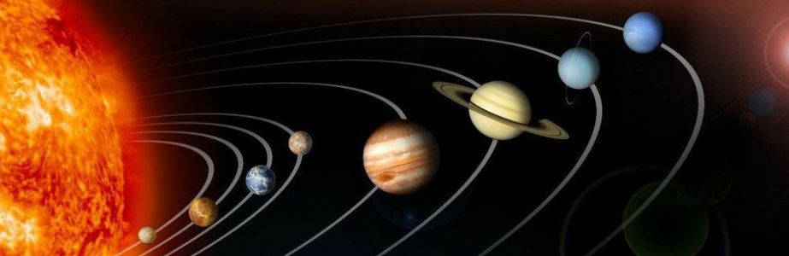
The Planets
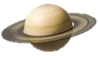
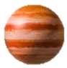
Neptune
Saturn
Venus
Uranus
Jupiter
Mars
Earth
Mercury

