Cambois Primary School

Positive Relationships Policy

September 2023

Introduction

This policy works in close conjunction with The Governing Body’s Statement of Behaviour Principles (see Appendix 1)

We are a caring community, whose values are built on mutual trust and respect for all. The school’s behaviour policy is therefore designed to support the way in which all members of the school can live and work together in a supportive way. It aims to promote an environment where everyone feels happy, safe and secure.

At Cambois Primary, we have high expectations of behaviour from both our pupils and adults and strongly believe that all behaviour is a means of communication; a way of expressing an emotion. The standard you walk past is the standard you expect.

Our Positive Relationship Policy ensures that within a framework of expectations, routines, rights, and responsibilities, we guide, encourage and teach pupils to form positive relationships with all that are around them which in turn, allows teachers to teach and pupils to learn.

To ensure that the school community operates fairly, everyone is expected to participate in making and agreeing the expectations by which we work.

To create and maintain a positive classroom and school environment we encourage:
- Self-regulating behaviour (self-control/self-discipline/self-management)
- Taking responsibility for the choices we make and the consequences of these choices)
- Having respect for the rights and beliefs of adults and of other pupils
- Working co-operatively
- Honesty and fairness

This is achieved through a clear and shared set of expectations, rights, routines, and responsibilities.

Expectations
For the safety and well-being of everyone in the school community, it is necessary for us to work within a set of expectations.

Our school expectations are clear and simple. They are displayed around our school, are used consistently and are linked with consequences. They are:

Ready | Respectful | Safe

Rights
Every person in the school has rights. Each teacher has the right to teach without disruption and children have the right to learn without interference. We also recognise that every member of the school community also has:
- The right to learn and help others through careful listening and turn taking.
- The right to feel safe in, and moving around the school, classroom, and playground.
- The right to express themselves, ask questions and, share opinions and ideas.
- The right to be treated fairly, with equality and respect in line with our Equality Statement.
- The right to be listened to in a dispute and have difficulties with others settled.
- The right to work in an environment that is cared for by everyone in the school and, equipment and belongings looked after.

Consistent Adult Behaviour
At Cambois Primary School, you will see visible adult consistencies everywhere. We believe that excellent behaviour from all children is only achieved when all adults are modelling excellent, wholly consistent behaviours in line with this policy.

We Do Not Shout | There is never a valid reason for shouting at a child.  The only exception might be if a child was in danger, for example shouting “Stop!” across a busy playground if a child was seen to be doing something which was going to put themselves or other children in harm’s way.
We Always Refer to the Behaviour and Not the Child | When we are speaking to children about negative behaviour, we always talk about the behaviour so that they understand they have a choice in how they behave.
“It Takes a Whole Village to Raise a Child.” | Beyond the school gates, we encourage children to continue their positive behaviour outside of school in a number of ways. We model good behaviour when out and about in the local community.
Non-Confrontational Approach | We use a non-confrontational approach when speaking to the children and the rest of the school community.
Behaviour Outside of School | If the school becomes aware that anti-social or unacceptable behaviour has been displayed by pupils outside of the school, it will be dealt with appropriately.

Positive Recognition
We work on the principle that for most of our children they will respond well when their efforts are recognised and rewarded. At Cambois Primary School we use a range of rewards:

Reward System | Who for? | Why?
Star in a jar | Individual to a group  Reception to Year 6 | We use to promote positive behaviour. These are awarded to children for going beyond expectation actions.  Once awarded, stars are never taken away.  All staff can award stars. These must relate to the core principles and ethos in the policy and written on a star post it note. Classes decide themselves what the values of jars are and what the rewards are/
Celebration Assembly  Pupil of the week | Individual  Nursery to Year 6 | A weekly assembly celebrating the achievements of all our children. Staff award a certificate to a child/children in their class who have worked really hard in their learning, effort and progress.
Hot Chocolate Friday | Individual weekly one child from each class | As a way of acknowledging children who go over and above the expectations, our staff nominate children to have a monthly ‘hot chocolate’ with our Headteacher.
Writer of the week |  | Improved effort with writing and a pen and notebook reward. Writing displayed in the hall.
Golden time | Reception to year 6 | Weekly amount relating to the criteria in the progress files.  Children earn time daily for meeting the criteria of the system. Sign up to an activity on a Monday so they know what they are working towards. They earn daily and set activities on a Friday to go to for their earned reward.

Support

The role of the class teacher

It is the responsibility of class teachers to ensure that the school rules are enforced in their classes, and that their classes behave in a responsible manner during lesson time.

The class teachers in our school have high expectations of the children with regard to behaviour, and they strive to ensure that all children work to the best of their ability.

All staff treat each child fairly, and enforce the school rules consistently. They treat all children in their classes with respect and understanding.

If a child misbehaves repeatedly in class, the class teacher deals with incidents him/herself in the normal manner. However, if misbehaviour continues, the class teacher seeks help and advice from the Headteacher. It may be appropriate to keep a Behaviour Log or a Home/School Communications Book for that child. Parents are always involved with strategies at this stage.

The class teacher liaises with the SENDCO who then liaises with external agencies, as necessary, to support and guide the progress of each child. They may, for example, discuss the needs of a child with the school nurse, social worker or Inclusion support team. Pupils at risk of exclusion will have a Pastoral Support Plan.

The class teacher reports to parents about the progress of each child in their class termly, in line with the whole-school policy. The class teacher, in consultation with the Headteacher, may also contact a parent if there are concerns about the behaviour or welfare of a child.

The role of Support Staff including T.A.s, Midday Meals Supervisors and Office Staff

All support staff may respond to behaviour that requires a reminder or warning. They should report any incidents to the class teacher or Headteacher for appropriate action if necessary.

The role of the Headteacher

It is the responsibility of the Headteacher, under the School Standards and Framework Act 1998, to implement the school behaviour policy consistently throughout the school, and to report to governors, when requested, on the effectiveness of the policy. It is also the responsibility of the Headteacher to ensure the health, safety and welfare of all children in the school.

The Headteacher supports the staff by implementing the policy, by setting the standards of behaviour, and by supporting staff in their implementation of the policy.

The Headteacher notes any incidents when pupils are referred to them on account of bad behaviour and keeps records of all reported serious incidents of misbehaviour. These must be sent in line with the policy on the set document in the google drive.

The Headteacher has the responsibility for giving fixed-term exclusions to individual children for serious acts of misbehaviour. For repeated or very serious acts of anti-social behaviour, the Headteacher may permanently exclude a child. Numbers of pupils excluded each term is reported to governors in the termly Headteachers report.

The role of parents

The school collaborates actively with parents, so that children receive consistent messages about how to behave at home and at school.

We explain the school rules in the school prospectus, and we expect parents to read them and support them.

We expect parents to support their child’s learning, and to cooperate with the school, as set out in the home-school agreement. We try to build a supportive dialogue between the home and the school, and we inform parents immediately if we have concerns about their child’s welfare or behaviour. If the school has to use reasonable sanctions to punish a child, we expect parents to support the actions of the school.

If parents have any concerns about the way that their child has been treated, they should initially contact the class teacher. If the concern remains, they should contact the Headteacher. If these discussions cannot resolve the problem, a formal grievance or appeal process can be implemented in accordance with the school’s Complaints Procedures.

The role of governors

The governing body has the responsibility of setting down both the Behaviour Policy and a Statement of Behaviour Principles (see Appendix 1), and of reviewing their effectiveness. The governors support the Headteacher in adhering to these guidelines.

The Headteacher has the day-to-day authority to implement the school’s policy on behaviour and discipline, but governors may give advice to the Headteacher about particular disciplinary issues. The Headteacher must take this into account when making decisions about m

The approach
Classroom Support

Calm and easy on every step with plenty of take-up time. Resist the urge to jump steps.

Reminder

Take up time
…………………...

Warning
Take up time
…………………...

2 mins + last chance
Script

Lots of take up time
…………………...

Behaviour lead/ HT or DHT Referral

…………………...

Time out
Removal from lesson is a sanction

Teacher’s choice
(Quick catchup, restorative conversation, imposition, detention, or natural consequence)

Serious Breaches
Students who commit a serious breach will be triaged immediately without support steps. This might include bullying (see separate whole school Anti-Bullying Policy), racist language, violence, homophobic behaviour.
For the vast majority of pupils, a gentle reminder or nudge in the right direction is all that is needed. This may be a quiet word or a visual cue in order to correct the behaviour.
Although there are occasions when it is necessary, every minute a pupil is out of your lesson is one where they are not learning. Steps should always be taken with care and consideration, individual needs must be taken into account where necessary. Praise the behaviour you want to see and do not pander to attention seekers. All pupils must be given ‘take up time’ in between steps. It is not possible to leap or accelerate steps for repeated low-level disruption.
A reminder and warning of the expectations for pupils referring to the rules of ‘Ready, Respectful, Safe’ should be delivered privately to the pupil. The teacher makes them aware of their behaviour. The pupil has a choice to do the right thing. Pupils should be given time to respond to this request ‘take up time’.
A clear, verbal, final last chance warning should be delivered privately to the pupil making them aware of their behaviour and clearly outlining the consequences if they continue. Pupils will be reminded of their previous good conduct to prove that they can make good choices. It is important to give the pupil some time here to have the opportunity to reflect on what you have said and respond appropriately.
Scripted approaches at this stage are encouraged:
“I’ve noticed that...You know the school rules ready, respectful, safe. Can you remember when I phoned home when you...and how that made you feel? I expect you to...Thank you for listening”.
Walk away as soon as you have finished and praise pupils who are getting it right.
Following an incident where a pupil has been removed, it is important that the classroom teacher follows this up. ‘Picking up your own tab’ is a key principle here. The classroom teacher has the following options:

1. Catch up
Behaviour that results in a student being referred to the hub may need no more consequences. However, it is very important, to catch up with the student before the next lesson, acknowledge that the previous lesson wasn’t good for anyone and that next lesson is a fresh slate.

2. Restorative Conversation
Walk and talk, stack books and talk, clean tables and talk. The Restorative Conversation is so much easier and more productive if it isn’t two people sat at a table making awkward eye contact. Much better to talk while doing something else.

The restorative 5:
’What happened?
What were you thinking at the time?
Who has been affected?
What should we do to put things right?
How can we do things differently in the future?

These are questions for both the adult and the child. The purpose of the restorative conversation is not to build to a climax of apology. Rather to get students to look in the mirror and see their behaviour from a different perspective. It is a coaching conversation using a recent incident in sharp focus. There is real learning here, most of the time for the students, sometimes for everyone.

3. Imposition
Work that was not done in the lesson to be done at home or in own time. Impositions are ideal for students who have not completed work due to their poor behaviour.

4. Call back
5 minutes at breaktime or 10 minutes to think about what happened at lunch

5. Natural consequence
Cleaning up the mess, repairing the display, reorganising the classroom, making up with peers are examples of natural consequences. If you can find a consequence that repairs the damage rather than just punishing the behaviour it all makes more sense.

TYPES OF ABUSE
There are many forms of abuse that can occur between children and the following list is not exhaustive:
Physical abuse
Physical abuse may include hitting, kicking, nipping, shaking, biting, hair pulling, or otherwise causing physical harm to another person. There may be many reasons why a child harms another and it is important to understand why a young person has engaged in such behaviour, including accidentally before considering the action to take or sanctions to introduce.

Bullying - physical, name calling, homophobic etc.

Bullying in whatever form is unwanted, aggressive behaviour that involves a real or perceived power imbalance. The behaviour is repeated, or has the potential to be repeated, over time. Young people who bully and those who are bullied can have longterm problems.

To be considered as bullying, the behaviour must be aggressive and include:
• an imbalance of power: young people who bully use their power, such as physical strength, access to embarrassing information, or popularity to control or harm others. Power imbalances can change over time and in different situations, even if they involve the same people.
• repetition: bullying behaviours happen more than once or have the potential to happen more than once.

Cyberbullying
The rapid development of, and widespread access to, technology has provided a medium for cyberbullying, which can occur in or outside the academy. Cyberbullying is a different form of bullying and can happen at all times of the day, with a potentially bigger audience. Cyberbullying involves the use of mobile devices, instant messaging, e-mail, chat rooms or social networking sites such as Facebook, Instagram, Twitter etc. to harass, threaten or intimidate someone. Cyberbullying can fall into criminal behaviour under the Malicious which states that a person who sends electronic communications which are “indecent or grossly offensive, convey a threat or false information or demonstrate that there is an intention to cause distress or anxiety to the victim” would be deemed to have committed an offence. The Communications Act 2003 (Section 127) further supports this and states that a person is guilty of an offence if he/she sends by means of a public electronic communications network a message or other matter that is grossly offensive or of an indecent, obscene or menacing character or if for the purpose of causing annoyance, inconvenience or needless anxiety to another he/she sends a message by means of a public electronic communications network knowing that the message is false. If the behaviour involves the taking or distributing indecent images of young people under the age of 18 then this is also a criminal offence under the Sexual Offences Act 2003.

Child on child sexual violence and sexual harassment

Sexual violence and sexual harassment can occur between two children of any sex. They can also occur through a group of children sexually assaulting or sexually harassing a single child or group of children. Children who are victims of sexual violence and sexual harassment will likely find the experience stressful and distressing. Children’s sexual behaviours exist on a wide continuum, from normal and developmentally expected to highly abnormal and abusive. We recognise the importance of distinguishing between problematic and abusive sexual behaviour. A model continuum to demonstrate the range of sexual behaviours presented by children can be used when seeking to understand a pupil’s sexual behaviour and deciding how to respond to it. If staff have any concerns about a child’s welfare, they should act on them immediately. Staff in this school will follow the academy’s Child Protection Policy and procedures and speak to the DSL (or deputy).
In relation to any reports or disclosures of sexual violence and sexual harassment between children we will:
• make it clear that sexual violence and sexual harassment is never acceptable, will never be tolerated and is not an inevitable part of growing up;
• challenge behaviours (which are potentially criminal in nature), such as grabbing bottoms, breasts and other private areas of the body.

Ultimately any decisions on how to proceed with an allegation of sexual violence and sexual harassment will be made on a case by case basis with the DSL (or deputy) taking a leading role and using their professional judgement, supported by other agencies, such as children’s social care and the Police as required.
We have a zero tolerance approach to sexual violence and sexual harassment. It is never acceptable and will not be tolerated. All staff have been made aware that even if there are no reports in our school, it does not mean it is not happening – it may be the case that it is just not being reported. If staff have any concerns regarding such abuse they must speak to the DSL (or deputy) as soon as possible. We will ensure that pupils are aware of the NSPCC dedicated helpline (report abuse in education – 0800 136 663) for children and young people who have experienced abuse at school, and for worried adults and professionals that need support and guidance
. Decisions about what action to take will consider:
• the wishes of the victim in terms of how they want to proceed; • the nature of the incident – might a crime have been committed?
• the ages of the children involved;
• any power imbalance between the children for example, if one child is much older, more mature or more confident. Does the victim have a disability, learning difficulty or other health related issues;
• whether it was a one-off incident or a pattern of behaviour by the alleged perpetrator;
• that sexual violence and sexual harassment can take place within intimate personal relationships between children; and
• other related issues and wider context, including any links to child sexual exploitation and child criminal exploitation. Some situations, however, are statutorily clear
• a child under the age of 13 can never consent to any sexual activity
• the age of consent is 16; • sexual intercourse without consent is rape;
• rape, assault by penetration and sexual assault are defined in law; and
• creating and sharing sexual photos and videos of under-18s is illegal

Time out

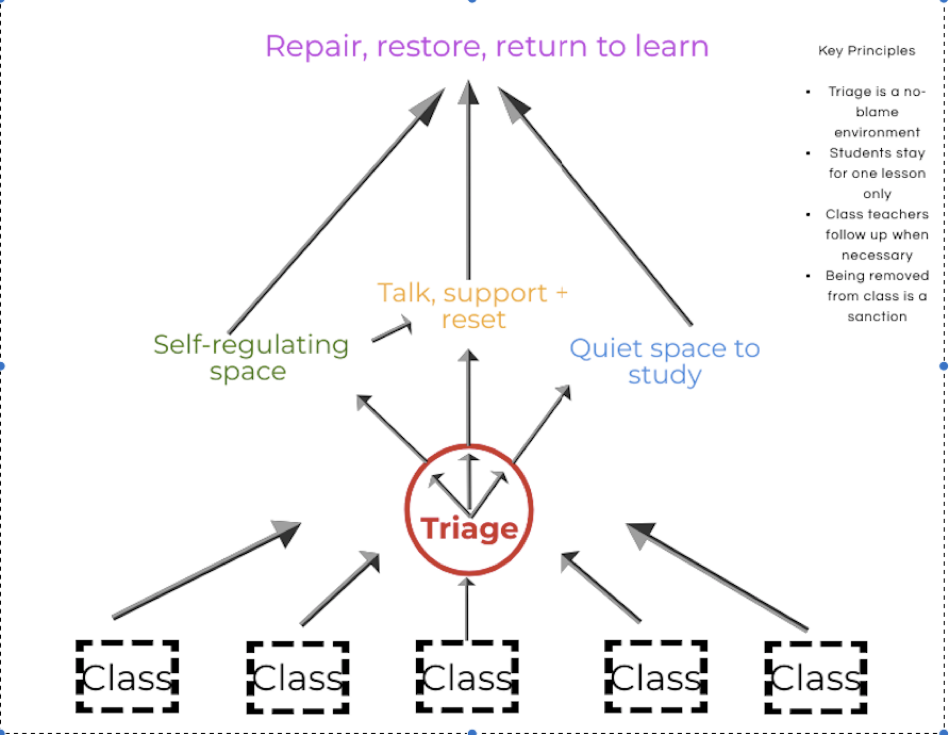

What happens in Triage?

- Self regulating space
- Opportunity to talk, access support and reset
- Quiet place to study

Repair - Self regulating space

Initial contact with a member of the primary support base staff or thrive staff to determine whether there needs to be some time in this area. This is a quiet space using sensory aids/blackout tent/headphones/ happiness boxes (for regular attendees) until the student is ready to talk and access support to help regulate their emotions.

Restore - Space to talk, access support and reset

For most students the aim is for the repair/restore to take place straight away, if necessary, with the student staying in the thrive space for only one lesson and returning to their next lesson ready for learning. In some instances, there may be a need to unpick an underlying issue and this may take longer, to allow the student the time to regulate their emotions.

Return to learn - Quiet space to study – The Cubby

This would be the area where students would complete the work that they are missing due to being removed from class. There would always be an expectation that the work is completed. Some students may be placed into this area quite quickly after, if for instance their removal was a one off and by means of being removed from the situation they had calmed and self regulated. They would then return to their next class ready for learning.

Consequences are not intended to humiliate or make an example of any child. The aim is to help the child think about his/her choices and take responsibility for changing their behaviour(s).

At Cambois Primary , we use a variety of consequences. They are tailored to suit the needs for each child within our school. These may include:

- Verbal reminders
- Involvement from home
- Discussions with an adult
- Coaching
- Spending time out in another classroom. This must be agreed by a member of SLT and the receiving class teacher
- SLT involvement
- A non-verbal reminder
- Restorative conversation
- In school exclusion (please see below for further guidance)
- Fixed Term Exclusion (please see below for further guidance)
- Visual cues
- Time Out – 5/10 minutes, either in the classroom or in the playground dependant on location of incident
- Permanent Exclusion (please see below for further guidance)

We record all behaviour incidents on an online system called CPOMS which enables us to have a clear picture of the choices our children are making and how we can best support them.

Support will be tailored to suit the needs of each child. This support may include:

- Verbal praise
- Circle times and/or PSHE sessions
- Open communication with parents and carers
- Support from SLT, including AHT for Well-Being, Inclusion and Assistant SENCO
- Support from our Learning Mentor, Place 2 Be
- Behaviour / Well-Being Support Plan – formulated with the child and family
- Where appropriate, referrals may be made to Cyps, EP, Social Care in conjunction with our SENCO and behaviour lead

In School Separation/Fixed term Exclusion
The separation or fixed term exclusion may be used for incidents of:

- Physical assault on another child or an adult
- Offensive verbal abuse towards another child or an adult
- Racial/homophobic abuse
- Bullying
- Being in possession of a weapon at school

The following can be applied:
1. In-school separation in which a child is removed from her/his class and placed with another teacher for a given period of time. We call this an internal exclusion.
2. Fixed term exclusion where a child is not permitted to attend school for a fixed period of time.
3. Permanent exclusion whereby a pupil is no longer permitted to attend Cambois Primary School.

Consideration will be taken of the age, knowledge and understanding of the child/ren involved in the incident when determining whether an in-school or fixed term exclusion will be used.

The school avoids these at all costs but when safety of adults or children are at risk and behaviours are continuing over time with no progress we will issue exclusions.

Reintegration of Excluded Pupils
All pupils being reintegrated following exclusion will have our expectations of behaviour re-clarified. Systems will be established where appropriate/necessary, to support the pupil in making a successful return to class/school.

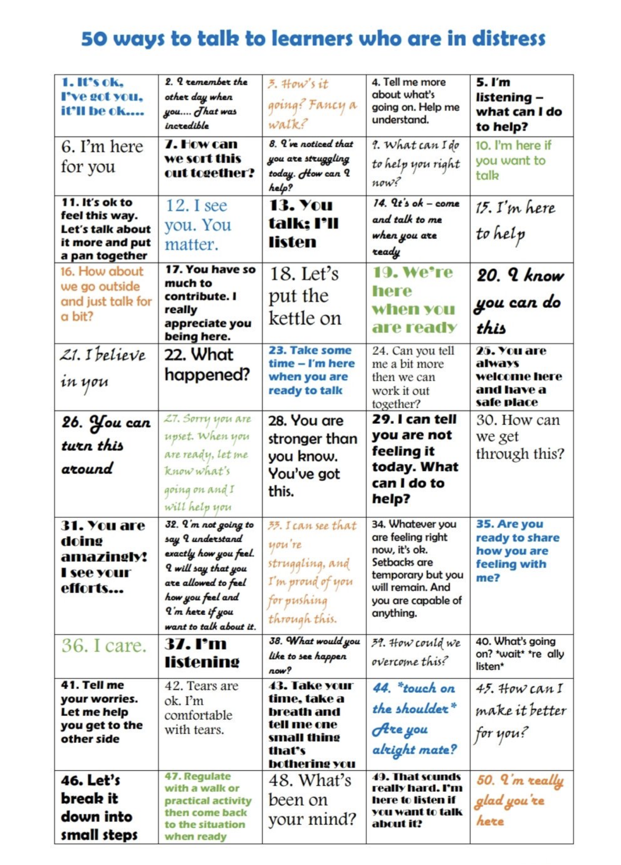

Appendix 1

Cambois Primary School Governing Body
Statement of Behaviour Principles

The standard you walk past is the standard you expect.

Section 88(2) of the Education and Inspections Act 2006 requires the governing body to:

a. make, and from time to time review, a written statement of general principles to guide the head teacher in determining measures to promote good behaviour and discipline amongst pupils; and

b. notify the head teacher and give him or her related guidance if the governing body wants the school’s behaviour policy to include particular measures or address particular issues.

This statement is to be taken in conjunction with the school behaviour policy and home school agreement which are reviewed and approved annually by the governing body.

The Behaviour Policy is publicised to staff and families every September. It is also available on the school website.
Principles

1. The importance of good behaviour: The Governors of Cambois Primary School strongly believe that high standards of behaviour lie at the heart of a successful school and enable (a) all pupils to make the best possible progress in all aspects of their school life and work and (b) all staff to teach and promote good learning without interruption or harassment.

2. Safety at school: All pupils and staff have the right to feel safe at all times in school. All visitors to the school should feel safe and free from the effects of poor behaviour at all times and in all parts of the school. The Governors expect procedures to be in place and well-known, and measures to be taken when necessary to ensure the safety of all at the school.

3. Discrimination and bullying: Cambois Primary Primary School is an inclusive school. All members of the school community should be free from discrimination of any sort (as laid down in the Equality Act, 2010). The school has a clear and comprehensive Anti-Bullying Policy that is known and understood by all, and is consistently applied and monitored for its effectiveness. The Governors expect measures to protect pupils from bullying and discrimination on the basis of gender, race, ability, sexual orientation or background to be clearly set out and regularly monitored for their effective implementation.

4. Equality and safeguarding: The school’s legal duties under the Equality Act, 2010 in respect of safeguarding pupils with Special Educational Needs and/or Disabilities, and all vulnerable pupils, are set out in the Behaviour Policy and known to all staff. The Governors expect that the implementation of the Behaviour Policy will be regularly monitored and the results of monitoring reported to them.

5. Parents and carers: Parents/carers should be encouraged and helped to support their children’s education, just as pupils are helped to understand their responsibilities during their time at school, in the local community and in preparation for their life after school. The responsibilities of pupils, parents/carers and school staff with respect to pupils’ behaviour are outlined in the ‘Home School Agreement’ which pupils and parents/carers are asked to sign when a pupil joins the school. Governors expect a high return rate from on this signing, and wish to have the return rate reported to them.

6. Sanctions for unacceptable/poor behaviour should be known and understood by all staff and pupils and consistently applied. The full range of sanctions should be clearly described in the Behaviour Policy so
that pupils, staff and parents can understand how and when these are applied. The Governors strongly feel that exclusions, particularly those that are permanent, must be used only as a very last resort.
‘Unofficial’ exclusions are illegal and are avoided. The Headteacher may inform the police, as appropriate, if there is evidence of a criminal act or if she/he fears that one may take place, e.g. if illegal drugs are discovered during a search, cyber-bullying is reported, or there is evidence of criminal harassment or even physical assault. The Governors expect sanctions to be monitored for their proper use and effective impact.

7. Procedures: The Governors expect the Headteacher to include the following in some detail in the Behaviour Policy:

a. Screening and searching pupils: the reasons for searching pupils should be made explicit, together with details of who may search pupils, where such searching should take place, what will happen to any banned items found as a result of such a search and what sanctions will be applied. It should also be made clear that parents do not have to be informed before a search. Governors expect authorised staff to be appropriately trained in how to carry out a search.

b. The power to use reasonable force or make other physical contact: the situations in which reasonable force may be used (including removing disruptive pupils from classrooms, or preventing them from leaving) should be stated. A definition of ‘reasonable force’ should be included, which should also explain how and when pupils may be restrained. Governors would expect all staff to be trained in the use of reasonable force and restraint. See positive handling policy for more detail.

c. The power to discipline outside the school gates: disciplining beyond the school gates covers the school’s response to all non-criminal bad behaviour and bullying that occurs anywhere off the school premises. The Governors must be satisfied, in all situations arising, that the measures proposed by the Headteacher are lawful and that staff and pupils know that sanctions can be applied in these circumstances.

Cambois Primary School
Behaviour Blueprint

Our vision
Cambois Primary is a place where everyone is welcome. We have high expectations in all we do.

Core Values and behaviours
Resilience | Kindness | Tolerance | Respect | Pride
I work hard in all lessons and do not give up. | I always let others join in. | I will always make people feel welcome | I will listen to others. | I will show pride in all my work with full effort.
I always give things a go with a can do attitude | I will use kind words and push ups to others. | I wlll accept people are different. | I will look after property and equipment. | I can express what is important to me.
When things get tough I know I am learning so I will dig deeper. | I will share with others. | I will value different opnions that are not the same as mine | I will speak rto people lilke I would want to be spoken to. | I will say well done to others.

Our Rules
To always try our best in all we do and treat everyone with respect.
Be ready Be Respectful Be Safe

Our Behaviour Principles
The standard you walk past is the standard you expect.

Relentless Routines | Visible consistency, visible kindness | Relationships Matter | Over and above Recognition
Scripted routines | RWI attention systems | Daily meet and greets | Recognition boards
Timekeeping and expectation | Restorative approaches | Using names | Praise postcards/calls

Our Rewards and Sanctions
Rewards | Sanctions
Every lesson a new start  Going for green | Reminder  Caution  Last chance  Time out and discussion  Imposition  Repair
Staff praise  Praise postcards  Praise points  Reward trips  Golden time | Time out  Meeting with parents  Reports  Internal/ external exclusions

